

Professional Practice – Geodesy: Terrain Mapping (Setting Out an Object)

FLIGHT RESOURCE CENTER

Stredná priemyselná škola stavebná - Építőipari Szakközépiskola,
Konkolyho 8, Hurbanovo


Ing. Adriana Eleková

Table of Contents
Table of Contents 1
1. SHORT DESCRIPTION 2
(UP 3000 CHARACTERS) 2
2. TARGET 2
3. SUBJECT AREA 2
4. TYPE 2
5. DRONE USED 2
6. DURATION 3
7. LEARNING OBJECTIVES 3
8. KEY COMPETENCES DEVELOPED 3
1. Communication and Languages 3
2. Mathematical, Scientific, Technical and Professional Skills 3
3. Digital Competences 3
4. Personal, Social and Professional Competences 3
5. Safety, Quality and Sustainability 4
6. Citizenship and Cultural Competence 4
7. Creativity, Problem-Solving and Entrepreneurship 4
8. Work-Based Learning and Workplace Integration 4
9. Prior Knowledge / Prerequisites 4
10. Lesson/Project Outline 4
Phase 1 – Introduction (Engage & Contextualize) 4
Phase 2 – Exploration (Investigate & Compare) 4
Phase 3 – Application (Hands-On Practice) 5
Phase 4 – Reflection & Consolidation (Present & Connect) 5
11. Assessment Criteria 5
12. Teaching Materials 5
13. External Resources 5
14. References 6

SHORT DESCRIPTION

Characteristics of Project-Based Learning
Subject: Professional Practice – Geodesy
Topic: Setting Out an Object (Construction Setting-Out)
Educational level: Upper secondary vocational education and training (VET)
Project-based learning on the topic Setting Out an Object focuses on the practical application of geodetic methods in real field conditions. Through project work, students acquire a comprehensive workflow for setting out a construction object—from the preparation of source documentation to accuracy control using modern technologies. The project connects theoretical knowledge of coordinate systems, levelling, and surveying instrumentation with the practical skills required for professional practice in construction and geodesy.
The core of the project is the planimetric setting-out of an object using orthogonal coordinates, where students work with design drawings, a baseline, and right-angle (rectangular) coordinates. Students then perform vertical setting-out using a levelling instrument, ensuring that the object is correctly positioned in terms of elevation. The project also includes control measurements using drones, enabling students to verify the accuracy of the setting-out, compare classical and modern measurement approaches, and analyse differences between the datasets obtained.
Project-based learning strengthens students’ independence, responsibility, and teamwork, as the activities are carried out in groups with clearly assigned roles. Students learn to plan the workflow, follow technical procedures and discipline, maintain a surveying field book, and evaluate measurement results. An important component is the development of digital competences through the processing of measured data and its graphical presentation.
A key benefit of the project is the integration of traditional geodetic procedures with modern technologies, helping students better understand the importance of accuracy and quality control in professional geodetic practice. The project develops vocational, technical, and workplace competences and prepares students for real situations they will encounter in further study or employment.
The project places particular emphasis on:
- Use of modern measurement technologies – working with drones and GPS modules, planning flight routes, and collecting spatial data;
- Professional geodetic competences – understanding coordinate systems, the planimetric coordinates used to set out the future object on the site, and their processing;
- Analytical and technical thinking – processing measured data, evaluating GPS measurement accuracy, and comparing results with classical geodetic methods, including planimetric setting-out using the orthogonal method;
- Practical skills – maintaining measurement documentation, processing data in software, and producing outputs such as tables, graphical representations, and evaluations of results from the classical method (levelling measurements, calculations, and graphical representation of the coordinate system—i.e., the setting-out plan) and the modern method (drone monitoring and GPS-based photogrammetry) for the purpose of assessing setting-out accuracy;
- Responsibility and work safety – complying with drone operation rules, adhering to safety regulations, and ensuring the protection of people and property during field surveying activities.
Throughout the project, students complete all stages of geodetic work: from measurement preparation (including calculation of the X, Y coordinates of set-out points, planning the drone flight, and defining the methodology), through field measurements using a levelling instrument and a drone with GPS, to the processing and evaluation of results. The final output is a comprehensive report documenting the setting out of the planned object on the site, including an assessment of the accuracy of the geodetic work based on drone-based control measurements. The report includes a description of the technologies used, the measurement procedure, calculations, and an evaluation of accuracy.
This project-based learning approach supports active learning, increases student motivation, and prepares learners for real-world professional situations in modern geodetic practice, where unmanned systems and digital data are increasingly important.

TARGET
- 15
- 16
- 17
- 18
- Over 18

SUBJECT AREA
- Agriculture
- Disaster Response
- Constructions
- Water Management
- Environmental Protection
- Other

TYPE
- Lesson Plan
- Project
- Activity

DRONE USED
- Custom Drone
- Commercial drone (DJI)

DURATION
- 1 x 45-minute class - Portugal
- 1 x 60-minute class
- 1 x 90-minute block
- 2 x 45-minute classes
- 2 x 60-minute classes
- Double session (2 × 60 minutes) optional project-based homework.

LEARNING OBJECTIVES

O1: Cognitive Learning Objectives (Knowledge-Based)
- Explain the concept of setting out a construction object and its significance in construction and geodetic practice.
- Understand the principles of setting out an object using orthogonal (rectangular) coordinates.
- Describe the function and correct use of a levelling instrument.
- Explain the difference between classical and modern control measurement methods.
- Understand the purpose of control measurement and the verification of setting-out accuracy.
- Explain how technical and environmental factors influence measurement accuracy when using drones and GPS.

O2: Psychomotor Learning Objectives (Skills-Based)
- Apply core procedures used in professional geodetic practice; operate and supervise GPS coordinate acquisition using a drone; and use geodetic measuring equipment, particularly a levelling instrument.
- Plan a drone flight route for the purpose of collecting spatial data.
- Carry out field measurements of object heights using drone and GPS technology, and perform conventional height measurements using a levelling staff and levelling instrument.
- Work with project/design documentation and coordinate data.
- Set out an object in the field using orthogonal coordinates.
- Correctly centre and level the levelling instrument.
- Perform the planimetric (horizontal) setting-out of the object.
- Conduct a control measurement using a drone.
- Record, process, and evaluate measured data.
- Compare results from the individual methods and draw justified conclusions.
- Produce a measurement report, tables, graphical outputs, and basic technical documentation.
- Use digital tools and software to process and evaluate data from geodetic works and drone-based control measurements.

O3: Affective Learning Objectives (Attitudes and Values)
- Comply with safety regulations and operational rules for unmanned aerial systems (UAS).
- Demonstrate a responsible approach to fieldwork and the use of technical equipment.
- Collaborate effectively within a team, respect the distribution of roles, and communicate appropriately with other group members.
- Develop independence, accuracy, and systematic work habits when solving practical tasks.
- Recognise the importance of modern technologies in contemporary geodetic practice and their application in real working environments.

KEY COMPETENCES DEVELOPED

1. Communication and Languages
- Literacy competence (understanding and producing written/oral texts)
- Communication in professional contexts
- Multilingual competence

2. Mathematical, Scientific, Technical and Professional Skills
- Mathematical competence
- Scientific, technological and engineering competence (STEM)
- Numeracy applied to work tasks
- Interpretation of technical information (manuals, diagrams, standards)
- Professional/technical skills
- Execution of practical tasks

3. Digital Competences
- Digital competence (general digital literacy)
- Use of digital tools in workplace settings

4. Personal, Social and Professional Competences
- Personal, social and learning-to-learn competence
- Teamwork and collaboration
- Autonomy and responsibility
- Work ethics and professional behaviour
- Adaptability and flexibility
- Cooperation with supervisors and colleagues

5. Safety, Quality and Sustainability
- Application of health and safety standards (OHS/SST)
- Quality procedures and workplace norms
- Environmental and sustainability awareness

6. Citizenship and Cultural Competence
- Citizenship competence
- Cultural awareness and expression competence

7. Creativity, Problem-Solving and Entrepreneurship
- Problem-solving and critical thinking
- Entrepreneurship competence
- Initiative and creativity
- Decision-making in real work situations

8. Work-Based Learning and Workplace Integration
- Integration into workplace routines
- Following professional instructions and procedures
- Use of tools, equipment and technology

This checklist merges the EU Key Competences for Lifelong Learning with the core competences expected in European Vocational Education and Training (VET).

Prior Knowledge / Prerequisites
The teacher introduces students to the topic Terrain Mapping Using Drones and GPS and explains its importance in contemporary geodetic practice. The instruction builds on students’ prior knowledge acquired during previous stages of study, particularly in the following areas:

1. Knowledge of Mathematics
To successfully complete the task, students are required to apply basic numerical operations and correctly perform conversions of length units, as well as addition and subtraction. Calculations form an essential part of preparing the setting-out plan, computing the X and Y coordinate values of object points, and comparing the results of control measurements with the final outputs.
Through guided discussion and group work, students revise the unit conversions commonly used in geodetic calculations.

2. Theoretical Knowledge of Geodesy
Working in groups, students discuss and identify the individual components of the levelling instrument, label these components on a diagram, and explain their function in the measurement process. Prior to fieldwork, students demonstrate in the classroom the correct levelling (horizontal alignment) of the instrument and present the function of its individual parts in practice.
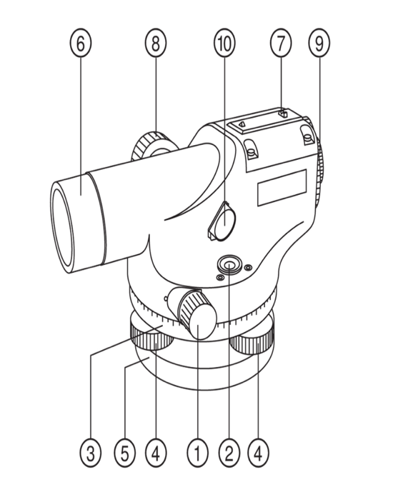
Students complete a worksheet containing diagrams of a theodolite, in which they fill in and consolidate the correct terminology for the individual components of the instrument.
- Horizontal movement control
- Box spirit level
- Horizontal circle
- Levelling screws (foot screws)
- Base plate
- Objective lens
- Approximate sighting device
- Focusing control
- Eyepiece
- Spirit level mirror

3. Skills in Technical Drawing Using Graphic Software
To successfully complete the task, students must be able to use graphic/CAD software to produce a setting-out plan for staking out the object on the site. This includes dimensioning individual sides and indicating the X and Y coordinate values of the project’s characteristic object points.

4. Skills in Using Digital Technologies and ICT
To prepare the final report, students apply ICT competences developed in informatics lessons. They produce a written document describing the workflow, include the required calculations, compile a table of measured values, and present a final visualisation and comparison of the results obtained.

Lesson/Project Outline

Phase 1 – Introduction (Engage & Contextualize)
Description: Introductory Phase of Project-Based Learning
Introducing students to the project topic
The introductory phase of project-based learning is designed to familiarise students with the topic, motivate them to engage in the work, and establish a clear understanding of the project’s objectives, content, and implementation process. In this phase, the teacher introduces the topic Setting Out an Object using the Orthogonal Method and Verifying the Accuracy of Surveying Works through Drone-Based Control Measurement, and explains its relevance to contemporary geodetic practice.
Within the introductory phase, the following key activities should be carried out:
- Presentation of the project topic
The teacher explains the purpose of the project, its professional focus, and its practical relevance. The teacher clarifies why the accuracy of setting-out works and control measurements is essential in geodesy and construction, and highlights the benefits of combining drones and GPS with traditional surveying methods.
- Student motivation
Students are motivated through examples of real-life applications of drones in geodetic practice (terrain mapping, construction monitoring, object inspection). The aim is to stimulate interest in modern technologies and emphasise the link between the project and students’ future professional opportunities.
- Definition of project objectives
The teacher clearly defines what students are expected to achieve during the project—what knowledge, skills, and attitudes they should acquire. Students are informed about the expected outputs and the format in which these outputs will be prepared.
- Core professional foundations
The teacher revises or explains the key concepts needed to complete the project (coordinate systems, GPS elevation data, and the role of the drone in collecting data for evaluating the accuracy of geodetic measurements carried out using the classical method—i.e., with a levelling instrument).
- Organisation of work
Students are informed about the project timeline, the working format (individual and/or group work), the distribution of roles within teams, and the communication procedures to be followed during the project.
- Safety and legal considerations
A crucial part of the introductory phase is instruction on drone safety, compliance with rules and regulations for field measurements, and measures to protect health, people, and property.
- Assessment and self-assessment criteria
The teacher presents the project assessment criteria, the method of group assessment, and the self-assessment tools, ensuring that students understand expectations and the basis on which their work will be evaluated.
The introductory phase establishes the foundation for successful project implementation, ensures that students fully understand the assignment, and supports an active and responsible approach to completing the project task.

Photo/Diagram:
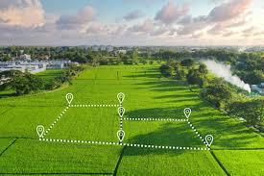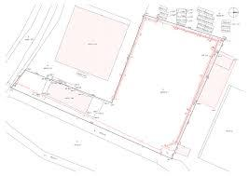

Guiding Questions / Class Discussion:
In your opinion, what are the benefits of using drones for control measurements when setting out a future object on a site?

Phase 2 – Exploration (Investigate & Compare)
Description:

Setting-Out Works
Geodetic setting-out works are carried out using the same methods as surveying measurements. They are based on an already established horizontal and vertical control network, and—through a combination of fundamental geodetic operations—the designed object is set out in accordance with the setting-out drawing.
The accuracy of setting-out must comply with the relevant standards and guidelines, or with specific requirements defined by the designer or investor.
Setting out construction objects is divided into:
a) setting out the spatial position, and
b) detailed setting out.
Part of the project documentation is also the coordination drawing of the construction project. It contains:
- a consolidated depiction of projects forming one functional unit (e.g., a housing estate, industrial complex, or construction site), and
- planimetric and height (vertical) data.
Setting-out works classified as geodetic works are, under Act No. 50/1976 Coll. on Spatial Planning and Building Regulations, the responsibility of construction stakeholders and must be ensured through authorised surveyors.

Setting-Out Drawing
The setting-out drawing is part of the construction design documentation and contains the complete specification of all setting-out data.
In accordance with STN 01 3419 – Setting-Out Drawings for Construction Works, the setting-out drawing includes:
- Setting-out network (horizontal and vertical control points with identifiers, connection of the design to existing objects, offsets from alignment/route, etc.);
- Axes and outlines of proposed objects;
- Setting-out elements linked to horizontal and vertical control points;
- Drawing orientation to north, a coordinate grid with identification of the coordinate reference system, and the applied vertical datum;
- Details linked to the main axes of the object, defined in relation to the setting-out network.
A setting-out drawing typically contains:
a) main alignment points and main height points (for setting out the spatial position);
b) points for detailed setting out (e.g., main points of curves, transition curves, and circular arcs);
c) points for vertical setting out (for detailed height setting out);
d) axes of construction objects (e.g., culverts), their chainage, and the layout of cross-sections;
e) tables with parameters of designed transition curves and arcs.
The setting-out drawing should clearly show the relationship of detailed setting-out points to the setting-out network and/or to the construction axes.
The most efficient approach is when setting-out elements are determined by analytical calculation. This is best achieved when detailed setting-out points are defined analytically within the coordinate system of the control network.
Setting-out drawings are prepared at an appropriate scale, typically 1:500, 1:1000, 1:2000, or 1:5000. It is recommended that the scale of the setting-out drawing matches the scale used for the detailed site plan.

How Drones Support Setting Out and Monitoring
- Data acquisition: Drones equipped with high-quality cameras and sensors (including LiDAR) capture terrain and construction features, producing accurate 3D models, orthophotos (georeferenced aerial imagery), and elevation models.
- Precise positioning: Drones with RTK (Real-Time Kinematic) technology can record positions with centimetre-level accuracy, which is critical for precise setting out.
- Digitisation: Collected data are processed into digital formats (e.g., within CAD software), enabling straightforward integration into project documentation.
- Control and monitoring: Drones enable regular monitoring of construction progress, quality control, detection of defects (e.g., cracks, corrosion), and time-based visualisation (e.g., time-lapse outputs).
- Safety and speed: Drones can survey hard-to-access areas, reducing risks to personnel and significantly shortening fieldwork time compared with traditional geodetic methods.

Typical Outputs Supporting Setting Out
- Survey of existing conditions: Creation of a digital terrain/site model.
- Planning: Accurate placement of the designed structure into real terrain conditions.
- Setting out boundaries and elements: Transfer of digital design points into the field (e.g., building corners, access road network).
- Control measurements: Verification of compliance between the executed works and the design documentation.
In summary, drones transform setting out from a manual, time-consuming activity into a digital, precise, and saferprocess supported by high-quality spatial data and efficient verification workflows.
Video https://www.youtube.com/watch?v=OPNnVTylq8c
Setting Out a Project Directly from a DXF or DWG Drawing – Surveying and Setting Out Points on Site Using GPS / GNSS
Photo/Diagram: 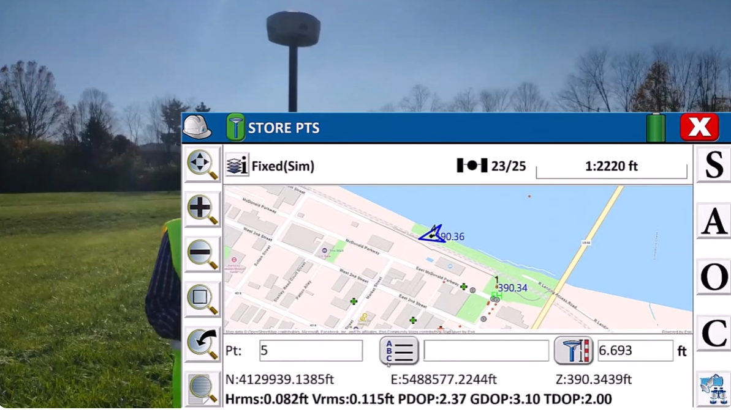
Fig. Setting out an object directly from the project using GPS coordinates

Guiding Questions / Class Discussion
- List the basic components of a levelling instrument.
- On what basis can a setting-out drawing be prepared?
- What information should a setting-out drawing contain?
- How can a drone be used in setting-out works?

Short Reading / Infographic
The setting-out process for a construction project includes the preparation of design documentation, a site inspection by an authorised surveyor, and the transfer of the main building points (e.g., foundation corner points) into the field using high-precision instruments (total station, GPS/GNSS). Through levelling, the surveyor also determines the elevation of the ground floor level. Stakes and profile boards are installed to ensure accurate foundation placement and to prevent errors during construction. This procedure is essential for compliance with the building permit and for correct implementation on site.

Steps in setting out a construction project
- Preparation of documentation: Securing design documentation (in particular the construction coordination site plan) and the building permit.
- Engaging a surveyor: Contracting a qualified/authorised surveyor with legal competence to set out construction works.
- Site inspection: The surveyor assesses the plot and the surrounding context.
- Geodetic setting out:
  - Transfer of points: Based on design dimensions, the surveyor transfers the key points of the future structure into the field (typically foundation corners).
  - Use of instruments: Total station, GPS/GNSS, and a levelling instrument are used to ensure accuracy.
  - Staking and profiles: The set-out is materialised using stakes and timber profile boards (“profiles”), supporting excavation and foundation works.
  - Levelling: The precise elevation of the ground floor level is determined.
- Verification and documentation: The surveyor confirms the correctness of the set-out and documents the work.

Why it matters
- Ensures accurate placement of the structure on the plot and prevents later disputes or corrective works.
- Supports a smooth construction process and reduces technical risk.
- Ensures compliance with the building permit and design parameters.

Phase 3 – Application (Hands-On Practice)

Setting Out an Object Using the Orthogonal Method with a Levelling Instrument and Drone-Based GPS Control Measurement
Field Measurement
Procedure:
Students work in three groups. Each group applies two methods: they carry out the planimetric setting-out of the object on the site using the orthogonal method with a levelling instrument, and then perform a control measurement using drone-based GPS data capture.
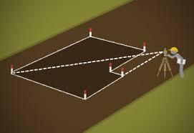
Task:
- You are provided with the ground plan of the 1st floor (ground floor) of a family house and a site plan (geometric plan) of the area. As part of the preparatory office work:
- Draw the baseline AB from which the setting out will be carried out in the field.
- Calculate the coordinates of the object’s characteristic points for setting out.
- Prepare a setting-out plan in a CAD programme and indicate the point coordinates (drawing format A…).
- Dimension all sides of the object along the perimeter and indicate two diagonals with their lengths to verify the right-angle layout during field setting out
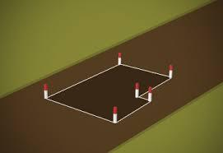
- Prepare the required fieldwork equipment and the setting-out plan.
- Set out the object using the specified orthogonal coordinates.
- Measure and record the as-set dimensions of the staked-out object. Enter the values in the worksheet.
- Carry out an accuracy control of the setting-out using two methods: (a) a measuring tape and (b) drone-based GPS data capture. The start point is the corner of the set-out object marked as Point 1. The flight path follows the object perimeter clockwise, closing the loop by returning to the starting point (Point 1).
- Produce photographic documentation of the set-out object. Fig.: Setting-out scheme.
- Evaluate measurement accuracy by calculating deviations of the measured check dimensions during office work. Complete the worksheet.
- Prepare the final report (protocol).

Sample setting-out paln Fig.: Drone
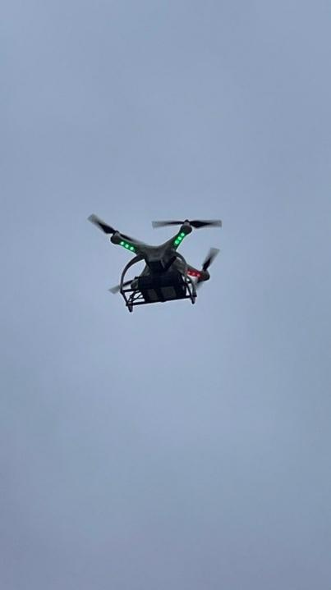
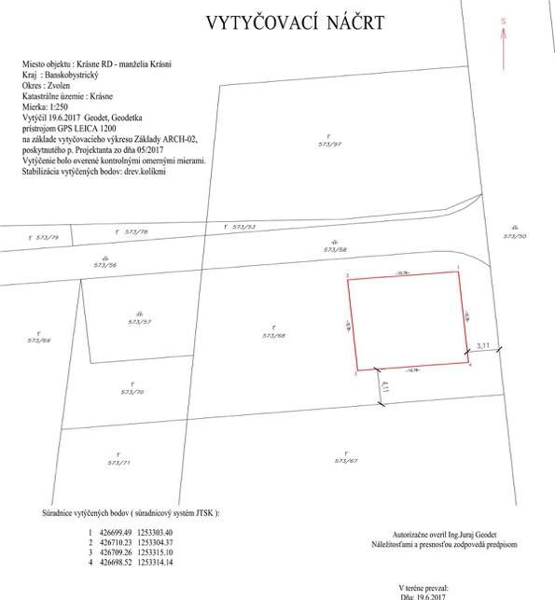

STUDENT WORKSHEET
Project-Based Learning – Geodesy
Topic: Setting Out an Object
Student’s full name: ..............................................................
Class: .......................
Group: .......................
Date: .......................

1. Project Aim
The aim of the project is to carry out the practical setting out of an object in the field using:
- orthogonal coordinates,
- a levelling instrument (vertical setting out),
- drone-based control measurement,
and to verify the accuracy of the setting out by comparing classical and modern geodetic methods.

2. Tools and Equipment Used
(tick or add as appropriate)
☐ levelling instrument
☐ levelling staff
☐ measuring tape
☐ stakes / markers
☐ design drawings
☐ drone with GPS
☐ field notebook
☐ other: .....................................................................

3. Setting Out the Object Using Orthogonal Coordinates

3.1 Basic Information
- Object name: ..............................................................
- Selected baseline: ..............................................................
- Starting point: ..............................................................

3.2 Orthogonal Coordinates of Setting-Out Points
Point | X coordinate (m) | Y coordinate (m)
1
2
3
4
5
6

3.3 Setting-Out Procedure
(briefly describe the procedure)
........................................................................................................
........................................................................................................
........................................................................................................
........................................................................................................
........................................................................................................
........................................................................................................

4. Control Measurement After Setting Out the Object in the Field

4.1 Collected Data
- Data capture method: ..............................................................
- Number of control points: ......................................................

4.2 Control Measurement Using a Drone – GPS Values
Segment | Start coordinate (m) | End coordinate (m) | Difference = segment length (m)
1–2
2–3
3–4
4–5
5–6
6–1

4.3 Control Measurement Using a Measuring Tape – Tape Values
Segment | Check dimensions (m) | End coordinate (m) | Difference = segment length (m)
1–2
2–3
3–4
4–5
5–6
6–1

4.4 Comparison of Control Measurement Results
Segment | Length – measured by drone (m) | Length – measured by tape (m) | Difference (m) | Measurement error (%)
1–2
2–3
3–4
4–5
5–6
6–1

5. Comparison of Measurement Results

5.1 Comparison of Results – Drone Data Capture Method
Segment | Length – setting-out plan (m) | Length – drone measurement (m) | Difference (m) | Measurement error (%)
1–2
2–3
3–4
4–5
5–6
6–1

5.2 Comparison of Results – Measuring Tape Method
Segment | Length – setting-out plan (m) | Length – tape measurement (m) | Difference (m) | Measurement error (%)
1–2
2–3
3–4
4–5
5–6
6–1

Setting-Out Conclusion
Is the planimetric placement of the object compliant with the design?
☐ yes ☐ no
Justification:
........................................................................................................

6. Accuracy Evaluation
- Which segment was set out with the highest accuracy?
........................................................................................................
- Which segment showed the greatest measurement error?
........................................................................................................
- What factors may have affected measurement accuracy?
........................................................................................................
........................................................................................................
- Which measurement method was more accurate, and why?
........................................................................................................
........................................................................................................

7. Project Conclusion
Briefly evaluate the course of the project and its contribution to your vocational learning:
........................................................................................................
........................................................................................................
........................................................................................................

8. Student Self-Assessment
Statement | Yes | Rather yes | Rather no | No
I understood the setting-out procedure | ☐ | ☐ | ☐ | ☐
I actively contributed to the work | ☐ | ☐ | ☐ | ☐
I worked accurately and responsibly | ☐ | ☐ | ☐ | ☐
The project helped me understand professional practice | ☐ | ☐ | ☐ | ☐
Student signature: ..............................................

Phase 4 – Reflection & Consolidation (Present & Connect)
Group Presentations
The presentation of project results will include an evaluation of the individual project phases, from preparation and field measurements through the processing of measured values, to the assessment of the accuracy of the setting-out works and the comparison of control-measurement results.
Each group will evaluate the project task based on its assigned object and the measurement results achieved.

Control Measurement – Method 1: Drone-Based GPS Measurement
- What are the advantages of using a drone to verify the accuracy of setting-out works?
- Why is precise point capture in the field necessary?
- How is the distance between two points determined using GPS coordinates?
- What factors can influence the accuracy of GPS measurements?

Control Measurement – Method 2: Measuring Tape Distance Measurement
- Why is precise setting out of points in the field necessary?
- How is the distance between two points determined using a measuring tape?
- What are the risks and potential sources of error when using a measuring tape to control the accuracy of setting-out works?

Class Discussion
Control questions for in-class discussion related to the project topic:
- What is meant by the term setting out an object?
- What does a setting-out plan contain?
- How can a perpendicular be set out using a levelling instrument?
- What is the purpose of control measurement after setting out an object?
- Why is it important to maintain measurement accuracy in geodesy?

Reflection Activity
Each student will provide written answers to the following questions:
- What role did I have in the group, and how did I fulfil it?
- Which part of the measurement process was the most challenging for me, and why?
- What new knowledge or skills did I gain about setting out objects?
- What differences do I observe between drone-based measurement and measuring tape measurement?
- If I were to repeat the measurement, what would I do differently?

Joint Assessment of the Project Work (Point-Based)
Subject: Professional Practice – Geodesy
Topic: Setting Out an Object
Assessed group: ........................................................
Assessing student: ........................................................
Class: .....................
Date: .....................

1. Professional Quality of the Project (max. 20 points)
Criterion | 5 pts | 4 pts | 3 pts | 2 pts
Quality of surveying work – orthogonal setting out of the object | ☐ | ☐ | ☐ | ☐
Use of drone and GPS data | ☐ | ☐ | ☐ | ☐
Correctness of outputs – worksheet and report (protocol) | ☐ | ☐ | ☐ | ☐
Professional level of procedural explanation | ☐ | ☐ | ☐ | ☐
Total points: ........ / 20
Comment:
.........................................................................................................................

2. Practical Implementation of the Project (max. 15 points)
Criterion | 5 pts | 4 pts | 3 pts | 2 pts
Organisation of fieldwork | ☐ | ☐ | ☐ | ☐
Compliance with safety regulations | ☐ | ☐ | ☐ | ☐
Accuracy and completeness of data collection | ☐ | ☐ | ☐ | ☐
Total points: ........ / 15
Comment:
.........................................................................................................................

3. Teamwork and Collaboration (max. 15 points)
Criterion | 5 pts | 4 pts | 3 pts | 2 pts
Distribution of roles within the team | ☐ | ☐ | ☐ | ☐
Active participation of team members | ☐ | ☐ | ☐ | ☐
Communication and mutual cooperation | ☐ | ☐ | ☐ | ☐
Total points: ........ / 15

4. Presentation and Project Outputs (max. 20 points)
Criterion | 5 pts | 4 pts | 3 pts | 2 pts
Clarity of the presentation | ☐ | ☐ | ☐ | ☐
Documentation structure and clarity | ☐ | ☐ | ☐ | ☐
Graphic and formal quality of outputs | ☐ | ☐ | ␠ | ☐
Ability to justify and defend results | ☐ | ☐ | ☐ | ☐
Total points: ........ / 20

5. Overall Impression and Project Added Value (max. 10 points)
Criterion | 5 pts | 4 pts | 3 pts | 2 pts
Overall quality of the project | ☐ | ☐ | ☐ | ☐
Contribution of the project to learning | ☐ | ☐ | ☐ | ☐
Total points: ........ / 10

Summary of Points
Area | Max. points | Points awarded
Professional quality | 20 | .....
Practical implementation | 15 | .....
Teamwork and collaboration | 15 | .....
Presentation and outputs | 20 | .....
Overall impression | 10 | .....
TOTAL | 80 | .....

Grade Conversion (Points to Grade)
Points | Grade | Verbal assessment
72–80 | 1 | Excellent
64–71 | 2 | Very good
56–63 | 3 | Good
48–55 | 4 | Satisfactory
Less than 48 | 5 | Unsatisfactory

6. Constructive Feedback
- Strongest aspect of the project:
.........................................................................................................................
- Recommendation for improvement:
.........................................................................................................................

Assessment Criteria
Quizzes with closed or open questions

Questionnaire – Comparison of Control Measurement Methods (Accuracy of Setting Out)

Method 1 – GPS / Drone
- Measurement accuracy: ☐ high ☐ medium ☐ low
- Speed of data acquisition: ☐ fast ☐ moderate ☐ slow
- Operational complexity: ☐ low ☐ medium ☐ high

Method 2 – Measuring Tape
- Measurement accuracy: ☐ high ☐ medium ☐ low
- Time demand: ☐ low ☐ medium ☐ high
- Precision requirements for fieldwork: ☐ low ☐ medium ☐ high
Final question:
Which method would you choose in professional practice to verify the accuracy of setting-out works, and why?
.........................................................................................................................
.........................................................................................................................

Self-Assessment Tools for Individual Reflection
Student Self-Assessment Instruments
Topic: Setting Out an Object Using the Orthogonal Method

1. Self-Assessment Questionnaire (Learning Reflection)
STUDENT WORKSHEET
Self-Assessment – Project-Based Learning
Subject: Professional Practice – Geodesy
Topic: Setting Out an Object
Student’s full name: ........................................................
Class: .....................
Date: .....................

1. Self-assessment of understanding
Circle the answer that best reflects your assessment. You may add a short comment to each item.
- I understand the principle of setting out an object using a levelling instrument and the orthogonal method (using X, Y coordinates).
YES / PARTLY / NO
Comment: ....................................................................................
- I understand the role of the drone in collecting geodetic data.
YES / PARTLY / NO
Comment: ....................................................................................
- I can explain the procedure for evaluating the accuracy of setting-out works.
YES / PARTLY / NO
Comment: ....................................................................................
- I understand the factors that influence measurement accuracy when using a drone.
YES / PARTLY / NO
Comment: ....................................................................................
- I understand the factors that influence measurement accuracy when using a measuring tape.
YES / PARTLY / NO
Comment: ....................................................................................

2. Self-assessment of practical skills
Mark (✖) how you assess your skills.
Activity | Independently | With support | Needs improvement
Planning the measurement and the drone flight | ☐ | ☐ | ☐
Safe handling of the drone / levelling instrument | ☐ | ☐ | ☐
Collection of GPS data | ☐ | ☐ | ☐
Processing measured data | ☐ | ☐ | ☐
Evaluation of setting-out accuracy | ☐ | ☐ | ☐
Preparation of the report/protocol | ☐ | ☐ | ☐

3. Reflection on my own work
Answer in complete sentences.
- What was my role in the project?
.........................................................................................................................
- What did I do best when working with the drone and GPS / with the levelling instrument?
.........................................................................................................................
- What problems did I encounter, and how did I solve them?
.........................................................................................................................

4. Self-assessment of collaboration and attitudes
Circle the answer that best describes you.
- I actively contributed to teamwork: YES / RATHER YES / RATHER NO / NO
- I complied with safety and work regulations: YES / RATHER YES / RATHER NO / NO
- I worked responsibly and precisely: YES / RATHER YES / RATHER NO / NO

5. Evaluation of the project outcome
- Am I satisfied with the result? Why?
.........................................................................................................................
- If I were to repeat the project, what would I do differently?
.........................................................................................................................

6. Final self-reflection
Complete the sentences:
- After completing the project, I can:
.........................................................................................................................
- The greatest benefit of the project for me was:
.........................................................................................................................
- The area in which I need to improve is:
.........................................................................................................................

Peer Review Protocols for Collaborative Evaluation

GROUP ASSESSMENT PROTOCOL
Joint Assessment of the Project Work
Subject: Professional Practice – Geodesy
Topic: Setting Out an Object
Assessed student / group: ........................................................
Assessing student: ........................................................
Class: .....................
Date: .....................

1. Assessment of the professional quality of the project
Select the option that best reflects your assessment.
Criterion | Excellent | Good | Partly | Insufficient
Selected setting-out procedure based on the setting-out plan | ☐ | ☐ | ☐ | ☐
Use of drone and GPS data / geodetic instruments | ☐ | ☐ | ☐ | ☐
Correctness of calculations | ☐ | ☐ | ☐ | ☐
Professional standard of the workflow explanation | ☐ | ☐ | ☐ | ☐
Short comment on the professional quality of the project:
.........................................................................................................................

2. Assessment of practical implementation
Criterion | YES | RATHER YES | RATHER NO | NO
Fieldwork was organised and systematic | ☐ | ☐ | ☐ | ☐
Safety regulations were followed when working with the drone | ☐ | ☐ | ☐ | ☐
Data collection was accurate and clearly documented | ☐ | ☐ | ☐ | ☐
Comment:
.........................................................................................................................

3. Assessment of teamwork
Criterion | YES | RATHER YES | RATHER NO | NO
Team members had clearly assigned roles | ☐ | ☐ | ☐ | ☐
Teamwork was effective | ☐ | ☐ | ☐ | ☐
Communication among team members was clear and professional | ☐ | ☐ | ☐ | ☐
What worked best in the cooperation?
.........................................................................................................................

4. Assessment of presentation of results
Criterion | Excellent | Good | Partly | Insufficient
Clarity of the presentation | ☐ | ☐ | ☐ | ☐
Clarity of outputs (tables, graphs, report/protocol) | ☐ | ☐ | ☐ | ☐
Ability to justify and defend the results | ☐ | ☐ | ☐ | ☐
Comment on the presentation:
.........................................................................................................................

5. Constructive feedback
Respond briefly and clearly.
- The strongest aspect of the project was:
.........................................................................................................................
- What could be improved in the next project:
.........................................................................................................................
- Recommendation for the assessed student / team:
.........................................................................................................................

6. Overall assessment of the project
Overall impression of the project:
EXCELLENT / VERY GOOD / GOOD / SATISFACTORY / UNSATISFACTORY
Justification:
.........................................................................................................................

Portfolio-Based Evidence (Selected Outputs / Documentation of Learning Process)

Assessment Criteria for Project-Based Learning
Topic: Setting Out an Object

1. Project Preparation and Planning
Assessed aspects:
- Quality of preparatory work: coordinate calculations and preparation of the setting-out plan in CAD
- Quality of measurement planning and the drone flight plan/route
- Understanding of the project objectives and workflow

2. Implementation of Field Measurements
Assessed aspects:
- Correct and safe use of the drone and GPS equipment, as well as geodetic instruments
- Compliance with technical procedures and safety regulations
- Accuracy and completeness of setting-out works
- Accuracy and completeness of data collection
- Accuracy and completeness of entries in the measurement protocol
- Independence and responsibility during fieldwork

3. Data Processing and Evaluation
Assessed aspects:
- Correct calculation of measured segment lengths
- Logical and clearly structured processing of measured data (tables, graphs)
- Evaluation of measurement accuracy and identification of potential errors
- Comparison of results from two methods
- Evaluation of setting-out works based on control measurement comparison

4. Project Documentation
Assessed aspects:
- Completeness and accuracy of the setting-out plan
- Completeness and professional standard of the measurement report/protocol
- Proper maintenance of surveying documentation and a clear description of procedures
- Graphic and formal quality of project outputs

5. Teamwork and Work Organisation
Assessed aspects:
- Active participation in team-based work
- Effective distribution of roles and tasks within the group
- Communication and problem-solving during project implementation

6. Presentation of Results
Assessed aspects:
- Clear, factual, and professionally accurate presentation of project results
- Ability to justify the chosen methodology and measurement results
- Clarity, precision, and appropriate professional communication

7. Student Attitude and Professional Conduct
Assessed aspects:
- Compliance with safety and workplace rules
- Accuracy, responsibility, and work discipline
- Interest in applying modern technologies in geodetic practice

Scoring Rubric

Criterion 1 – Technical Accuracy (0–10 points)
- Measurement accuracy
- Correct use of instruments
- Correct calculations of height differences

Criterion 2 – Output Development and Quality (0–10 points)
- Completeness of the worksheet
- Correct preparation of the project report/protocol
- Quality of the CAD drawing (scale, labelling, A3 format)

Criterion 3 – Teamwork and Work Organisation (0–10 points)
- Active student participation
- Cooperation within the group
- Compliance with the agreed workflow
Total: max. 30 points

Teaching Materials

Resource | Link
Presentation
worksheet

2- FLIGHT Kit (custom drone components) used:
- BME680 – Temperature, Humidity, Pressure, VOCs
- Laser PM2.5 Sensor – Particulate Matter
- MQ7 Gas Sensor – CO Detection
- GUVA-S12SD – UV Intensity

https://www.youtube.com/watch?v=5oPB8YNoUKk

External Resources

Resource | Link

1. Setting Out the Building on the Plot – The Final Step Before Building a House | https://www.daibau.sk/clanok/367/kolikovanie_-_posledny_krok_pred_stavbou_domu
- #3 LKhome | Setting out the building | https://www.youtube.com/watch?v=j9olxaAvC7g

References
- Dopravný úrad – civilné letectvo/ bezpilotné letectvo
https://letectvo.nsat.sk/bezpilotne-letectvo/formulare/

- Zákon 161/2024 Z.z.

https://letectvo.nsat.sk/bezpilotne-letectvo/formulare/

- Implementing Regulation (EU) 2019/947
https://letectvo.nsat.sk/en/unmanned-aviation/documents/

  - Monitoring and Management of Construction Sites Using Drone (konferenčný príspevok)

https://www.researchgate.net/publication/360254604_Monitoring_and_Management_of_Construction_Sites_Using_Drone?utm_source=chatgpt.com

- The Adoption of UAVs for Enhancing Safety in Construction Industry (review)

https://www.mdpi.com/3042-4720/1/1/3?utm_source=chatgpt.com

