

Precision Corn Monitoring with BME680

FLIGHT RESOURCE CENTER

DSU RCSOO “Kiro Burnaz”



Table of Contents
Table of Contents 1
1. SHORT DESCRIPTION 2
(UP 3000 CHARACTERS) 2
2. TARGET 2
3. SUBJECT AREA 2
4. TYPE 2
5. DRONE USED 2
6. DURATION 3
7. LEARNING OBJECTIVES 3
8. KEY COMPETENCES DEVELOPED 3
1. Communication and Languages 3
2. Mathematical, Scientific, Technical and Professional Skills 3
3. Digital Competences 3
4. Personal, Social and Professional Competences 3
5. Safety, Quality and Sustainability 4
6. Citizenship and Cultural Competence 4
7. Creativity, Problem-Solving and Entrepreneurship 4
8. Work-Based Learning and Workplace Integration 4
9. Prior Knowledge / Prerequisites 4
10. Lesson/Project Outline 4
Phase 1 – Introduction (Engage & Contextualize) 4
Phase 2 – Exploration (Investigate & Compare) 4
Phase 3 – Application (Hands-On Practice) 5
Phase 4 – Reflection & Consolidation (Present & Connect) 5
11. Assessment Criteria 5
12. Teaching Materials 5
13. External Resources 5
14. References 6

SHORT DESCRIPTION

This project explores the use of the FLIGHT Kit custom drone equipped with a BME680 sensor to monitor the microclimate of corn (Zea mays) fields. Students will move beyond visual scouting to analyze Temperature, Humidity, Pressure, and Volatile Organic Compounds (VOCs). The goal is to detect "silent" stressors like fungal humidity thresholds and pest-induced VOC signals (Green Leaf Volatiles) that are invisible to the naked eye.

TARGET
- 15
- 16
- 17
- 18
- Over 18

SUBJECT AREA
- Agriculture
- Disaster Response
- Constructions
- Water Management
- Environmental Protection
- Other

TYPE
- Lesson Plan
- Project
- Activity

DRONE USED
- Custom Drone
- Commercial drone (DJI)

DURATION
- 1 x 45-minute class - Portugal
- 1 x 60-minute class
- 1 x 90-minute block
- 2 x 45-minute classes
- 2 x 60-minute classes
- Double session (2 × 60 minutes) optional project-based homework.

LEARNING OBJECTIVES
Identify the correlation between BME680 environmental metrics and corn health stages.
Integrate and calibrate the BME680 sensor with the FLIGHT Kit flight controller or secondary MCU.
Analyze Raw Gas Resistance (VOCs) to identify potential biochemical stress signals in the crop.
Produce a microclimate "heat map" of a corn field using logged GPS and sensor data.

KEY COMPETENCES DEVELOPED

1. Communication and Languages
- Literacy competence (understanding and producing written/oral texts)
- Communication in professional contexts
- Multilingual competence

2. Mathematical, Scientific, Technical and Professional Skills
- Mathematical competence
- Scientific, technological and engineering competence (STEM)
- Numeracy applied to work tasks
- Interpretation of technical information (manuals, diagrams, standards)
- Professional/technical skills
- Execution of practical tasks

3. Digital Competences
- Digital competence (general digital literacy)
- Use of digital tools in workplace settings

4. Personal, Social and Professional Competences
- Personal, social and learning-to-learn competence
- Teamwork and collaboration
- Autonomy and responsibility
- Work ethics and professional behaviour
- Adaptability and flexibility
- Cooperation with supervisors and colleagues

5. Safety, Quality and Sustainability
- Application of health and safety standards (OHS/SST)
- Quality procedures and workplace norms
- Environmental and sustainability awareness

6. Citizenship and Cultural Competence
- Citizenship competence
- Cultural awareness and expression competence

7. Creativity, Problem-Solving and Entrepreneurship
- Problem-solving and critical thinking
- Entrepreneurship competence
- Initiative and creativity
- Decision-making in real work situations

8. Work-Based Learning and Workplace Integration
- Integration into workplace routines
- Following professional instructions and procedures
- Use of tools, equipment and technology

This checklist merges the EU Key Competences for Lifelong Learning with the core competences expected in European Vocational Education and Training (VET).

Prior Knowledge / Prerequisites
Students should have basic experience with drone flight safety, Python or Arduino programming, and a foundational understanding of the corn growth cycle (GDD - Growing Degree Days).

Lesson/Project Outline

Phase 1 – Introduction (Engage & Contextualize)

Description:

Discuss the limitations of standard visual inspection. How do we know if a plant is stressed before it turns brown? Introduce the concept of VOCs as the "silent language" of corn.
Photo/Diagram:

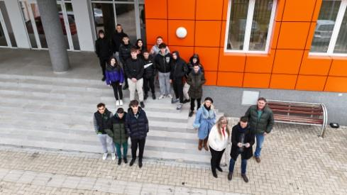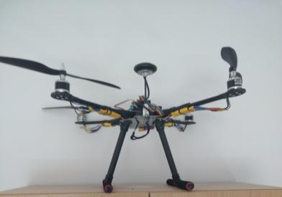
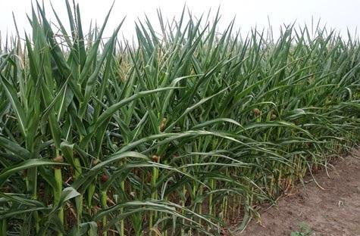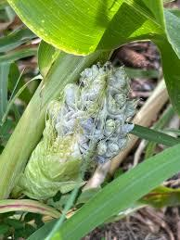

Guiding Questions / Class Discussion:
"Can a drone 'smell' a pest infestation?" "Why is humidity more important at the canopy level than at 10 meters high?".

Phase 2 – Exploration (Investigate & Compare)

Description:
Technical breakdown of the BME680 MOX (Metal Oxide) gas sensor. Compare standard meteorological data with drone-captured canopy-level data.

Photo/Diagram:

Corn Cultivation: Meteorological Standards & Sensor Correlation
Metric | Scientific Standard / Benchmark | Agricultural Impact | BME680 Data Interpretation
Temperature | Base: 10°C (50°F)Optimum: 24°C–30°CStress: >35°C (95°F) | Drives GDD (Growing Degree Days). High heat during pollination (tasseling) causes pollen sterilization and yield loss. | Monitors localized "Heat Pockets." Higher temps at canopy level vs. ambient air indicate a lack of cooling via transpiration.
Humidity | Ideal: 60%–70%Pathogen Risk: >90% for 12+ hours | High humidity promotes fungal pathogens like Gray Leaf Spot. Low humidity increases the water demand on the plant. | Identifies "Vapor Pockets" within the rows. High humidity readings help map disease risk zones without physical scouting.
Pressure | Standard: ~1013.25 hPa (Sea Level) | Significant for vertical flight precision and predicting incoming storm fronts (Barometric pressure drops). | Used to calibrate altitude for precision "canopy skimming." Essential for gas sensor accuracy compensation.
VOCs | Baseline: High Resistance (kΩ)Stress: Low Resistance (kΩ) | Corn releases GLVs (Green Leaf Volatiles) when cell walls are damaged by pests like the Fall Armyworm. | Raw Gas Resistance: A sharp drop in Ohms indicates a chemical "SOS" signal from the plant, detecting pests before visual damage.

Phase 3 – Application (Hands-On Practice)
Hands-On Activity:

Mounting the BME680 to the FLIGHT Kit. Students perform a grid-flight mission (3 meters above tassels) to log environmental data synchronized with GPS coordinates.

Video:
https://www.youtube.com/shorts/86Z4c-hu7bo

Photo/Diagram:

Variable | Ground Station (2m high) | Drone Simulation (3m above tassels) | Agricultural Interpretation
Temperature | 28.5°C | 31.2°C | High canopy temp indicates water stress (transpiration has stopped).
Humidity | 65% | 88% | High "canopy humidity" increases fungal risk (Gray Leaf Spot).
VOCs | 150 kΩ (Baseline) | 45 kΩ (Spike) | Significant VOC drop suggests a pest attack in that specific grid zone.
VPD | 1.1 kPa (Optimal) | 0.4 kPa (Low) | Air is too saturated; plant growth is inhibited by lack of transpiration.

Phase 4 – Reflection & Consolidation (Present & Connect)

Group Presentations

Groups will present a "Corn Health Diagnostic Report" based on the flight data. Each 5-minute presentation must include:
- Data Visualization: A heatmap or time-series graph showing the correlation between Air Temperature and Raw Gas Resistance (VOCs) across the sampled field coordinates
- The "Silent Stress" Identification: An analysis of any detected VOC "spikes." Students must argue whether these spikes represent potential pest activity or are environmental noise (e.g., nearby machinery or soil moisture shifts).

- VPD Calculation: A slide showing the calculated Vapor Pressure Deficit (VPD) for specific high-risk zones using the BME680 data.

Class Discussion:

The instructor will lead a debriefing focused on the technical and ecological implications of the mission:
- Prop-Wash Interference: "How did the drone's own airflow affect our BME680 readings? Was the air we sampled truly from the canopy, or was it mixed with higher atmosphere?"
- Economic Impact: "If we can detect a pest infestation 48 hours before physical damage appears, what is the potential cost-saving in terms of pesticide application?"
- The Ethics of Precision: "Does high-resolution field data help small-scale farmers, or does it primarily benefit large industrial operations?"

Reflection Activity:

Students will complete a "Sensor Integration Log" where they reflect on the hardware assembly process:
- Technical Troubleshooting: Describe one instance where the BME680 failed to log data and how the team resolved the issue (e.g., wiring, I2C address conflict, or SD card formatting).
- Future Innovation: Propose one modification to the FLIGHT Kit frame or the sensor mount that would provide cleaner "breathable" air for the VOC sensor in future flights

Assessment Criteria
Quizzes with closed or open questions:
These questions focus on objective knowledge regarding the BME680 sensor and its specific metrics: Temperature, Humidity, Pressure, and VOCs.
- Identification: Identifying which metric directly signals a plant's biochemical "SOS" (VOCs).
- Units of Measure: Matching metrics to their technical units, such as Ohms for Gas Resistance or hPa for atmospheric pressure.
- Safety & Thresholds: Selecting the correct humidity or temperature thresholds that trigger fungal risk in corn crops.
- Data Interpretation: Explaining how a simultaneous drop in gas resistance and a rise in temperature indicates a specific type of crop stress.
- Engineering Challenges: Describing how to mitigate "prop-wash" interference when the drone's propellers disturb the air being sampled by the BME680.
- Precision Agriculture Ethics: Discussing the environmental and economic impact of using high-resolution sensor data to reduce pesticide use in corn cultivation.
Self-assessment tools for individual reflection;
Students assess themselves based on the following professional standards:
Reflection Area | Self-Assessment Goal
Technical Autonomy | Evaluate your ability to follow technical diagrams for sensor integration without constant supervision.
Data Integrity | Assess your precision in logging Temperature, Humidity, and VOC data with correct GPS timestamps.
Collaborative Impact | Reflect on how your individual analysis of the VOC "SOS" signals contributed to the group's final health map.

Peer review protocols for collaborative evaluation:
This protocol is used during Phase 4 to evaluate the "Corn Health Diagnostic Reports" created by each group.

1. Review Criteria
Students use a standardized rubric to evaluate their peers' work based on:
- Data Integrity: Did the team correctly interpret the BME680 Gas Resistance to identify VOC signals from the corn?
- Scientific Accuracy: Is the Vapor Pressure Deficit (VPD) calculation mathematically sound based on the captured temperature and humidity?
- Engineering Design: Does the team's sensor mount effectively protect the BME680 from "prop-wash" interference?

2. The Feedback Loop (Critical Friends Model)
Each group is paired with another group to perform a cross-evaluation:
- The Warm Feedback: Identifying one specific strength in the data visualization or flight path efficiency.
- The "Cool" Challenge: Posing one critical question regarding the conclusions (e.g., "How do you knowthVOC spike wasn't caused by the drone's motor heat?")

Portfolios with selected outputs or documentation of learning process:
The portfolio must contain the following evidence of the learning process:
- Professional Flight Logbook: A regulatory-style log documenting date, GPS takeoff/landing coordinates, flight duration, and pilot-in-command details.
- Sensor Payload Schematic: A technical wiring diagram (I2C protocol) showing the BME680’s connection to the FLIGHT Kit flight controller or secondary MCU.
- Safety & Pre-Flight Documentation: Completed checklists for field operation, including "Go/No-Go" weather parameters specific to corn canopy flights.
- Raw Data Repository (CSV): A raw data export of the flight mission containing synchronized timestamps, GPS data, and the four BME680 metrics.
- Corn Health Diagnostic Report: The final analytical output, including:
  - VPD Calculations: Step-by-step mathematical derivation of Vapor Pressure Deficit.
  - Stress Heatmap: A visual 2D map of the field highlighting VOC "hotspots" or high-humidity zones.
- Evidence of Troubleshooting: A "Maintenance Log" or "Engineering Note" describing how the student addressed hardware interference (e.g., motor EMI or prop-wash shielding).
- Reflective Summaries: Final copies of the Self-Assessment Log and the Peer Review Audit received from other teams.

Teaching Materials
- FLIGHT Kit (custom drone components).
- BME680 – Temperature, Humidity, Pressure, VOCs.
- MicroSD Card and Data Logger module.

2- FLIGHT Kit (custom drone components) used:
- BME680 – Temperature, Humidity, Pressure, VOCs
- Laser PM2.5 Sensor – Particulate Matter
- MQ7 Gas Sensor – CO Detection
- GUVA-S12SD – UV Intensity

