

Drone-Based Microclimate Monitoring in Raised Garden Beds (Onion vs. Spinach)

FLIGHT RESOURCE CENTER

DSU RCSOO “Kiro Burnaz”


Table of Contents
Table of Contents 1
1. SHORT DESCRIPTION 2
(UP 3000 CHARACTERS) 2
2. TARGET 2
3. SUBJECT AREA 2
4. TYPE 2
5. DRONE USED 2
6. DURATION 3
7. LEARNING OBJECTIVES 3
8. KEY COMPETENCES DEVELOPED 3
1. Communication and Languages 3
2. Mathematical, Scientific, Technical and Professional Skills 3
3. Digital Competences 3
4. Personal, Social and Professional Competences 3
5. Safety, Quality and Sustainability 4
6. Citizenship and Cultural Competence 4
7. Creativity, Problem-Solving and Entrepreneurship 4
8. Work-Based Learning and Workplace Integration 4
9. Prior Knowledge / Prerequisites 4
10. Lesson/Project Outline 4
Phase 1 – Introduction (Engage & Contextualize) 4
Phase 2 – Exploration (Investigate & Compare) 4
Phase 3 – Application (Hands-On Practice) 5
Phase 4 – Reflection & Consolidation (Present & Connect) 5
11. Assessment Criteria 5
12. Teaching Materials 5
13. External Resources 5
14. References 6

SHORT DESCRIPTION
This lesson/project introduces students to the use of drones for microclimate monitoring in agriculture, focusing on real-time measurement of temperature and humidity above raised garden beds.
Using a custom drone equipped with FLIGHT Kit environmental sensors, learners collect data over raised wooden beds planted with winter onion and spinach. A bare soil area is included as a control zone.
Students investigate how crop morphology and canopy density influence microclimatic conditions such as humidity retention, temperature regulation, and potential disease risk.
The activity promotes sustainable farming practices, precision agriculture, and non-invasive environmental monitoring using UAV technology.

TARGET
- 15
- 16
- 17
- 18
- Over 18

SUBJECT AREA
- Agriculture
- Disaster Response
- Constructions
- Water Management
- Environmental Protection
- Other

TYPE
- Lesson Plan
- Project
- Activity

DRONE USED
- Custom Drone
- Commercial drone (DJI)

DURATION
- 1 x 45-minute class
- 1 x 60-minute class
- 1 x 90-minute block
- 2 x 45-minute classes
- 2 x 60-minute classes
- Double session (2 × 60 minutes) optional project-based homework.

LEARNING OBJECTIVES
Students will understand the concept of agricultural microclimate and explain how drones equipped with environmental sensors can support precision farming and sustainable crop monitoring.
Students will be able to operate a custom drone system safely and collect real-time temperature and relative humidity data above raised garden beds at different flight heights.
Students will compare microclimate conditions between spinach and onion crops by analyzing how differences in plant morphology and canopy density affect humidity retention and temperature regulation.
Students will identify potential agricultural risks related to excess humidity, such as fungal disease development, and propose sustainable management practices based on drone-measured environmental data.

KEY COMPETENCES DEVELOPED

1. Communication and Languages
- Literacy competence (understanding and producing written/oral texts)
- Communication in professional contexts
- Multilingual competence

2. Mathematical, Scientific, Technical and Professional Skills
- Mathematical competence
- Scientific, technological and engineering competence (STEM)
- Numeracy applied to work tasks
- Interpretation of technical information (manuals, diagrams, standards)
- Professional/technical skills
- Execution of practical tasks

3. Digital Competences
- Digital competence (general digital literacy)
- Use of digital tools in workplace settings

4. Personal, Social and Professional Competences
- Personal, social and learning-to-learn competence
- Teamwork and collaboration
- Autonomy and responsibility
- Work ethics and professional behaviour
- Adaptability and flexibility
- Cooperation with supervisors and colleagues

5. Safety, Quality and Sustainability
- Application of health and safety standards (OHS/SST)
- Quality procedures and workplace norms
- Environmental and sustainability awareness

6. Citizenship and Cultural Competence
- Citizenship competence
- Cultural awareness and expression competence

7. Creativity, Problem-Solving and Entrepreneurship
- Problem-solving and critical thinking
- Entrepreneurship competence
- Initiative and creativity
- Decision-making in real work situations

8. Work-Based Learning and Workplace Integration
- Integration into workplace routines
- Following professional instructions and procedures
- Use of tools, equipment and technology

This checklist merges the EU Key Competences for Lifelong Learning with the core competences expected in European Vocational Education and Training (VET).

Prior Knowledge / Prerequisites
Before starting this lesson/project, students should have:
- Basic knowledge of plant biology and the main differences between leafy crops such as spinach and onion.
- An introductory understanding of environmental factors affecting crop growth (temperature, humidity, air quality).
- Familiarity with the concept of air pollution and particulate matter (PM2.5) as a potential risk for human health and agriculture.
- Basic skills in data collection, reading simple tables, and interpreting environmental measurements.
- Awareness of safe drone operation rules and responsible behavior during outdoor field activities.
No advanced technical background is required, as the drone sensor system will be introduced and demonstrated during the lesson.

Lesson/Project Outline

Phase 1 – Introduction (Engage & Contextualize)

Description:
The lesson begins with an interactive introduction to the concept of microclimate in agriculture. Students learn that even small differences in temperature and humidity can strongly affect crop growth, disease development, and water needs.
The teacher explains that raised garden beds create unique environmental conditions compared to open field soil, because they warm up faster and retain moisture differently. Students are introduced to two winter crops with contrasting morphology: spinach (dense broad leaves) and onion (narrow upright leaves).
The class discusses how plant structure influences air circulation, humidity retention, and temperature regulation above the crop canopy.
To connect theory with modern technology, the teacher presents the custom drone equipped with FLIGHT Kit sensors for measuring air temperature and relative humidity. Students are informed that the drone will collect real-time data at different heights above the beds.
The project goal is introduced: comparing microclimatic conditions above spinach, onion, and bare soil control areas to understand crop-related differences and their relevance for sustainable farming.
Photo/Diagram:

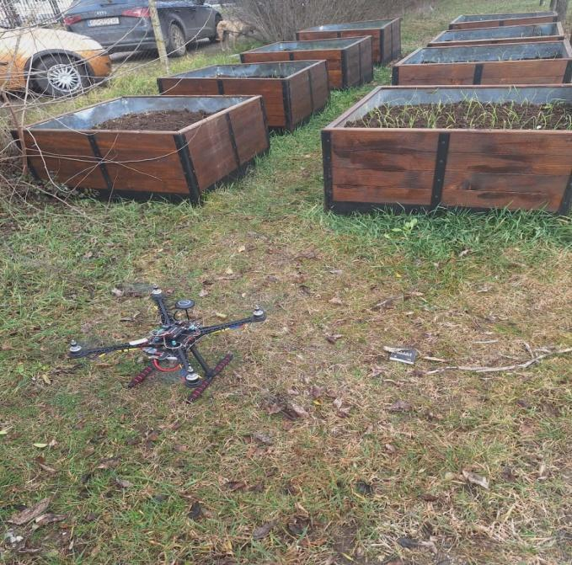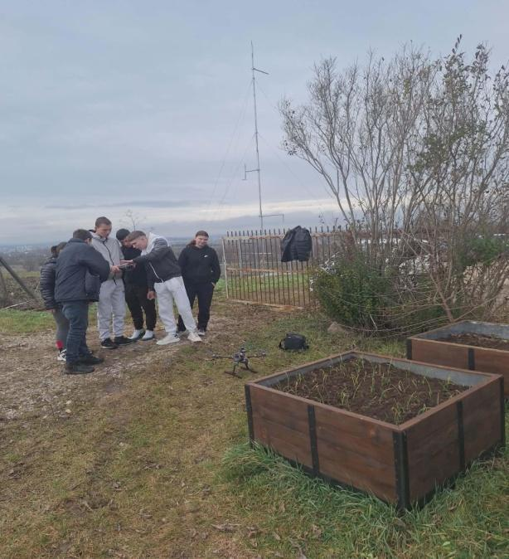

Guiding Questions / Class Discussion:

What is a microclimate and why is it important for crops?

How can raised beds change temperature and humidity conditions?

Why might spinach retain more moisture than onion?

How can drones support precision agriculture?

Phase 2 – Exploration (Investigate & Compare)

Description:
In this phase, students investigate how different crop structures influence microclimate conditions. The class is divided into small working groups, each focusing on one monitoring zone:
- Spinach raised bed
- Onion raised bed
- Bare soil control area
Students observe plant canopy density, leaf shape, and soil exposure. They predict which crop will show higher humidity and which zone will show higher temperature.
The teacher introduces the drone sensor system and explains how temperature and humidity are measured above crops. Students discuss how high humidity can increase fungal disease risk, while higher temperature may increase evaporation.
Groups prepare recording sheets and agree on how measurements will be compared across flight heights. This phase builds scientific inquiry and prepares students for fieldwork.
Video:
Photo/Diagram:
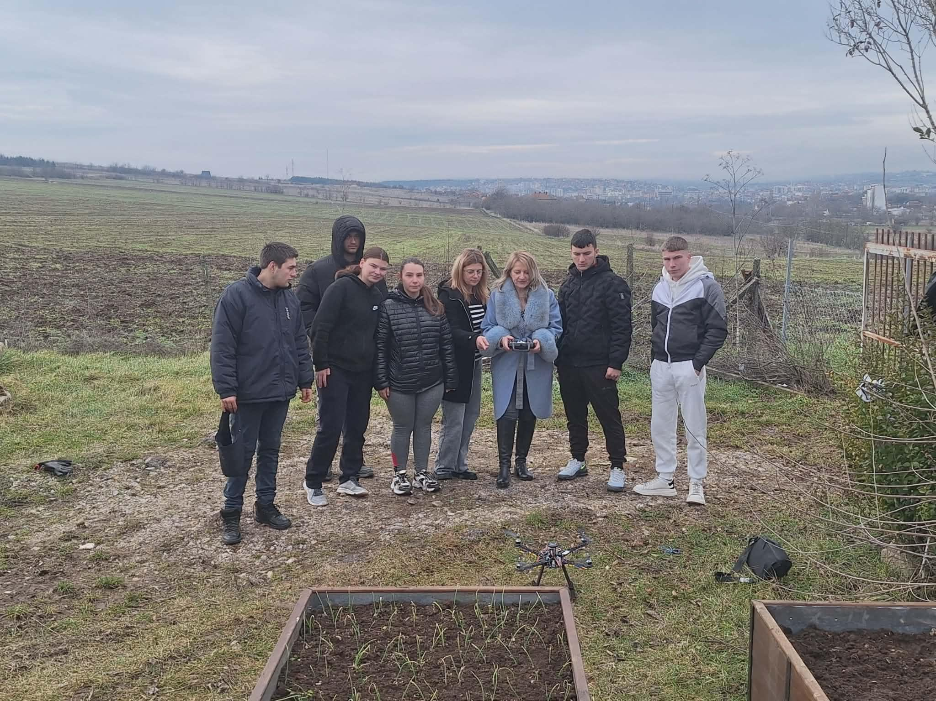
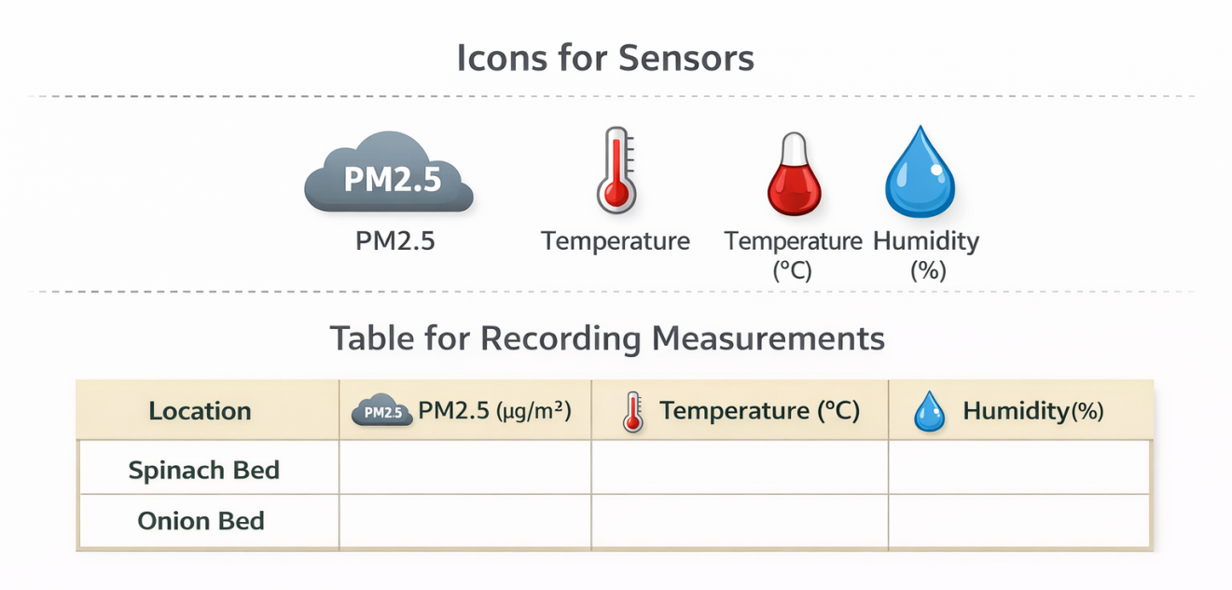

Guiding Questions / Class Discussion:
Which crop canopy creates the most humid environment?
How does airflow differ between spinach and onion beds?
Why is bare soil used as a control zone?

Group Work Activity:
Groups formulate a hypothesis:
“Spinach beds will show higher humidity and lower airflow compared to onion beds.”

Phase 3 – Application (Hands-On Practice)
Hands-On Activity:
Students carry out the main drone-based monitoring activity using the custom UAV equipped with FLIGHT Kit sensors.
The drone performs low-altitude flights above the three zones:
- Spinach raised bed
- Onion raised bed
- Bare soil control
Measurements are taken at three heights:
- 0.5 m
- 1.0 m
- 1.5 m
The drone records real-time values for:
- Air temperature (°C)
- Relative humidity (%)
Students fill in data tables and calculate average values. Example expected field results include higher humidity above spinach due to dense canopy and slightly higher temperature above bare soil due to direct heating.
Groups begin preparing graphs that compare onion vs spinach microclimate differences and discuss how these conditions relate to crop health and sustainable management.

Video:

https://drive.google.com/file/d/1kBS92iVraNTBNhYoMKlL5Hzr9eTnZalO/view?usp=drive_link

Photo/Diagram:

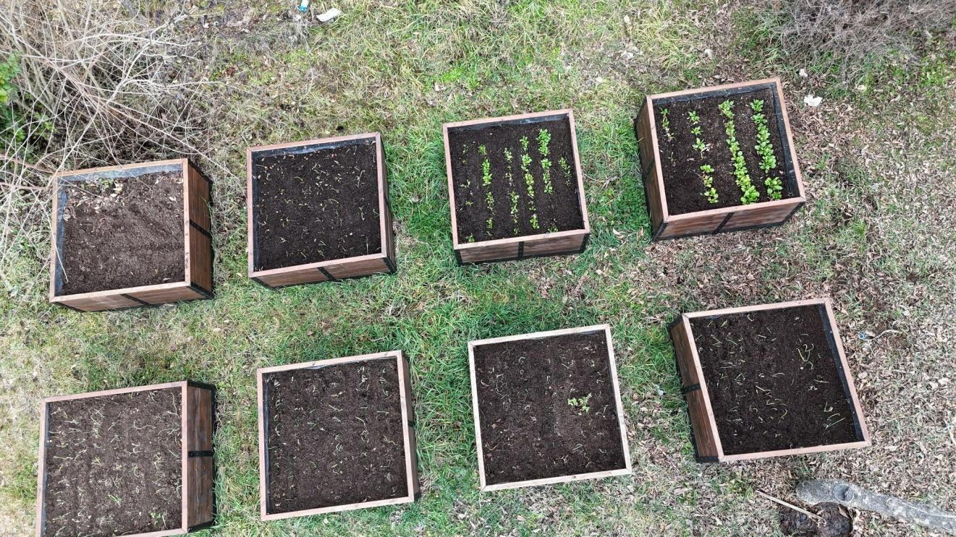
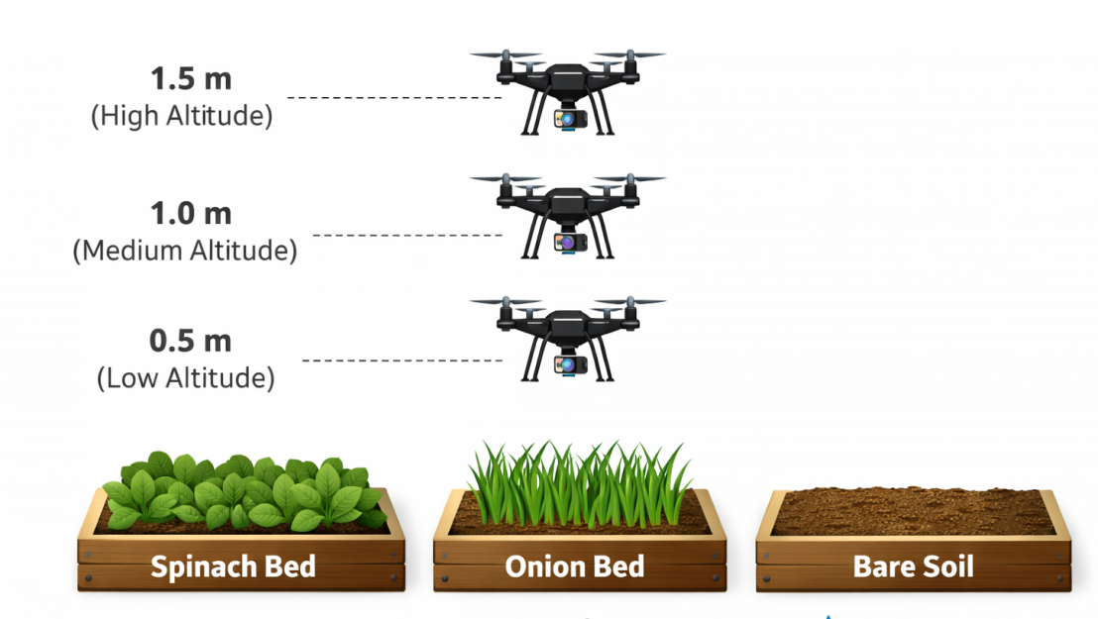

Temperature and Humidity Above Crop Beds (Average Values)✅ Spinach creates a more humid microclimate, supporting PM deposition.
✅ Bare soil shows higher temperature and lower humidity.

Visual Leaf Observation Results
Location / Crop Area | Temperature (°C) | Relative Humidity (%)
Spinach Raised Bed | 15.0 | 78
Onion Raised Bed | 15.4 | 70
Bare Soil (Control Area) | 16.1 | 62

Crop Type | Leaf Structure | Expected PM Deposition | Observation Notes
Spinach | Broad leaves | High | Dust particles visible on leaf surface
Onion | Narrow leaves | Low–Moderate | Less particle accumulation

Phase 4 – Reflection & Consolidation (Present & Connect)

Group Presentations
In the final phase, student groups present their collected results and explain the differences observed between spinach, onion, and bare soil zones.
Each group shares:
- Humidity and temperature patterns at different heights
- Which crop created a more humid microclimate
- How raised beds influence warming and moisture retention
The class discusses the agricultural importance of microclimate monitoring, especially for disease prevention, irrigation planning, and sustainable crop production.

Class Discussion:
Тhe class discusses the agricultural importance of microclimate monitoring, especially for disease prevention, irrigation planning, and sustainable crop production.

Reflection Activity:

Students complete a short reflection answering:
- What did the drone measurements reveal about crop microclimates?
- Why did spinach show higher humidity than onion?
- How could farmers use drone monitoring to reduce disease risk?
- How does precision agriculture support environmental sustainability?
This phase consolidates learning and highlights UAV technology as a modern tool for green agricultural skills.

Assessment Criteria
Quizzes with closed or open questions:
Short quizzes will be used to assess students’ understanding of microclimate concepts, drone operation, and the influence of plant morphology on temperature and humidity.
Questions may include multiple-choice, true/false, or short-answer formats.

Self-assessment tools for individual reflection;
Students complete reflection forms or journals after the drone measurement activity.
Self-assessment encourages learners to identify their strengths, challenges, and insights regarding microclimate monitoring.
Students reflect on how the observed conditions relate to sustainable crop management and disease risk.

Peer review protocols for collaborative evaluation:
- Students provide structured feedback to group members during data collection, analysis, and presentation.
- Peer review promotes critical thinking, shared responsibility, and constructive communication.
- Groups are evaluated on collaboration, problem-solving, and effective use of the drone technology.

Portfolios with selected outputs or documentation of learning process:
Each student or group maintains a portfolio including:
- Data tables and graphs from drone measurements
- Photos of fieldwork and raised beds
- Written reflections and conclusions
Portfolios document the complete learning process and demonstrate both practical skills and scientific understanding.

Teaching Materials

Resource | Link

2- FLIGHT Kit (custom drone components) used:
- BME680 – Temperature, Humidity, Pressure, VOCs
- Laser PM2.5 Sensor – Particulate Matter
- MQ7 Gas Sensor – CO Detection
- GUVA-S12SD – UV Intensity

