

IMPACT OF TEMPRATURE ON POMOTECHNICAL PRACTICES - PRUNING OF VINEUARDS

FLIGHT RESOURCE CENTER

DSU RCSOO “Kiro Burnaz”



Table of Contents
Table of Contents 1
1. SHORT DESCRIPTION 2
(UP 3000 CHARACTERS) 2
2. TARGET 2
3. SUBJECT AREA 2
4. TYPE 2
5. DRONE USED 2
6. DURATION 3
7. LEARNING OBJECTIVES 3
8. KEY COMPETENCES DEVELOPED 3
1. Communication and Languages 3
2. Mathematical, Scientific, Technical and Professional Skills 3
3. Digital Competences 3
4. Personal, Social and Professional Competences 3
5. Safety, Quality and Sustainability 4
6. Citizenship and Cultural Competence 4
7. Creativity, Problem-Solving and Entrepreneurship 4
8. Work-Based Learning and Workplace Integration 4
9. Prior Knowledge / Prerequisites 4
10. Lesson/Project Outline 4
Phase 1 – Introduction (Engage & Contextualize) 4
Phase 2 – Exploration (Investigate & Compare) 4
Phase 3 – Application (Hands-On Practice) 5
Phase 4 – Reflection & Consolidation (Present & Connect) 5
11. Assessment Criteria 5
12. Teaching Materials 5
13. External Resources 5
14. References 6

SHORT DESCRIPTION
This lesson explores the intersection of thermodynamics and viticulture, focusing on how drones equipped with environmental sensors (Temperature, Humidity, and Air Clarity) optimize pruning practices. Students will learn to perform a "Bioclimatic Audit" to identify "Infection Windows" and micro-climates within a vineyard. The lesson moves from theoretical understanding of vine dormancy to the practical application of Variable Rate Pruning (VRP) using data from the FLIGHT sensor kit.

TARGET
- 15
- 16
- 17
- 18
- Over 18

SUBJECT AREA
- Agriculture
- Disaster Response
- Constructions
- Water Management
- Environmental Protection
- Other

TYPE
- Lesson Plan
- Project
- Activity

DRONE USED
- Custom Drone
- Commercial drone (DJI)

DURATION
- 1 x 45-minute class - Portugal
- 1 x 60-minute class
- 1 x 90-minute block
- 2 x 45-minute classes
- 2 x 60-minute classes
- Double session (2 × 60 minutes) optional project-based homework.

LEARNING OBJECTIVES
- Understand the biological impact of temperature and humidity on vine dormancy and wound healing (callusing).\
- Analyze data from BME680 – Temperature, Humidity, Pressure, VOCs sensors to calculate Vapor Pressure Deficit (VPD) and assess air clarity for sensor calibration.
- Develop a pruning strategy that mitigates fungal infection risks (e.g., Esca or Eutypa) based on localized "Humidity Pockets".

KEY COMPETENCES DEVELOPED

1. Communication and Languages
- Literacy competence (understanding and producing written/oral texts)
- Communication in professional contexts
- Multilingual competence

2. Mathematical, Scientific, Technical and Professional Skills
- Mathematical competence
- Scientific, technological and engineering competence (STEM)
- Numeracy applied to work tasks
- Interpretation of technical information (manuals, diagrams, standards)
- Professional/technical skills
- Execution of practical tasks

3. Digital Competences
- Digital competence (general digital literacy)
- Use of digital tools in workplace settings

4. Personal, Social and Professional Competences
- Personal, social and learning-to-learn competence
- Teamwork and collaboration
- Autonomy and responsibility
- Work ethics and professional behaviour
- Adaptability and flexibility
- Cooperation with supervisors and colleagues

5. Safety, Quality and Sustainability
- Application of health and safety standards (OHS/SST)
- Quality procedures and workplace norms
- Environmental and sustainability awareness

6. Citizenship and Cultural Competence
- Citizenship competence
- Cultural awareness and expression competence

7. Creativity, Problem-Solving and Entrepreneurship
- Problem-solving and critical thinking
- Entrepreneurship competence
- Initiative and creativity
- Decision-making in real work situations

8. Work-Based Learning and Workplace Integration
- Integration into workplace routines
- Following professional instructions and procedures
- Use of tools, equipment and technology

This checklist merges the EU Key Competences for Lifelong Learning with the core competences expected in European Vocational Education and Training (VET).

Prior Knowledge / Prerequisites
- Basic understanding of the vineyard growth cycle (dormancy, budbreak).
- Familiarity with basic drone flight operations and safety protocols.

Lesson/Project Outline

Phase 1 – Introduction (Engage & Contextualize)

Description:
- Discuss the "Infection Window." Explain how pruning creates open wounds and how temperature dictates the vine’s "antifreeze" levels. Introduce the concept of "Bioclimatic Audits" via drone
Photo/Diagram:

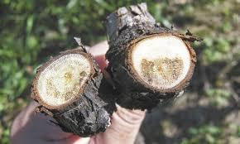

Guiding Questions / Class Discussion:
- Why is pruning in high-humidity environments (>80%) dangerous for the vine's longevity?.

Phase 2 – Exploration (Investigate & Compare)
Description:
- Investigate the sensors. Analyze how the BME680 measures the "Infection Window" (Temp/Humidity) and how the VOCs sensor ensures "Air Clearness" for accurate LiDAR and optical mapping.
Video:
Photo/Diagram:
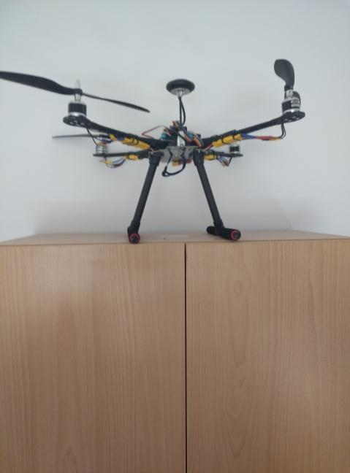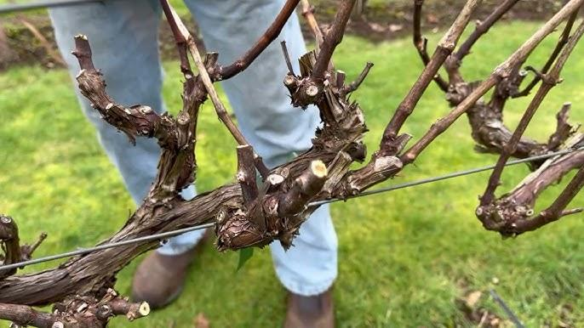

Short Reading or Infographic:
- A chart comparing Traditional Pruning (Calendar-based) vs. Precision Pruning (Sensor-based).
Group Work Activity:
- Calculate the Vapor Pressure Deficit (VPD) from sample drone data sets.

Phase 3 – Application (Hands-On Practice)

Hands-On Activity:
- Students deploy the custom drone to map a simulated "high-risk" zone. They must identify "Humidity Pockets" and "Cold Spots" using real-time telemetry from the FLIGHT kit.

Photo/Diagram:

Parameter | Ideal Range | Why It Matters
Temperature | 12°C – 15°C | Higher temperatures age wine too quickly; fluctuations can cause the cork to expand/contract, leading to oxidation.
Humidity | 60% – 80% RH | If it's too dry, corks shrink and let air in. If it's too wet (above 85%), labels may mold and peel.
Pressure | Stable (1013 hPa) | While barometric pressure isn't controllable, sudden drops often signal storms/humidity spikes that require HVAC adjustment.
Gas Resistance | High Resistance | In these sensors, higher resistance usually means lower VOCs. You want minimal "off-gasses" (paint, cleaning chemicals, or fermentation CO2) to avoid tainting the wine.

Phase 4 – Reflection & Consolidation (Present & Connect)
Group Presentations
- Teams present a "Pruning Map" indicating where to prune immediately, where to delay, and where to apply fungicidal sealants based on sensor data.
Class Discussion:
- How does air clarity (dust/smoke) affect the drone's ability to distinguish between live and dead wood?

Reflection Activity:
- Group Presentations: Teams present a "Pruning Map" indicating where to prune immediately, where to delay, and where to apply fungicidal sealants based on sensor data.
- Class Discussion: How does air clarity (dust/smoke) affect the drone's ability to distinguish between live and dead wood?.

Assessment Criteria
Quizzes with closed or open questions:
- Open questions on the correlation between GDD (Growing Degree Days) and pruning timing.
Self-assessment tools for individual reflection;
Use of individual reflection tools and peer review protocols to evaluate collaborative efforts during the "Bioclimatic Audit"
Peer review protocols for collaborative evaluation:
- Mapping Strategy Evaluation: Peers evaluate the accuracy of the "Pruning Map" produced by other teams, focusing on the identification of "Humidity Pockets" and "Cold Spots".
- Data Interpretation Quality: Students review the logic used by their peers to interpret BME680 sensor logs, specifically how they calculated the Vapor Pressure Deficit (VPD).
- Mitigation Logic: Peers assess the justification provided for where to apply fungicidal sealants based on the localized risks identified during drone telemetry.
- Safety & Operational Responsibility: Each student is evaluated by their teammates on their adherence to drone safety protocols and team autonomy during the deployment of the FLIGHT sensor kit.

Portfolios with selected outputs or documentation of learning process:
Documentation of the generated "Pruning Map" and the specific sensor data logs (Temperature, Humidity, Pressure, VOCs) used to create it.

Teaching Materials
- 1- FLIGHT Kit components: BME680 (Temp/Humidity), Laser PM2.5 (Air Clearness), and GUVA-S12SD (UV).
- Software: Data visualization tool for sensor logs.

2- FLIGHT Kit (custom drone components) used:
- BME680 – Temperature, Humidity, Pressure, VOCs
- Laser PM2.5 Sensor – Particulate Matter
- MQ7 Gas Sensor – CO Detection
- GUVA-S12SD – UV Intensity

