

Microclimate and Health Monitoring in Barley Production using BME680

FLIGHT RESOURCE CENTER

DSU RCSOO “Kiro Burnaz”



Table of Contents
Table of Contents 1
1. SHORT DESCRIPTION 2
(UP 3000 CHARACTERS) 2
2. TARGET 2
3. SUBJECT AREA 2
4. TYPE 2
5. DRONE USED 2
6. DURATION 3
7. LEARNING OBJECTIVES 3
8. KEY COMPETENCES DEVELOPED 3
1. Communication and Languages 3
2. Mathematical, Scientific, Technical and Professional Skills 3
3. Digital Competences 3
4. Personal, Social and Professional Competences 3
5. Safety, Quality and Sustainability 4
6. Citizenship and Cultural Competence 4
7. Creativity, Problem-Solving and Entrepreneurship 4
8. Work-Based Learning and Workplace Integration 4
9. Prior Knowledge / Prerequisites 4
10. Lesson/Project Outline 4
Phase 1 – Introduction (Engage & Contextualize) 4
Phase 2 – Exploration (Investigate & Compare) 4
Phase 3 – Application (Hands-On Practice) 5
Phase 4 – Reflection & Consolidation (Present & Connect) 5
11. Assessment Criteria 5
12. Teaching Materials 5
13. External Resources 5
14. References 6

SHORT DESCRIPTION
This project teaches students how to utilize a custom-built drone equipped with the BME680 sensor to monitor the microclimate and health of barley crops. Students will collect data on Temperature, Humidity, Pressure, and Volatile Organic Compounds (VOCs) to identify invisible stressors before they impact yield. The lesson focuses on calculating Vapor Pressure Deficit (VPD) to predict plant stress and using VOC spikes to detect early-stage fungal pathogens or fermentation in the canopy.

TARGET
- 15
- 16
- 17
- 18
- Over 18

SUBJECT AREA
- Agriculture
- Disaster Response
- Constructions
- Water Management
- Environmental Protection
- Other

TYPE
- Lesson Plan
- Project
- Activity

DRONE USED
- Custom Drone
- Commercial drone (DJI)

DURATION
- 1 x 45-minute class - Portugal
- 1 x 60-minute class
- 1 x 90-minute block
- 2 x 45-minute classes
- 2 x 60-minute classes
- Double session (2 × 60 minutes) optional project-based homework.

LEARNING OBJECTIVES
Understand the technical function of the BME680 sensor and its role in precision agriculture.
Calculate Vapor Pressure Deficit (VPD) using temperature and humidity data to assess crop transpiration.
Analyze VOC data to identify potential localized disease outbreaks in barley fields

KEY COMPETENCES DEVELOPED

1. Communication and Languages
- Literacy competence (understanding and producing written/oral texts)
- Communication in professional contexts
- Multilingual competence

2. Mathematical, Scientific, Technical and Professional Skills
- Mathematical competence
- Scientific, technological and engineering competence (STEM)
- Numeracy applied to work tasks
- Interpretation of technical information (manuals, diagrams, standards)
- Professional/technical skills
- Execution of practical tasks

3. Digital Competences
- Digital competence (general digital literacy)
- Use of digital tools in workplace settings

4. Personal, Social and Professional Competences
- Personal, social and learning-to-learn competence
- Teamwork and collaboration
- Autonomy and responsibility
- Work ethics and professional behaviour
- Adaptability and flexibility
- Cooperation with supervisors and colleagues

5. Safety, Quality and Sustainability
- Application of health and safety standards (OHS/SST)
- Quality procedures and workplace norms
- Environmental and sustainability awareness

6. Citizenship and Cultural Competence
- Citizenship competence
- Cultural awareness and expression competence

7. Creativity, Problem-Solving and Entrepreneurship
- Problem-solving and critical thinking
- Entrepreneurship competence
- Initiative and creativity
- Decision-making in real work situations

8. Work-Based Learning and Workplace Integration
- Integration into workplace routines
- Following professional instructions and procedures
- Use of tools, equipment and technology

This checklist merges the EU Key Competences for Lifelong Learning with the core competences expected in European Vocational Education and Training (VET).

Prior Knowledge / Prerequisites
Students should have a basic understanding of the barley growth cycle, fundamental Python programming concepts, and safety protocols for operating custom drones.

Lesson/Project Outline

Phase 1 – Introduction (Engage & Contextualize)

- Introduction to "Smart Farming" and the economic impact of barley diseases like Fusarium. We will discuss how plants "smell" (VOCs) and how we can detect stress before it is visible to the human eye.
- Guiding Questions: How does air pressure and humidity affect how a plant breathes?

Photo/Diagram:

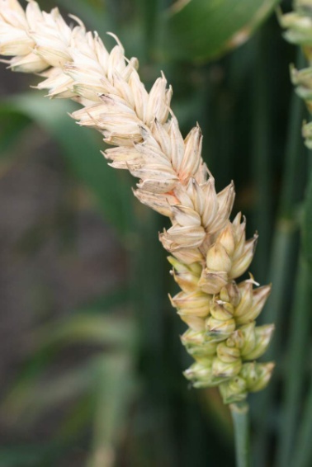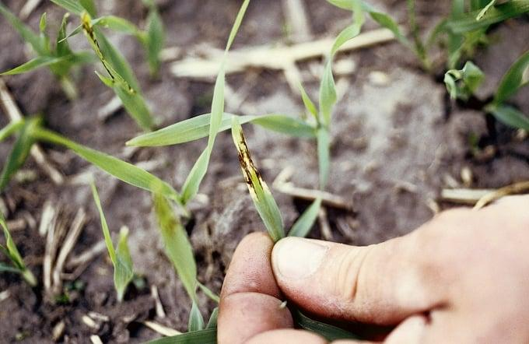

Phase 2 – Exploration (Investigate & Compare)
Deep dive into the BME680 sensor specifications. Students will learn the formula for VPD and why it is more accurate than relative humidity for farming.
- VPD Formula: VPD = VP_{sat} - VP_{air}
Group Work Activity:
Comparing historical weather data vs. localized sensor readings.

Phase 3 – Application (Hands-On Practice)
Conducting a "hover-and-dip" flight maneuver over a test plot to collect vertical microclimate profiles. Students will log real-time data to a CSV file using their custom drones.
Video:
https://www.youtube.com/watch?v=C9_AaaNaj6Q

Photo/Diagram:

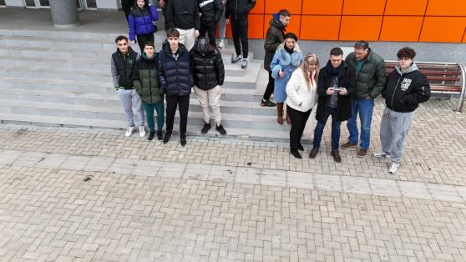

Phase 4 – Reflection & Consolidation (Present & Connect)

Each group presents a "Stress Map" of the field, highlighting areas with high disease risk or low transpiration.

Class Discussion:
How can this data reduce the chemical footprint of a farm?

Reflection Activity:
Data Visualization & Comparison
Students will review the CSV logs or live graphs generated during the flight.
- The "Wait, What?" Moment: Ask students to identify any unexpected spikes in VOC levels or VPD.
- Contextualizing: Did the spikes happen near a damp area of the field (high humidity) or near the tractor path (potential VOC exhaust interference)?.

Assessment Criteria

Open-ended questions on interpreting sensor data spikes

Self-assessment tools for individual reflection;
- Safety Awareness: "Did I follow all health and safety standards (OHS) during the drone flight and battery handling?"
- Technical Confidence: "On a scale of 1–5, how confident am I in configuring the BME680 oversampling and filter settings in Python?"
- Problem Solving: "What was my biggest challenge when the drone encountered wind or signal interference, and how did I adapt?"

Peer review protocols for collaborative evaluation:
- Teamwork: Using a rubric, peers evaluate each other on their ability to collaborate during the "Farmer’s Dilemma" roleplay.
- Communication: Did the team spokesperson present the "Stress Map" findings clearly and use professional technical terminology?
- Logic Check: Reviewing a classmate's VPD calculation to verify accuracy and provide constructive feedback.

Portfolios with selected outputs or documentation of learning process:
Documentation of the flight logs and the resulting VPD calculations.

Teaching Materials
- 1- FLIGHT Kit (custom drone components).
- BME680 – Temperature, Humidity, Pressure, VOCs.
- BME680 – Temperature, Humidity, Pressure, VOCs.

2- FLIGHT Kit (custom drone components) used:
- BME680 – Temperature, Humidity, Pressure, VOCs
- Laser PM2.5 Sensor – Particulate Matter
- MQ7 Gas Sensor – CO Detection
- GUVA-S12SD – UV Intensity

