

“Drone Research – Nitrogen Concentration in Plants”

FLIGHT RESOURCE CENTER

DSU RCSOO “Kiro Burnaz”



Table of Contents
Table of Contents 1
1. SHORT DESCRIPTION 2
2. TARGET 2
3. SUBJECT AREA 2
4. TYPE 2
5. DRONE USED 2
6. DURATION 3
7. LEARNING OBJECTIVES 3
8. KEY COMPETENCES DEVELOPED 3
1. Communication and Languages 3
2. Mathematical, Scientific, Technical and Professional Skills 3
3. Digital Competences 3
4. Personal, Social and Professional Competences 3
5. Safety, Quality and Sustainability 4
6. Citizenship and Cultural Competence 4
7. Creativity, Problem-Solving and Entrepreneurship 4
8. Work-Based Learning and Workplace Integration 4
9. Prior Knowledge / Prerequisites 4
10. Lesson/Project Outline 4
Phase 1 – Introduction (Engage & Contextualize) 4
Phase 2 – Exploration (Investigate & Compare) 4
Phase 3 – Application (Hands-On Practice) 5
Phase 4 – Reflection & Consolidation (Present & Connect) 5
11. Assessment Criteria 5
12. Teaching Materials 5
13. External Resources 5
14. References 6

SHORT DESCRIPTION
The teaching unit is focused on the application of drones in agriculture in order to monitor and assess the concentration of nitrogen in plants. Through a theoretical introduction and practical activity, students will learn about the role of nitrogen as an important nutrient, as well as the opportunities offered by modern technology for precision agriculture. By using a drone and analyzing images, students will identify differences in vegetation and draw conclusions about the condition of plants.

TARGET
- 15
- 16
- 17
- 18
- Over 18

SUBJECT AREA
- Agriculture
- Disaster Response
- Constructions
- Water Management
- Environmental Protection
- Other

TYPE
- Lesson Plan
- Project
- Activity

DRONE USED
- Custom Drone
- Commercial drone (DJI)

DURATION
- 1 x 45-minute class
- 1 x 60-minute class
- 1 x 90-minute block
- 2 x 45-minute classes
- 2 x 60-minute classes
- Double session (2 × 60 minutes) optional project-based homework.

LEARNING OBJECTIVES
01. Explain the importance of nitrogen for plants

Students will gain knowledge about the role of nitrogen as one of the most important macroelements in plant nutrition. They will understand how nitrogen participates in the creation of chlorophyll, proteins and enzymes, as well as its impact on the growth, development and yield of crops. Students will also be able to recognize symptoms of nitrogen deficiency or excess in plants (color change, growth retardation, weak vegetation).
O2: Use a drone to monitor crops
Students will be trained in the basic and safe use of a drone for educational purposes, with an emphasis on its application in agriculture. They will learn how to prepare a drone for flight, how to perform controlled filming and how to monitor crops from the air. Through this activity, they will see the advantage of drones in quickly and efficiently monitoring large agricultural areas.
O3: Analyze visual data from images
Students will develop skills in analyzing visual data obtained from drone images. They will compare differences in color, density, and plant health to determine potential differences in nitrogen concentration. Through image analysis, students will connect theoretical knowledge with practical examples from the field.
O4: Draw conclusions based on observations
Students will be able to draw logical and reasoned conclusions based on observations and analyses. They will connect visual indicators from the images with possible causes of plant condition, such as nitrogen deficiency or optimal presence. Additionally, they will develop critical thinking and a scientific approach when interpreting the results.

KEY COMPETENCES DEVELOPED

1. Communication and Languages
- Literacy competence (understanding and producing written/oral texts)
- Communication in professional contexts
- Multilingual competence

2. Mathematical, Scientific, Technical and Professional Skills
- Mathematical competence
- Scientific, technological and engineering competence (STEM)
- Numeracy applied to work tasks
- Interpretation of technical information (manuals, diagrams, standards)
- Professional/technical skills
- Execution of practical tasks

3. Digital Competences
- Digital competence (general digital literacy)
- Use of digital tools in workplace settings

4. Personal, Social and Professional Competences
- Personal, social and learning-to-learn competence
- Teamwork and collaboration
- Autonomy and responsibility
- Work ethics and professional behaviour
- Adaptability and flexibility
- Cooperation with supervisors and colleagues

5. Safety, Quality and Sustainability
- Application of health and safety standards (OHS/SST)
- Quality procedures and workplace norms
- Environmental and sustainability awareness

6. Citizenship and Cultural Competence
- Citizenship competence
- Cultural awareness and expression competence

7. Creativity, Problem-Solving and Entrepreneurship
- Problem-solving and critical thinking
- Entrepreneurship competence
- Initiative and creativity
- Decision-making in real work situations

8. Work-Based Learning and Workplace Integration
- Integration into workplace routines
- Following professional instructions and procedures
- Use of tools, equipment and technology

This checklist merges the EU Key Competences for Lifelong Learning with the core competences expected in European Vocational Education and Training (VET).

Prior Knowledge / Prerequisites
1. Communication and languages
Oral and written presentation of results and conclusions.
2. Mathematical, scientific, technical and professional skills
Data analysis, scientific approach and technical application.
3. Digital competences
Using drones, digital tools and visual data.
4. Personal, social and professional competences
Teamwork, responsibility and independence.
5. Safety, quality and sustainability
Safe use of drones and sustainable agriculture.
6. Civic and cultural competence
Awareness of the importance of technology in the community.
7. Creativity, problem solving and entrepreneurship
Identifying problems and proposing solutions.
8. Learning through work and integration in the workplace
Introduction to real agricultural practices.
9. Prior knowledge / Prerequisites
Basic knowledge of plants, nutrients and the basics of working with ICT

Lesson/Project Outline

Phase 1 – Introduction (Engage & Contextualize)

Description: The teaching activity begins with an introduction to the topic of the importance of nitrogen, one of the main macroelements for plants. The teacher explains the role of nitrogen in growth, green color and yield of which part of the body, and what are the consequences of its deficiency or excess. Then the concept of precision agriculture and the characteristics of the modern tool for observing and monitoring the condition of crops are introduced. Students are motivated by real examples from modern agriculture and connect theory with practical application.
Video: https://www.youtube.com/watch?v=ubANrz13Ysg

Photo/Diagram: [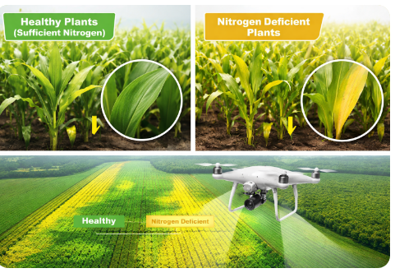
Guiding Questions
- Why is nitrogen important for plants?
- How can nitrogen deficiency be recognized?
- What are the advantages of using a drone in agricultural work?

Phase 2 – Exploration (Investigate & Compare)

Description: In this phase, students participate in an investigative activity by observing crops using a drone. Under the guidance of the teacher, the drone is used to record a specific agricultural area. Students follow the recordings and note differences in color, density and plant development. A comparison is made between different parts of the crop in order to identify potential differences in nitrogen concentration. 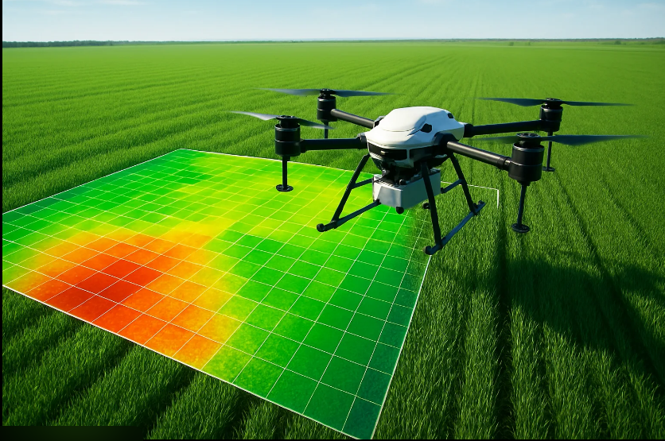 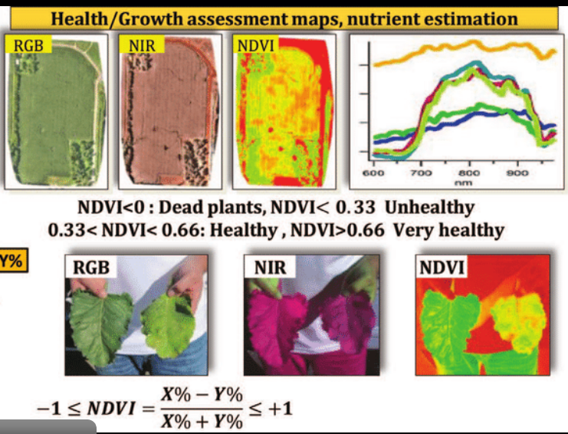
What is NDVI?
NDVI uses infrared and visible (red) light from plants to determine their health.
The formula is:
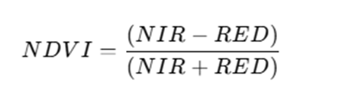
NIR = Near Infrared
RED = Visible Red Light
The result is a number between -1 and +1, where:
NDVI close to +1 → dense, healthy, green growth
NDVI close to 0 → little or no vegetation (bare land, urban area)
NDVI close to -1 → water, snow or clouds
Example of an NDVI map
Green = healthy plants
Yellow/orange = lower nitrogen concentration / stressed plants
Red = very low biomass / stressed or dead plants

Guiding Questions / Class Discussion:
- What differences do you notice in the images?
- What could be the reason for these differences?
- How does visual data help in assessing the condition of plants?

Short Reading or Infographic:
Nitrogen is one of the most important nutrients for plants and plays a key role in the synthesis of chlorophyll, proteins and enzymes. Leaf color is a direct indicator of plant health and the presence of nitrogen.

Dark green leaves → sufficient nitrogen concentration, optimal growth and development.

Light green to yellowish leaves → beginning of nitrogen deficiency, poor growth and reduced photosynthesis.

Yellow or brown leaves → significant nitrogen deficiency, stressed or dead cells, reduced biomass.
Group Work Activity:
Students work in small groups and are assigned to analyze a certain portion of the footage and record their observations.

Phase 3 – Application (Hands-On Practice)
Hands-On Activity:
Students actively participate in the practical application of the acquired knowledge. In groups or individually, they analyze drone footage and connect visual indicators with theoretical knowledge about nitrogen. Short notes or tables are made with observations about the condition of the plants and possible measures are proposed (for example, additional fertilization).

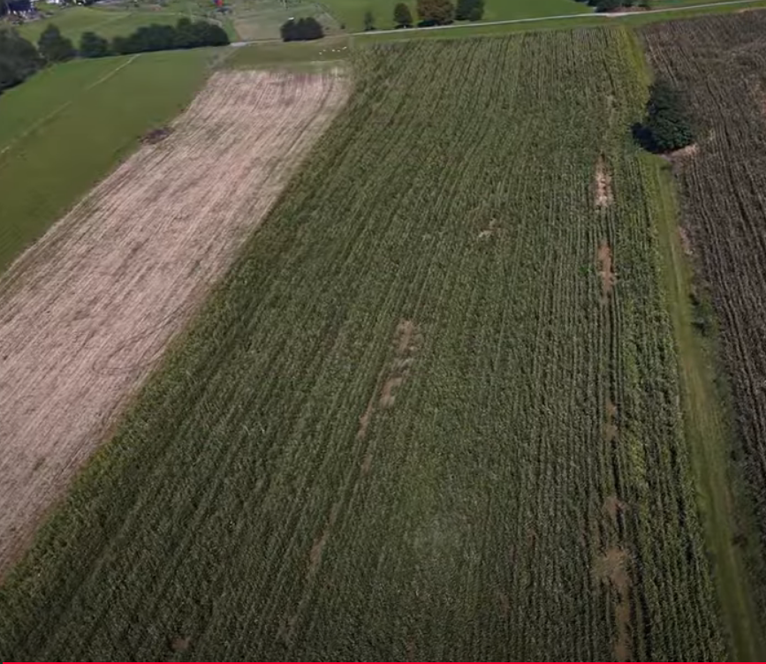

Phase 4 – Reflection & Consolidation (Present & Connect)

Group Presentations
Each group presents their observations and conclusions to the class. Students explain what they observed in the recordings and how it relates to the nitrogen concentration.

Class Discussion:
Joint discussion on the results obtained, the importance of accurate nutrient assessment and the role of drones in modern agriculture
Reflection Activity:
Students individually or in writing answer questions:
What new things did I learn today?
How did the drone help in research?
Where else can this technology be applied?

Assessment Criteria
Quizzes with closed or open questions: Activity and Participation
Self-assessment tools for individual reflection; Content Understanding
Peer review protocols for collaborative evaluation: Analysis and Conclusions
Portfolios with selected outputs or documentation of learning process: Teamwork

Teaching Materials
1- Drone, tablet/computer, worksheets, projector.

2- FLIGHT Kit (custom drone components) used:
- BME680 – Temperature, Humidity, Pressure, VOCs
- Laser PM2.5 Sensor – Particulate Matter
- MQ7 Gas Sensor – CO Detection
- GUVA-S12SD – UV Intensity

External Resources
Websites and videos

Resource | Link

References
Curriculums, manuals for agriculture and drone technology.

