

Fertilisation of Autumn Crops Based on Growth Stage

FLIGHT RESOURCE CENTER

DSU RCSOO “Kiro Burnaz”


Table of Contents
Table of Contents 1
1. SHORT DESCRIPTION 2
(UP 3000 CHARACTERS) 2
2. TARGET 2
3. SUBJECT AREA 2
4. TYPE 2
5. DRONE USED 2
6. DURATION 3
7. LEARNING OBJECTIVES 3
8. KEY COMPETENCES DEVELOPED 3
1. Communication and Languages 3
2. Mathematical, Scientific, Technical and Professional Skills 3
3. Digital Competences 3
4. Personal, Social and Professional Competences 3
5. Safety, Quality and Sustainability 4
6. Citizenship and Cultural Competence 4
7. Creativity, Problem-Solving and Entrepreneurship 4
8. Work-Based Learning and Workplace Integration 4
9. Prior Knowledge / Prerequisites 4
10. Lesson/Project Outline 4
Phase 1 – Introduction (Engage & Contextualize) 4
Phase 2 – Exploration (Investigate & Compare) 4
Phase 3 – Application (Hands-On Practice) 5
Phase 4 – Reflection & Consolidation (Present & Connect) 5
11. Assessment Criteria 5
12. Teaching Materials 5
13. External Resources 5
14. References 6

SHORT DESCRIPTION
This lesson introduces students to the principles of fertilization management in autumn-sown crops (wheat, barley, rye) based on plant growth stages, supported by visual assessment using a commercial drone equipped with an RGB camera. Through drone-based field observation, students learn how aerial imagery can support decision-making related to the timing, rate, and spatial distribution of fertilization.
The use of drone technology enables the identification of spatial variability in crop growth, early signs of nutrient deficiency, and uneven field development that are often not visible from ground level. By correlating crop growth stages with visual indicators such as plant density, color intensity, and field uniformity, students gain a deeper understanding of crop nutrient requirements during autumn development.
The lesson integrates classical agronomic knowledge with precision agriculture approaches, emphasizing resource efficiency, environmental protection, and sustainable nutrient management. Special attention is given to reducing excessive fertilizer application, preventing nutrient losses, and aligning agricultural practices with EU environmental and sustainability policies.

TARGET
- 15
- 16
- 17
- 18
- Over 18

SUBJECT AREA
- Agriculture
- Disaster Response
- Constructions
- Water Management
- Environmental Protection
- Other

TYPE
- Lesson Plan
- Project
- Activity

DRONE USED
- Custom Drone
- Commercial drone (DJI)

DURATION
- 1 x 45-minute class - Portugal
- 1 x 60-minute class
- 1 x 90-minute block
- 2 x 45-minute classes
- 2 x 60-minute classes
- Double session (2 × 60 minutes) optional project-based homework.

LEARNING OBJECTIVES
Students will understand the role of fertilization in autumn crops and explain how nutrient requirements change according to crop growth stages.
Students will use drone-acquired RGB imagery to visually assess crop development and field uniformity.
Students will identify zones with uneven growth or potential nutrient deficiency and propose appropriate fertilization measures.
Students will explain how drone-assisted monitoring contributes to precision fertilization and environmentally responsible farming.

KEY COMPETENCES DEVELOPED

1. Communication and Languages
- Literacy competence (understanding and producing written/oral texts)
- Communication in professional contexts
- Multilingual competence

2. Mathematical, Scientific, Technical and Professional Skills
- Mathematical competence
- Scientific, technological and engineering competence (STEM)
- Numeracy applied to work tasks
- Interpretation of technical information (manuals, diagrams, standards)
- Professional/technical skills
- Execution of practical tasks

3. Digital Competences
- Digital competence (general digital literacy)
- Use of digital tools in workplace settings

4. Personal, Social and Professional Competences
- Personal, social and learning-to-learn competence
- Teamwork and collaboration
- Autonomy and responsibility
- Work ethics and professional behaviour
- Adaptability and flexibility
- Cooperation with supervisors and colleagues

5. Safety, Quality and Sustainability
- Application of health and safety standards (OHS/SST)
- Quality procedures and workplace norms
- Environmental and sustainability awareness

6. Citizenship and Cultural Competence
- Citizenship competence
- Cultural awareness and expression competence

7. Creativity, Problem-Solving and Entrepreneurship
- Problem-solving and critical thinking
- Entrepreneurship competence
- Initiative and creativity
- Decision-making in real work situations

8. Work-Based Learning and Workplace Integration
- Integration into workplace routines
- Following professional instructions and procedures
- Use of tools, equipment and technology

This checklist merges the EU Key Competences for Lifelong Learning with the core competences expected in European Vocational Education and Training (VET).

Prior Knowledge / Prerequisites
Students should have a basic understanding of autumn-sown crops, their growth stages, and the function of essential nutrients (nitrogen, phosphorus, potassium). Familiarity with basic fertilization practices and crop management is recommended. No prior experience with drone operation is required; however, students should be aware of general safety rules and responsible use of digital and technological tools in agriculture.

Lesson/Project Outline

Phase 1 – Introduction (Engage & Contextualize)
Description:
- The teacher introduces the importance of growth stage–based fertilisation in autumn-sown crops, explaining that nutrient requirements vary significantly depending on the physiological stage of plant development. Special attention is given to key stages such as emergence, early vegetative growth, and tillering, where balanced nutrient supply is essential for proper root development, uniform crop establishment, and winter hardiness.
- Drone technology is presented as a modern precision agriculture tool for visual field assessment, allowing farmers and agronomists to monitor crop uniformity and spatial variability across the field at an early stage. Through aerial RGB imagery, it becomes possible to identify areas with delayed development, reduced plant density, or uneven growth, supporting timely, site-specific fertilisation decisions that improve nutrient use efficiency and reduce unnecessary fertiliser inputs.

Video: https://youtu.be/dnvj-y8XRKY
Photo/Diagram:

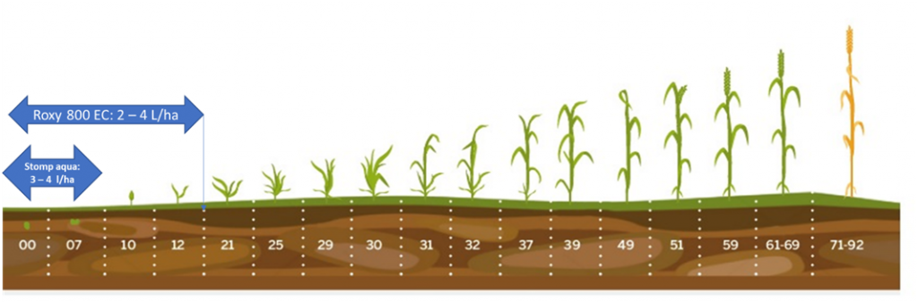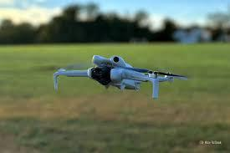

Guiding Questions / Class Discussion:

How can aerial imagery support fertilization decisions?

Do all areas of a field require the same nutrient input?

Phase 2 – Exploration (Investigate & Compare)
Description:
Students analyze RGB images captured with the DJI Mini 4 Pro of autumn crops at different growth stages. They compare uniform, healthy growth areas with zones showing slower development, sparse plant density, or color variation that may indicate nutrient deficiency or stress.
The teacher guides students in interpreting spatial variability, discussing potential causes such as nutrient imbalance, soil heterogeneity, delayed emergence, or water stress. Students annotate images, mark weaker zones, and hypothesize limiting factors, linking visual observations to agronomic decisions for stage-specific fertilisation.
This activity develops visual analysis, critical thinking, and data-driven decision-making skills, showing how drone imagery supports precision agriculture and sustainable nutrient management.

Photo/Diagram:

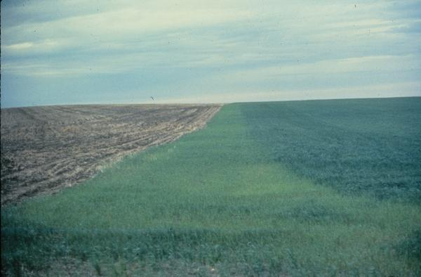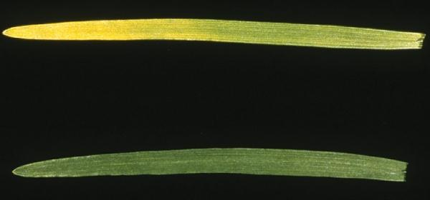

Guiding Questions / Class Discussion:

Short Reading or Infographic:

Group Work Activity:
Students work in small groups to interpret visual data and propose fertilization strategies adjusted to crop development and field variability.

Phase 3 – Application (Hands-On Practice)
Hands-On Activity:
Students participate in a supervised flight with the DJI Mini 4 Pro over autumn crops. They collect RGB imagery to analyze emergence uniformity and determine the growth stage of the plants (e.g., emergence, early vegetative growth, tillering).
Using the drone images, students:
- identify areas with uniform growth and normal emergence;
- detect zones with slower growth, sparse plant density, or delayed emergence;
- compare plant density and color variations to determine potential causes of variability, such as nutrient deficiency, soil heterogeneity, water stress, or other limiting factors;
- mark weaker zones on images and propose stage-specific fertilisation based on the observed growth stage.
he teacher guides students in interpreting drone imagery, showing how visual observations can be linked to agronomic decisions for precise and sustainable nutrient management.
This activity develops:
- skills in visual crop analysis;
- critical thinking for determining causes of uneven emergence;
- data-driven decision-making for optimal nutrient management;
- understanding of growth stages and their relevance for fertilisation planning.

Video:
DJI_20251222103355_0128_D (1).MP4

Phase 4 – Reflection & Consolidation (Present & Connect)
Group Presentations
Each group presents its fertilization plan and explains the reasoning behind its decisions.

Class Discussion:
How can drone-assisted fertilization planning reduce environmental impact and input costs?

Reflection Activity:
Students write a short reflection on the benefits and limitations of using drones for nutrient management.

Assessment Criteria
Quizzes with closed or open questions:
Short formative quizzes are used to assess students’ understanding of fertilisation principles in autumn-sown crops and their relation to crop growth stages.
Closed questions (multiple-choice / true–false) check basic knowledge of key nutrients (N, P, K), fertiliser timing, and early growth stages (emergence, tillering).
Open questions assess students’ ability to explain simple cause–effect relationships, such as how nutrient deficiency affects early crop growth or why growth stage matters for fertilisation decisions.
Self-assessment tools for individual reflection;
Students complete structured self-assessment checklists or reflection reports to evaluate their own learning progress. Reflection focuses on understanding fertilisation strategies, confidence in interpreting drone imagery, and the ability to link crop growth stages with appropriate nutrient management decisions.
Learners also reflect on their awareness of environmental responsibility, prevention of nutrient losses, and the role of digital technologies in sustainable and efficient fertiliser use.

Peer review protocols for collaborative evaluation:
During group activities and presentations, students engage in peer review using predefined evaluation criteria. These include the accuracy of growth stage identification, clarity of agronomic explanations, correct interpretation of drone images, teamwork, and the justification of proposed fertilisation measures.
Peer feedback encourages critical thinking, professional communication, and shared responsibility, reflecting real-world decision-making processes in modern crop production.
Portfolios with selected outputs or documentation of learning process:
Each student or group compiles a learning portfolio documenting the learning process and outcomes. The portfolio may include annotated drone images, growth stage observations, fertilisation plans, quiz results, and reflective entries.
The portfolio demonstrates both theoretical understanding and practical application, showing how drone-assisted monitoring supports precision fertilisation and sustainable nutrient management.

Teaching Materials
1- DJI drone and RGB images
2- Fertilization tables and guidelines

Resource | Link
DJI drone and RGB images
Fertilization tables and guidelines

External Resources

-
Resource | Link
FAO – Nutrient Management | https://www.fao.org

References

FAO (2022). Sustainable Nutrient Management
Agronomy manuals on cereal crop fertilization

