

Detection of Zabrus tenebroides in wheat with a commercial drone
FLIGHT RESOURCE CENTER

DSU RCSOO “Kiro Burnaz”


Table of Contents
Table of Contents 1
1. SHORT DESCRIPTION 2
(UP 3000 CHARACTERS) 2
2. TARGET 2
3. SUBJECT AREA 2
4. TYPE 2
5. DRONE USED 2
6. DURATION 3
7. LEARNING OBJECTIVES 3
8. KEY COMPETENCES DEVELOPED 3
1. Communication and Languages 3
2. Mathematical, Scientific, Technical and Professional Skills 3
3. Digital Competences 3
4. Personal, Social and Professional Competences 3
5. Safety, Quality and Sustainability 4
6. Citizenship and Cultural Competence 4
7. Creativity, Problem-Solving and Entrepreneurship 4
8. Work-Based Learning and Workplace Integration 4
9. Prior Knowledge / Prerequisites 4
10. Lesson/Project Outline 4
Phase 1 – Introduction (Engage & Contextualize) 4
Phase 2 – Exploration (Investigate & Compare) 4
Phase 3 – Application (Hands-On Practice) 5
Phase 4 – Reflection & Consolidation (Present & Connect) 5
11. Assessment Criteria 5
12. Teaching Materials 5
13. External Resources 5
14. References 6

SHORT DESCRIPTION

This project focuses on the detection and monitoring of the cereal pest Zabrus tenebroides in wheat fields using a commercial drone (DJI Mini 4 Pro). Students actively engage in identifying early visual symptoms of pest damage, mapping infested zones, and proposing sustainable pest management strategies.

The project integrates theoretical knowledge about the biology and life cycle of Zabrus tenebroides with practical, hands-on analysis of drone images. Learners examine characteristic symptoms, including leaf damage, crop thinning, and irregular field patterns caused by larval feeding.

The project emphasizes early detection, precision agriculture, and environmentally responsible pest management, with students applying their findings to propose localized interventions and Integrated Pest Management (IPM) strategies.

Through practical activities, collaborative group work, and discussions, participants develop key skills relevant to modern agriculture, including digital monitoring, interpretation of visual data, critical decision-making, and application of IPM principles.

The project encourages sustainable wheat production, reduces pesticide use through targeted measures, and aligns with EU agricultural and environmental standards, providing learners with both theoretical understanding and practical experience in UAV-assisted crop protection.

TARGET
- 15
- 16
- 17
- 18
- Over 18

SUBJECT AREA
- Agriculture
- Disaster Response
- Constructions
- Water Management
- Environmental Protection
- Other

TYPE
- Lesson Plan
- Project
- Activity

DRONE USED
- Custom Drone
- Commercial drone (DJI)

DURATION
- 1 x 45-minute class
- 1 x 60-minute class
- 1 x 90-minute block
- 2 x 45-minute classes
- 2 x 60-minute classes
- Double session (2 × 60 minutes) optional project-based homework.

LEARNING OBJECTIVES
Students will understand the biology, life cycle, and impact of Zabrus tenebroides on wheat crops, and recognize how larval feeding affects crop health and yield.
Students will identify visual symptoms of Zabrus infestation using drone RGB images and distinguish infested from healthy wheat areas.
Students will assess the severity of infestation in the field and propose appropriate management strategies, including localized insecticide application or Integrated Pest Management (IPM) measures, supported by their data analysis.
Students will explain the benefits of using drones for monitoring wheat fields, including how drone-based observations support sustainable agriculture, precision farming, and informed pest management decision

KEY COMPETENCES DEVELOPED

1. Communication and Languages
- Literacy competence (understanding and producing written/oral texts)
- Communication in professional contexts
- Multilingual competence

2. Mathematical, Scientific, Technical and Professional Skills
- Mathematical competence
- Scientific, technological and engineering competence (STEM)
- Numeracy applied to work tasks
- Interpretation of technical information (manuals, diagrams, standards)
- Professional/technical skills
- Execution of practical tasks

3. Digital Competences
- Digital competence (general digital literacy)
- Use of digital tools in workplace settings

4. Personal, Social and Professional Competences
- Personal, social and learning-to-learn competence
- Teamwork and collaboration
- Autonomy and responsibility
- Work ethics and professional behaviour
- Adaptability and flexibility
- Cooperation with supervisors and colleagues

5. Safety, Quality and Sustainability
- Application of health and safety standards (OHS/SST)
- Quality procedures and workplace norms
- Environmental and sustainability awareness

6. Citizenship and Cultural Competence
- Citizenship competence
- Cultural awareness and expression competence

7. Creativity, Problem-Solving and Entrepreneurship
- Problem-solving and critical thinking
- Entrepreneurship competence
- Initiative and creativity
- Decision-making in real work situations

8. Work-Based Learning and Workplace Integration
- Integration into workplace routines
- Following professional instructions and procedures
- Use of tools, equipment and technology

This checklist merges the EU Key Competences for Lifelong Learning with the core competences expected in European Vocational Education and Training (VET).

Prior Knowledge / Prerequisites
Learners should have a basic understanding of crop production systems, particularly the growth stages of wheat and key plant health indicators. Previous exposure to common cereal pests and typical symptoms of biotic stress (e.g., leaf damage, crop thinning, or uneven stand development) is recommended, although in-depth entomological knowledge is not required.
Students are expected to have basic digital literacy, including the ability to interpret visual information, work with images, and use simple digital tools for data collection, observation, and analysis. Familiarity with agricultural terminology and sustainability concepts (such as reduced pesticide use, ecosystem protection, and sustainable resource management) is advantageous.
No prior experience in drone operation is necessary. However, learners should demonstrate awareness of safety rules, responsible technology use, and occupational health and safety (OHS) principles relevant to fieldwork and agricultural environments.
This project builds upon these foundational competences by engaging learners in UAV-assisted crop monitoring, practical analysis of drone imagery, and precision agriculture decision-making. Students will develop hands-on skills in identifying pest damage, mapping infested zones, and proposing sustainable management strategies, reinforcing both digital and professional competences relevant to modern agriculture.

Lesson/Project Outline

Phase 1 – Introduction (Engage & Contextualize)

Description:
Planned Activities: Teacher presents Zabrus tenebroides biology, life cycle, economic impact, and the importance of early detection.
Project Activities: Students discuss the significance of pest monitoring, precision agriculture, and environmentally responsible practices.
Objective: Students understand the role of drones in crop monitoring and sustainable pest management.
Photo/Diagram:

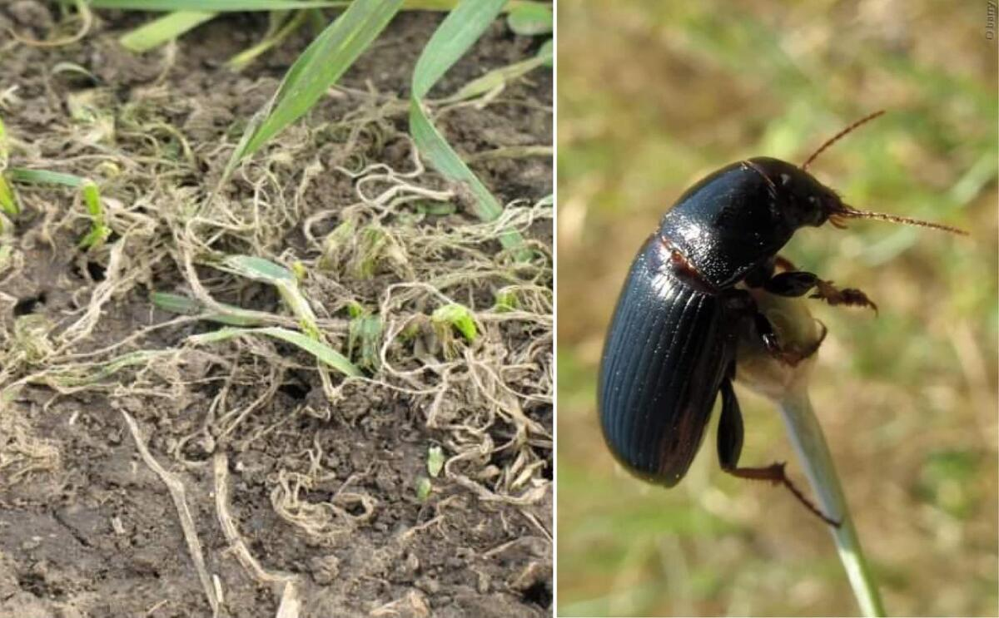
Guiding Questions / Class Discussion:

Why is early detection of Zabrus tenebroides important?

How can drones improve pest monitoring compared to field scouting?

Phase 2 – Exploration (Investigate & Compare)
Planned Activities:
- Analyze the images to identify healthy and infested zones.
- Discuss the visual symptoms of larval damage, such as leaf yellowing, chewed parts, crop thinning, and irregular patterns.
Realized Activities:
- Students identify affected areas in the images and document pest symptoms.
- Compare healthy and damaged zones to understand spatial variability and distinguish pest damage from other stress factors (e.g., nutrient deficiency, drought).
- Work in small groups to discuss which areas appear most affected and propose preliminary interventions for crop protection.
Objective:
- Develop analytical skills, diagnostic thinking, and the ability to interpret visual data for practical decision-making in crop protection.
Video:
KAKO ŽITNI BAULJAR UNIŠTAVA PŠENICU? MALA ŠKOLA RATARSTVA ; HOW WHEAT GROUND BEETLE DESTROY CROPS?
Photo/Diagram:

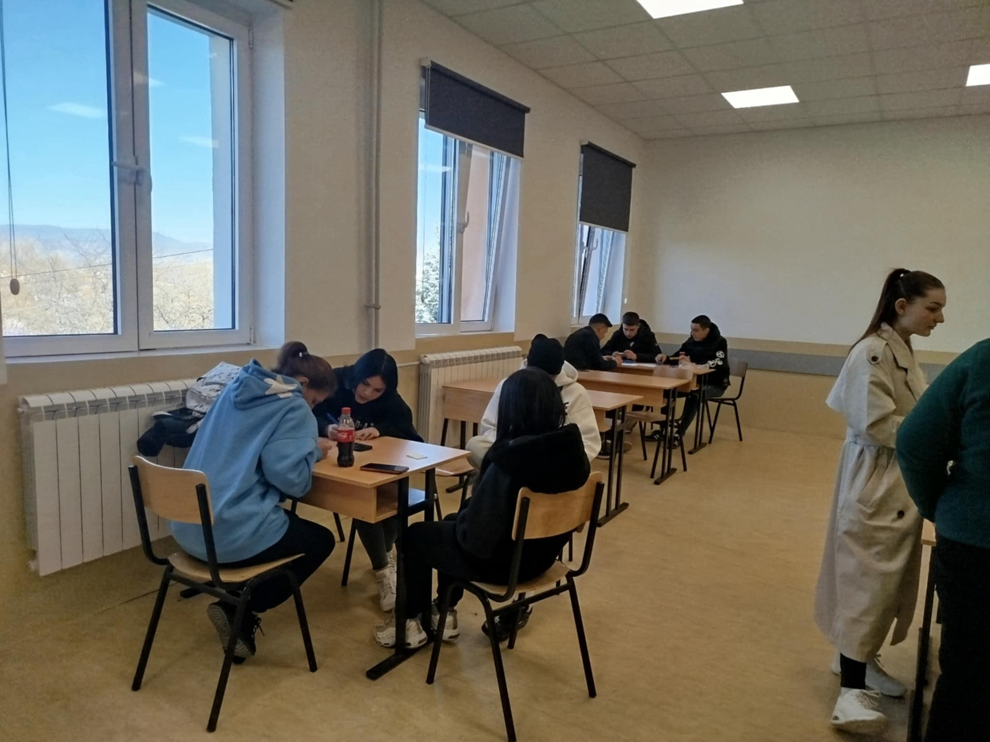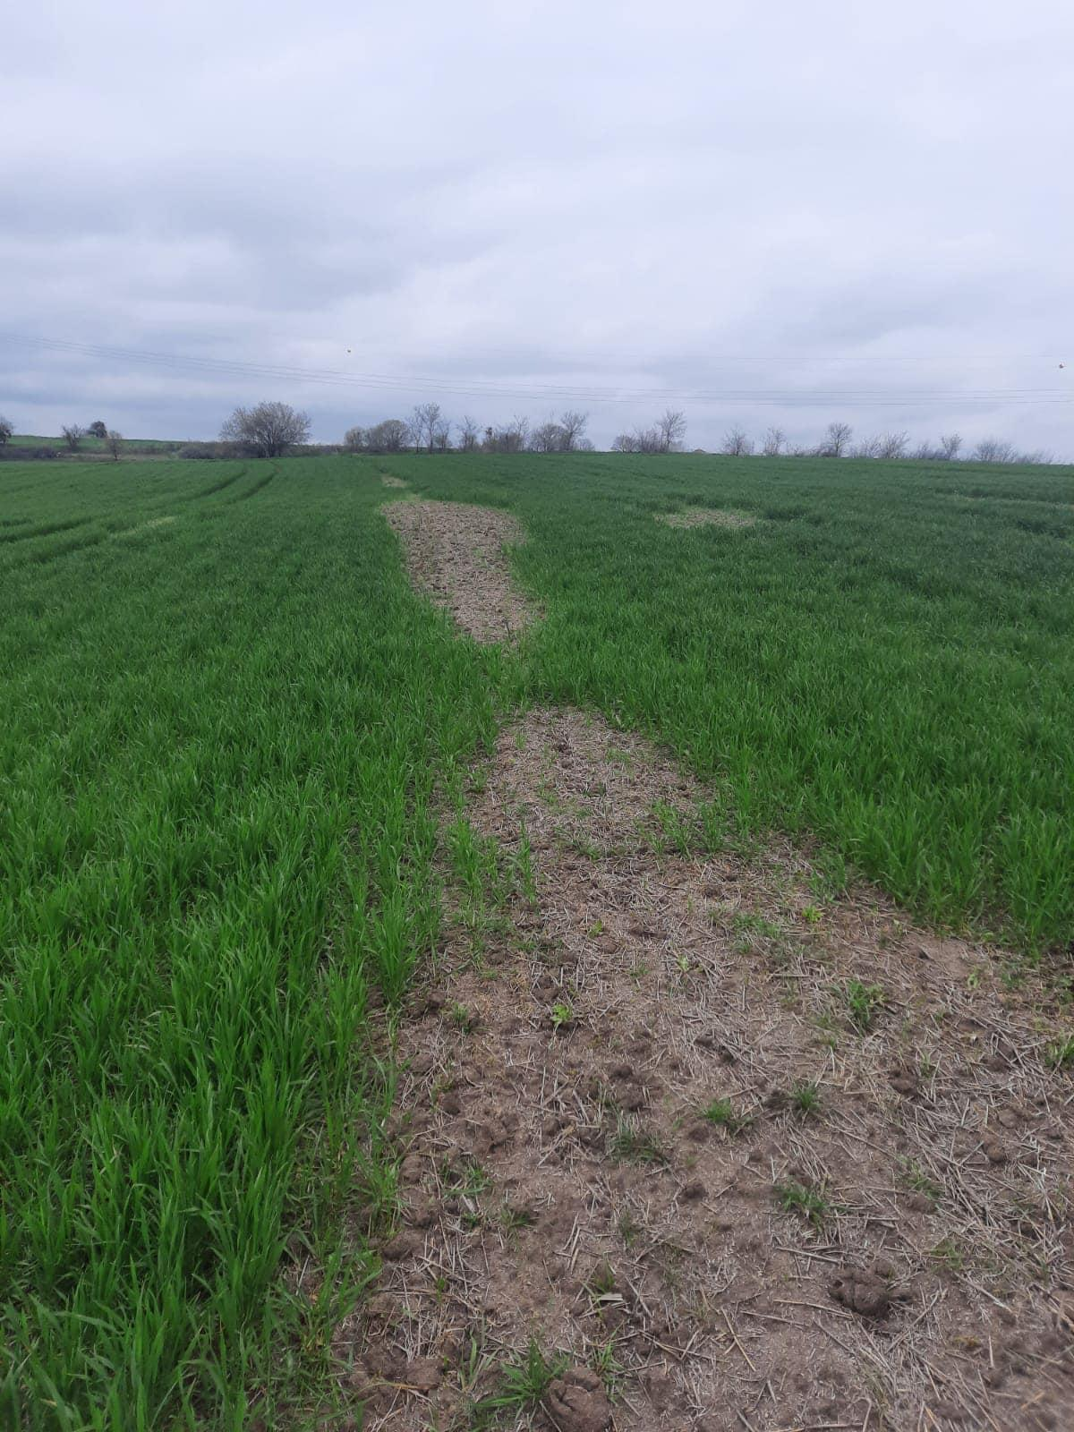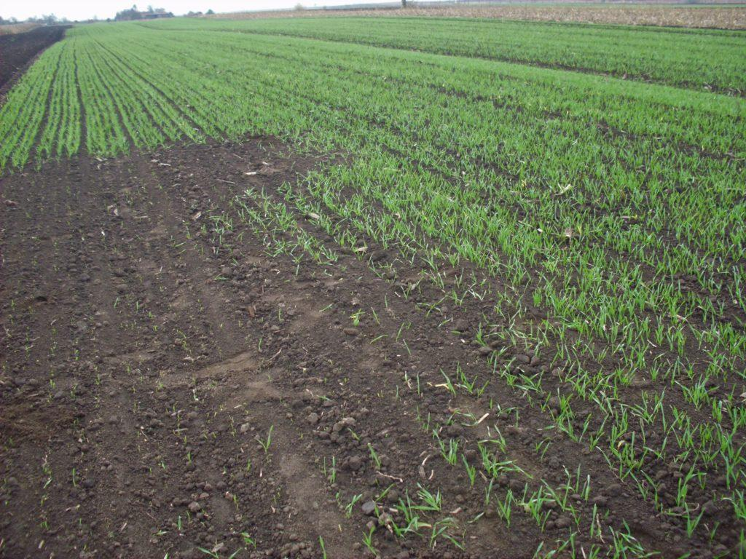

Guiding Questions / Class Discussion:
Which patterns in the images indicate Zabrus tenebrioides infestation?
How can pest damage be differentiated from other stresses in wheat?
Why is understanding spatial variability important for precision agriculture and targeted interventions?
Short Reading or Infographic:
Infographic showing the life cycle of Zabrus tenebroides and the types of damage caused by larvae at different growth stages.
Group Work Activity:
mall groups analyze the internet images and create preliminary maps of infested zones.
Groups discuss possible localized interventions and identify areas requiring further monitoring or treatment.

Phase 3 – Application (Hands-On Practice)
Hands-On Activity:
Planned Activities:
Students participate in a supervised drone demonstration or analyze pre-recorded footage from the school farm in November. Instructions on safe drone operation, data recording, and observation are provided.
Realized Activities (School Farm, November):
- Groups create detailed maps of affected areas using the drone imagery.
- They assess the severity of pest damage, document visual symptoms, and propose localized IPM interventions or insecticide treatments.
- Students visit a local agricultural shop to learn about available crop protection products, proper use of insecticides, localized treatments, and environmentally responsible options.
- Groups discuss and justify their recommendations based on both the drone data and the information obtained from the agricultural shop, considering crop health, environmental impact, and sustainability.
Objective:
Students apply theoretical knowledge to practical situations, develop critical thinking and analytical skills, and learn to make informed, environmentally responsible decisions for crop protection, including consultations with agricultural professionals to optimize IPM interventions.

Video:
DJI_20251212111527_0076_D.MP4

Phase 4 – Reflection & Consolidation (Present & Connect)

Group Presentations
Each project group presents its findings from drone image analysis, including:
- Identified infestation zones in the wheat field
- Estimated severity of Zabrus tenebroides damage
- Proposed management strategies (localized interventions or IPM-based measures)

Class Discussion:
Students and the instructor discuss and compare different pest management approaches, such as localized chemical treatment versus IPM strategies. The discussion emphasizes environmental impact, economic efficiency, and long-term sustainability of each approach.
Reflection Activity:
Students reflect on the role of drone technology in:
Supporting sustainable and precision agriculture
Protecting the environment
Complying with EU agricultural and environmental policies
Enhancing decision-making in crop protection based on real data

Assessment Criteria
Quizzes with closed or open questions:
Formative and summative quizzes are used to evaluate students’ understanding of key concepts related to Zabrus tenebroides, wheat crop damage, and drone-assisted monitoring.
- Closed questions (multiple-choice / true–false): Assess factual knowledge, such as:
  - Biology and life cycle of Zabrus tenebroides
  - Typical damage symptoms in wheat
  - Basic principles of RGB drone imaging
- Open-ended questions: Require students to explain cause–effect relationships, e.g.:
  - How larval feeding leads to visible crop thinning
  - Why early detection is critical for yield protection
  - How drone monitoring supports precision agriculture and sustainable pest management

Self-assessment tools for individual reflection;

Students complete structured self-assessment checklists or short reflection reports to evaluate their own learning progress.
Reflection focuses on:
- Understanding pest biology
- Confidence in interpreting drone imagery
- Ability to propose appropriate control measures (localized insecticide application or IPM-based solutions)
- Awareness of environmental responsibility, reduced pesticide use, and use of digital tools in sustainable agriculture

Peer review protocols for collaborative evaluation:
During group activities and presentations, students engage in peer review using predefined evaluation criteria.
Criteria include:
- Accuracy of pest identification
- Clarity of explanations
- Correct interpretation of drone images
- Teamwork and collaboration
- Justification of proposed management strategies
Peer feedback encourages critical thinking, professional communication, and shared responsibility, reflecting real-world agricultural decision-making processes

Portfolios with selected outputs or documentation of learning process:
- Each student or group compiles a learning portfolio documenting the project process and outcomes.
- Portfolio may include:
  - Annotated drone images
  - Observation notes
  - Short reports on infestation severity
  - Quiz results
  - Reflective entries
- Assessment focuses on:
  - Theoretical understanding
  - Practical application of UAV monitoring
  - Quality, relevance, and interpretation of drone imagery
  - Ability to identify infested zones, apply analytical reasoning, and justify IPM interventions
- Attention is also given to safe and responsible drone operation according to operational guidelines

Teaching Materials

Resource | Link
DJI drone or recorded footage

Images of Zabrus damage

Insectarium

Book Wheat Diseases and Pests | www.e-ucebnici.mon.gov.mk/pdf/Болести%20и%20штетници%20кај%20поледелски%20култури.pdf
USB digital microscope

External Resources
EU Drone Regulations - https://www.easa.europa.eu
Integrated Pest Management guidelines

Resource | Link

References
- FAO (2022). Digital Agriculture and UAV Applications
- EASA. Drone Safety and Operations Guidelines
- Agricultural manuals on cereal pest management

