

Alfalfa Cultivation & Drone Technology

FLIGHT RESOURCE CENTER

DSU RCSOO “Kiro Burnaz”



Table of Contents
Table of Contents 1
1. SHORT DESCRIPTION 2
(UP 3000 CHARACTERS) 2
2. TARGET 2
3. SUBJECT AREA 2
4. TYPE 2
5. DRONE USED 2
6. DURATION 3
7. LEARNING OBJECTIVES 3
8. KEY COMPETENCES DEVELOPED 3
1. Communication and Languages 3
2. Mathematical, Scientific, Technical and Professional Skills 3
3. Digital Competences 3
4. Personal, Social and Professional Competences 3
5. Safety, Quality and Sustainability 4
6. Citizenship and Cultural Competence 4
7. Creativity, Problem-Solving and Entrepreneurship 4
8. Work-Based Learning and Workplace Integration 4
9. Prior Knowledge / Prerequisites 4
10. Lesson/Project Outline 4
Phase 1 – Introduction (Engage & Contextualize) 4
Phase 2 – Exploration (Investigate & Compare) 4
Phase 3 – Application (Hands-On Practice) 5
Phase 4 – Reflection & Consolidation (Present & Connect) 5
11. Assessment Criteria 5
12. Teaching Materials 5
13. External Resources 5
14. References 6

SHORT DESCRIPTION

This lesson plan introduces students to the practical application of the DJI Mini 4 Pro for the visual monitoring of alfalfa crops. Alfalfa, known as the "Queen of Forages," requires precise management to balance yield and protein quality. Traditionally, scouting is done on foot, which is time-consuming and can miss issues in the center of large fields.
This module teaches students how to use high-resolution 4K video and 48MP imagery to perform "digital scouting." Students will learn to identify visual indicators of plant stress (such as root rot and nutrient deficiency), detect pest infestations (alfalfa weevil), and determine the optimal harvest window by visually identifying growth stages (Bud vs. Bloom). The focus remains strictly on visual observation, leveraging the drone’s portability and superior camera to replace or supplement manual field walks

TARGET
- 15
- 16
- 17
- 18
- Over 18

SUBJECT AREA
- Agriculture
- Disaster Response
- Constructions
- Water Management
- Environmental Protection
- Other

TYPE
- Lesson Plan
- Project
- Activity

DRONE USED
- Custom Drone
- Commercial drone (DJI)

DURATION
- 1 x 45-minute class
- 1 x 60-minute class
- 1 x 90-minute block
- 2 x 45-minute classes
- 2 x 60-minute classes
- Double session (2 × 60 minutes) optional project-based homework.

LEARNING OBJECTIVES
Students will identify key visual indicators of alfalfa crop health by analyzing high-resolution aerial imagery, including signs of common pests, diseases, uneven growth, chlorosis, and water stress, in order to recognize early risks that may affect yield and forage quality.
Students will execute a systematic scouting flight using the DJI Mini 4 Pro by planning and flying an efficient flight pattern that ensures 100% field coverage without crop trampling, while applying basic drone safety, operational, and responsible-use principles.
Students will analyze aerial photographs to distinguish between the “Late Bud” and “Early Flower” growth stages of alfalfa, enabling them to determine the optimal economic harvest timing based on forage quality and yield considerations.
Document irrigation system leaks or dry stress areas through aerial visual inspection, supporting improved water management efficiency and sustainable alfalfa production.

KEY COMPETENCES DEVELOPED

1. Communication and Languages
- Literacy competence (understanding and producing written/oral texts)
- Communication in professional contexts
- Multilingual competence

2. Mathematical, Scientific, Technical and Professional Skills
- Mathematical competence
- Scientific, technological and engineering competence (STEM)
- Numeracy applied to work tasks
- Interpretation of technical information (manuals, diagrams, standards)
- Professional/technical skills
- Execution of practical tasks

3. Digital Competences
- Digital competence (general digital literacy)
- Use of digital tools in workplace settings

4. Personal, Social and Professional Competences
- Personal, social and learning-to-learn competence
- Teamwork and collaboration
- Autonomy and responsibility
- Work ethics and professional behaviour
- Adaptability and flexibility
- Cooperation with supervisors and colleagues

5.Safety, Quality andSustainability
- Application of health and safety standards (OHS/SST)
- Quality procedures and workplace norms
- Environmental and sustainability awareness

6. Citizenship and Cultural Competence
- Citizenship competence
- Cultural awareness and expression competence

7. Creativity, Problem-Solving and Entrepreneurship
- Problem-solving and critical thinking
- Entrepreneurship competence
- Initiative and creativity
- Decision-making in real work situations

8. Work-Based Learning and Workplace Integration
- Integration into workplace routines
- Following professional instructions and procedures
- Use of tools, equipment and technology

This checklist merges the EU Key Competences for Lifelong Learning with the core competences expected in European Vocational Education and Training (VET).

Prior Knowledge / Prerequisites
Students should possess a foundational understanding of alfalfa cultivation, including the main growth stages from seedling establishment through vegetative development, budding, flowering, and harvest. They should be familiar with basic agronomic concepts such as crop health, irrigation needs, and the importance of timely harvesting for forage quality.Learners are expected to have introductory knowledge of drone technology, including basic drone components (airframe, camera, battery, and controller) and their functions. Basic familiarity with the DJI Fly application interface is recommended, including camera view, telemetry data, GPS status, battery monitoring, and simple flight controls.
Students should also be aware of essential drone safety principles and local flight regulations. This includes understanding airspace limitations, maximum flight altitude, visual line-of-sight requirements, and no-fly zones, in accordance with applicable regulations (e.g., Part 107 in the United States or the EASA Open Category in Europe). Prior experience with basic manual drone flight is beneficial but not mandatory.
Finally, students should have basic digital skills, such as viewing and organizing photos, recognizing visual patterns, and interpreting simple visual data, as these skills support effective analysis of aerial imagery for agricultural decision-making.

Lesson/Project Outline

Phase 1 – Introduction (Engage & Contextualize)

Description:
The lesson begins with a guided discussion on the economic importance of alfalfa quality in forage production. Students explore how harvest timing directly affects Relative Feed Value (RFV), protein content, digestibility, and overall market value. The teacher explains that even a 10% delay or advancement in harvest timing can lead to significant losses or gains in feed quality, influencing livestock performance and farm profitability.Students are introduced to the challenge of traditional field scouting in dense, mature alfalfa stands. Walking large fields is time-consuming, physically demanding, and may damage crops, while driving vehicles into the field risks soil compaction and plant loss. At this point, the DJI Mini 4 Pro is presented as an “eye in the sky” — a modern precision agriculture tool that allows farmers to monitor crop health, growth stages, and irrigation systems without physically entering the field.The instructor explains how high-resolution aerial imagery and video enable early detection of problems that are difficult to notice from ground level, such as uneven growth, pest damage patterns, early flowering, or water stress. This phase establishes the real-world relevance of drone technology in sustainable and economically efficient alfalfa production.

Photo/Diagram: Guiding
Photo/Diagram:

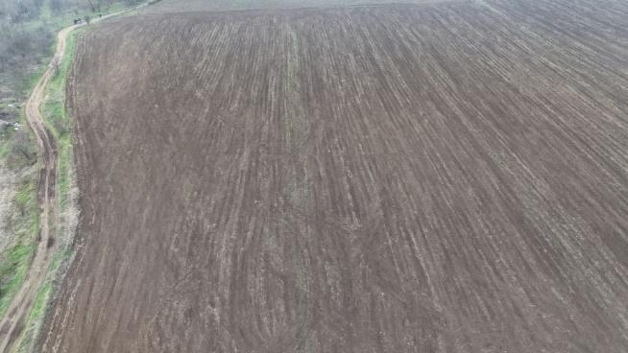

Guiding Questions / Class Discussion:

1.How long would it realistically take a farmer to walk and visually inspect a 16-hectare alfalfa field?
2.What risks are associated with driving a truck or tractor into a standing alfalfa field for scouting purposes?
3.Why might some crop problems remain unnoticed when scouting is done only from ground level?

Phase 2 – Exploration (Investigate & Compare)

Description:
Students examine a Visual Identification Guide that includes labeled, high-resolution images of alfalfa under different conditions. The guide presents side-by-side comparisons of healthy, uniformly green alfalfa and fields showing common problems.
Students analyze images displaying:
- “Frosting” caused by alfalfa weevil feeding damage
- Yellow circular patterns associated with root rot or nutrient uptake issues
- Purple dots or patches indicating early flowering and advancing maturity
Through guided observation, students learn to associate specific visual patterns with underlying agronomic problems. Emphasis is placed on recognizing differences in color, texture, canopy density, and uniformity from an aerial perspective.
Video:
Photo/Diagram:

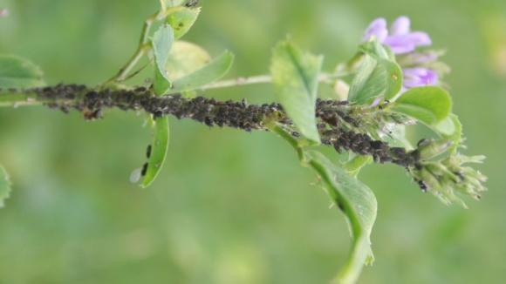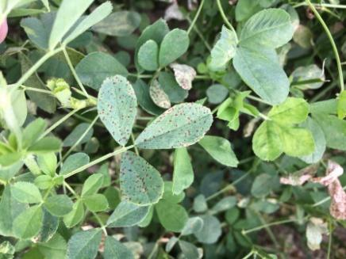

Guiding Questions / Class Discussion:
- What visual clues help distinguish pest damage from nutrient deficiency?
- Why do some problems appear in patterns or zones rather than across the entire field?

Short Reading or Infographic:
Group Work Activity: Working in small groups, students receive a sample set of aerial images. Each group categorizes identified “Problem Zones” based on visual symptoms and briefly explains their reasoning.

Phase 3 – Application (Hands-On Practice)
Hands-On Activity:
Simulated Scouting Mission Using DJI Mini 4 Pro
Students participate in a structured, simulated drone scouting mission designed to mirror real agricultural practice. The activity follows a step-by-step operational workflow:
1.Pre-flight:
- Check battery level, SD card capacity, GPS signal, and camera settings.
- Review basic safety rules and flight boundaries.
2.Launch & Overview:
- Ascend to approximately 45–50 m (adjusted for safety and regulations) to obtain a general overview of the field.
- Observe overall crop uniformity and color variation.
3.Grid Flight:
- Fly a manual grid pattern to ensure systematic coverage of the entire field.
- Identify areas showing unusual color, density, or texture.
4.Low-Pass Inspection:
- Descend to approximately 6 m over selected “suspect zones.”
- Use 2× digital zoom to inspect canopy details.
5.Capture:
- Take 48MP high-resolution still images and short 4K video clips documenting identified issues.
Students work in teams, rotating roles (pilot, observer, data recorder) to build both technical and analytical skills.
Video:
https://www.youtube.com/shorts/kUsDjGGgnA4

Photo/Diagram:

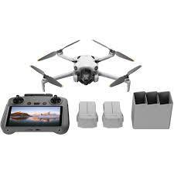

Phase 4 – Reflection & Consolidation (Present & Connect)
Group Presentations
Each group presents the results of their simulated scouting mission using captured 48MP images and 4K video footage. Presentations must include:
Top 3 Findings:
Students highlight the three most significant observations, such as:
- Pest infestations (e.g., alfalfa weevil damage)
- Nutrient deficiency patterns
- Irrigation leaks or dry stress zones
Harvest Readiness Justification:
Using aerial imagery, students distinguish between “Late Bud” and “Early Flower” stages. Based on visual evidence, each group provides a reasoned recommendation on whether the field is ready for harvest to achieve optimal Relative Feed Value (RFV).

Class Discussion:
- How does sunlight angle (e.g., Golden Hour vs. midday sun) affect the visibility of irrigation leaks or moisture stress?
- Why is timing important not only for harvest, but also for aerial scouting?
Reflection Activity:
Students individually or in groups reflect on their top three findings and explain how drone-based scouting supports better decision-making compared to traditional methods. They justify their harvest recommendation using visual evidence of crop maturity and field condition.

Assessment Criteria
Quizzes with closed or open questions:

A 10-question visual identification test identifying alfalfa pests and growth stages from aerial photos

Self-assessment tools for individual reflection;

As part of the Assessment Criteria for the Alfalfa Cultivation & Drone Technology module, the following self-assessment tool is designed to help students reflect on their technical proficiency and agricultural analysis skills.

Individual Reflection & Self-Assessment Rubric
Students should evaluate their performance based on the following criteria to identify areas of strength and opportunities for growth:
- Technical Flight Execution: How effectively did I perform the pre-flight checks (battery and SD card) and execute a systematic grid flight pattern to ensure 100% field coverage?
- Visual Scouting Accuracy: Am I confident in my ability to identify "frosting" from weevil damage, "yellow circles" indicating root rot, and "purple dots" for early bloom within the 48MP imagery?
- Harvest Timing Decision: Can I accurately distinguish between the "Late Bud" and "Early Flower" stages to justify a harvest window that optimizes the Relative Feed Value (RFV)?

- Resource Management: How well did I document irrigation system leaks or dry spots, and did I consider environmental factors like the "Golden Hour" on my image quality?
- Operational Efficiency: Do I understand the economic and physical benefits of "digital scouting" (e.g., avoiding crop trampling) compared to traditional manual field walks?

Peer review protocols for collaborative evaluation:

In this session, groups will evaluate each other’s simulated scouting missions and data analysis

Flight Execution & Coverage
- Grid Systematicity: Did the group demonstrate a manual grid flight pattern that ensured 100% coverage of the 16 ha field?
- Altitude Management: Did they effectively use high-altitude (450 m) for field overviews and low-altitude (6 m) for detailed "Problem Zone" inspections?
- Technical Proficiency: Did the group leverage the DJI Mini 4 Pro’s 2x zoom and 48MP imagery to capture clear evidence without trampling the standing alfalfa?

2. Visual Identification Accuracy
- Symptom Recognition: How accurately did the team identify visual indicators of plant stress, such as "frosting" from weevil damage, "yellow circles" of root rot, or "purple dots" of early bloom?
- Water Management: Did the team successfully document irrigation system leaks or dry spots through visual inspection?
- Environmental Awareness: Did they explain how lighting (e.g., "Golden Hour" vs. midday sun) affected their ability to see these issues?

3. Economic Analysis & Decision Making
- Harvest Timing: Based on the aerial photos, is their classification of "Late Bud" versus "Early Flower" accurate?
- Value Justification: Did the group provide a clear justification for their harvest recommendation, considering that a 10% difference in timing affects the Relative Feed Value (RFV)?

Portfolios with selected outputs or documentation of learning process:

Students may include responses to these questions in their final learning portfolio:
- Problem Solving: When I identified a "suspect" area, how effective was my low-pass maneuver at 6 meters using the 2x zoom for detailed inspection?
- Safety and Regulations: Did I maintain compliance with local drone flight regulations (e.g., EASA Open Category or Part 107) throughout the mission?
- Future Application: How could the use of the DJI Mini 4 Pro be adapted to other crops based on what I learned about alfalfa scouting?

Teaching Materials
1. DJI Mini 4 Pro + RC 2 Controller
2. Extra batteries (Fly More Combo)
3. High-speed microSD cards
4. Tablet or screen for class image review

2- FLIGHT Kit (custom drone components) used:
- BME680 – Temperature, Humidity, Pressure, VOCs
- Laser PM2.5 Sensor – Particulate Matter
- MQ7 Gas Sensor – CO Detection
- GUVA-S12SD – UV Intensity

External Resources

Resource | Link

References
- Relevant University Agricultural Extension scouting manuals.
- DJI Mini 4 Pro Technical Specifications.

