

Winter Management in the Apiary

FLIGHT RESOURCE CENTER

DSU RCSOO “Kiro Burnaz”


Table of Contents
Table of Contents 1
1. SHORT DESCRIPTION 2
(UP 3000 CHARACTERS) 2
2. TARGET 2
3. SUBJECT AREA 2
4. TYPE 2
5. DRONE USED 2
6. DURATION 3
7. LEARNING OBJECTIVES 3
8. KEY COMPETENCES DEVELOPED 3
1. Communication and Languages 3
2. Mathematical, Scientific, Technical and Professional Skills 3
3. Digital Competences 3
4. Personal, Social and Professional Competences 3
5. Safety, Quality and Sustainability 4
6. Citizenship and Cultural Competence 4
7. Creativity, Problem-Solving and Entrepreneurship 4
8. Work-Based Learning and Workplace Integration 4
9. Prior Knowledge / Prerequisites 4
10. Lesson/Project Outline 4
Phase 1 – Introduction (Engage & Contextualize) 4
Phase 2 – Exploration (Investigate & Compare) 4
Phase 3 – Application (Hands-On Practice) 5
Phase 4 – Reflection & Consolidation (Present & Connect) 5
11. Assessment Criteria 5
12. Teaching Materials 5
13. External Resources 5
14. References 6

SHORT DESCRIPTION
This lesson provides a comprehensive guide for beginner beekeepers to manage apiaries during the critical winter months. Students will explore the biological needs of honeybees (the "thermocluster"), identify the "Three Big Killers" (starvation, moisture, and physical accidents), and learn non-invasive monitoring techniques. The lesson integrates drone technology to perform remote inspections, allowing beekeepers to check for physical hive damage or snow blockages without breaking the bees' internal heat seal.

TARGET
- 15
- 16
- 17
- 18
- Over 18

SUBJECT AREA
- Agriculture
- Disaster Response
- Constructions
- Water Management
- Environmental Protection
- Other

TYPE
- Lesson Plan
- Project
- Activity

DRONE USED
- Custom Drone
- Commercial drone (DJI)

DURATION
- 1 x 45-minute class - Portugal
- 1 x 60-minute class
- 1 x 90-minute block
- 2 x 45-minute classes
- 2 x 60-minute classes
- Double session (2 × 60 minutes) optional project-based homework.

LEARNING OBJECTIVES
O1: Identify and explain the primary causes of winter colony loss—starvation, excess moisture, and physical damage—by analyzing hive conditions, environmental factors, and beekeeper management practices, in order to recognize early risk indicators and apply timely preventive measures to ensure colony survival during winter.
O2: Demonstrate and apply non-invasive hive assessment techniques, including the Heft Test and Knock Test, to evaluate food reserves, colony vitality, and cluster position without opening the hive, thereby minimizing stress on bees and maintaining optimal winter conditions.
O3:Utilize drone imagery and planned flight operations to monitor apiary safety and surrounding environmental conditions, identifying potential winter hazards such as wind exposure, flooding risk, physical obstructions, or animal interference, while respecting safety regulations and ethical use of technology.
O4: Develop a basic winter management plan for an apiary by integrating observational data, non-invasive assessments, and digital monitoring tools, demonstrating an understanding of sustainable beekeeping practices, risk mitigation strategies, and the role of technology in modern apiculture.

KEY COMPETENCES DEVELOPED

1. Communication and Languages
- Literacy competence (understanding and producing written/oral texts)
- Communication in professional contexts
- Multilingual competence

2. Mathematical, Scientific, Technical and Professional Skills
- Mathematical competence
- Scientific, technological and engineering competence (STEM)
- Numeracy applied to work tasks
- Interpretation of technical information (manuals, diagrams, standards)
- Professional/technical skills
- Execution of practical tasks

3. Digital Competences
- Digital competence (general digital literacy)
- Use of digital tools in workplace settings

4. Personal, Social and Professional Competences
- Personal, social and learning-to-learn competence
- Teamwork and collaboration
- Autonomy and responsibility
- Work ethics and professional behaviour
- Adaptability and flexibility
- Cooperation with supervisors and colleagues

5. Safety, Quality and Sustainability
- Application of health and safety standards (OHS/SST)
- Quality procedures and workplace norms
- Environmental and sustainability awareness

6. Citizenship and Cultural Competence
- Citizenship competence
- Cultural awareness and expression competence

7. Creativity, Problem-Solving and Entrepreneurship
- Problem-solving and critical thinking
- Entrepreneurship competence
- Initiative and creativity
- Decision-making in real work situations

8. Work-Based Learning and Workplace Integration
- Integration into workplace routines
- Following professional instructions and procedures
- Use of tools, equipment and technology

This checklist merges the EU Key Competences for Lifelong Learning with the core competences expected in European Vocational Education and Training (VET).

Prior Knowledge / Prerequisites
(UP 2000 CHARACTERS)
Learners are expected to have a basic understanding of honeybee biology, including the roles of the queen, worker bees, and drones, as well as fundamental aspects of the honeybee life cycle and seasonal behavior. They should be familiar with standard hive components such as frames, brood boxes, supers, entrance reducers, and basic hive tools, and understand their functions within the colony.
In addition, learners should possess introductory knowledge of beekeeping practices, including routine hive inspections, feeding methods, and basic disease and pest awareness. An understanding of how environmental factors such as temperature, weather conditions, and forage availability influence colony health is also recommended.
Regarding technology use, learners should have familiarity with basic drone flight safety principles, including pre-flight checks, safe takeoff and landing procedures, battery management, and maintaining visual line of sight. Awareness of general regulations and ethical considerations related to drone use, especially in agricultural or rural environments, is desirable. Basic digital skills, such as operating a mobile device or tablet for flight control and reviewing captured imagery, will support effective participation in the lesson.

Lesson/Project Outline

Phase 1 – Introduction (Engage & Contextualize)
Description:
The lesson begins by introducing the concept of the “Winter Challenge” faced by honeybee colonies. Students learn that honeybees do not hibernate during winter; instead, they survive by forming a thermocluster, a tightly packed group of bees that generates and conserves heat. The cluster maintains a core temperature of approximately 32°C (90°F) around the queen and brood area, even when external temperatures fall far below freezing.
The role of honey as the colony’s primary energy source is emphasized. Students explore how bees metabolize honey to produce heat through muscle activity and how insufficient stores can lead to colony collapse. The instructor explains why opening hives during cold weather is dangerous, as breaking the cluster can cause bees to become chilled, separated from food reserves, and unable to re-form the cluster.
Visual aids such as diagrams or photographs of a winter cluster inside a hive are used to help students visualize heat distribution, cluster movement, and food consumption patterns during winter months.

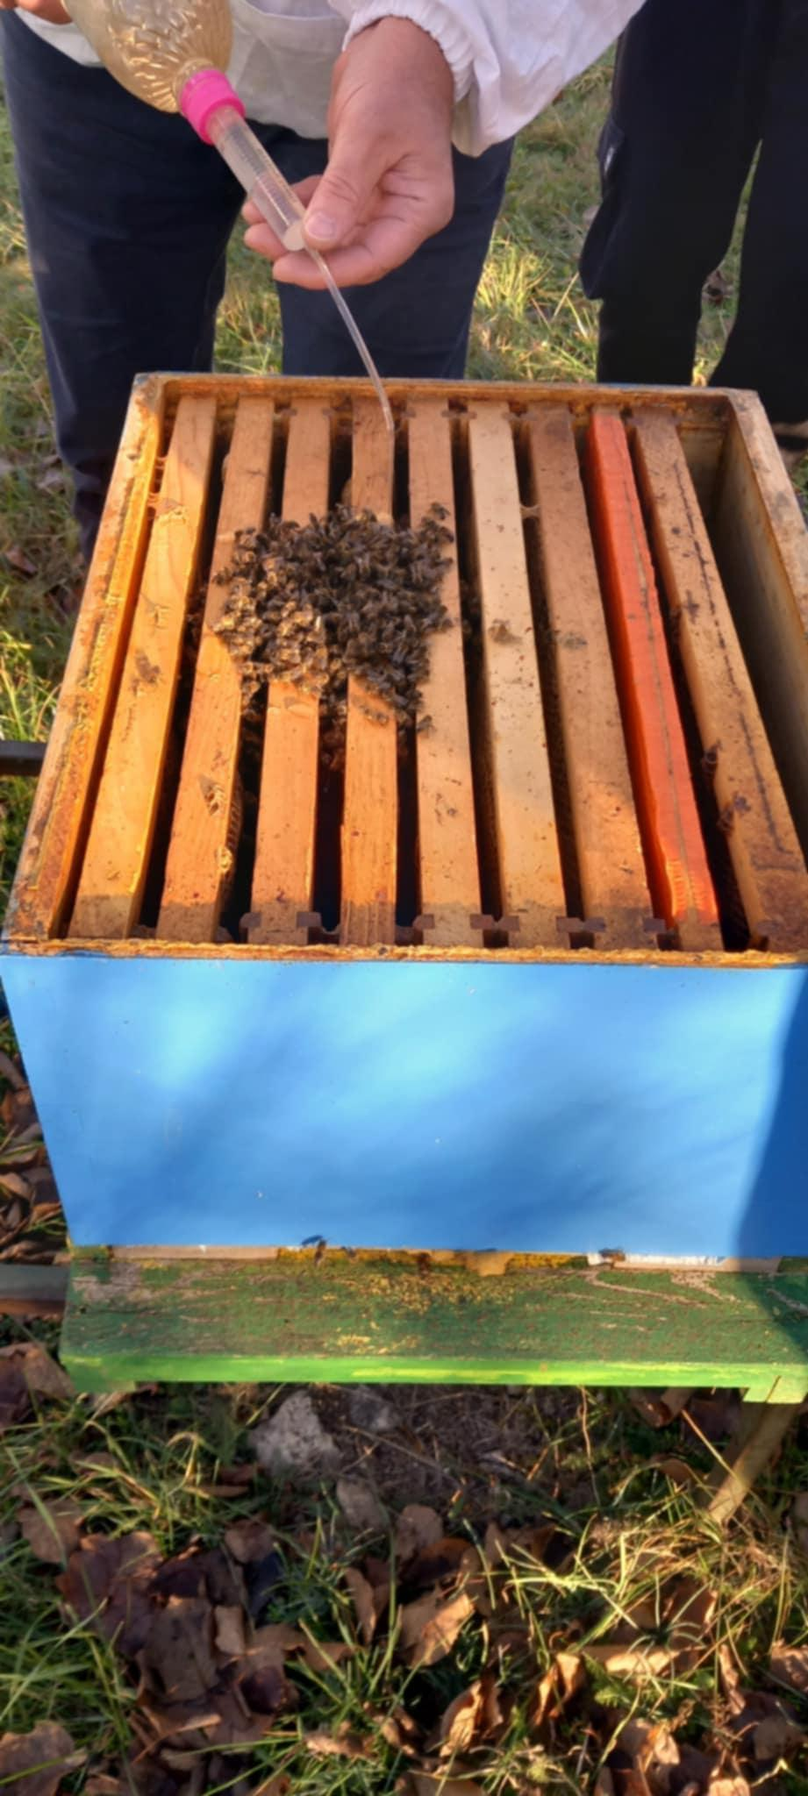

Guiding Questions / Class Discussion:
- Why is honey often described as the “battery” or fuel source of the hive?
- What risks arise if the winter cluster is disturbed when temperatures drop below 10°C?
- How does cluster movement relate to access to food stores?

Phase 2 – Exploration (Investigate & Compare)
Description:
In this phase, students investigate the “Three Big Killers” of winter colonies: starvation, moisture, and physical accidents. Through guided discussion and observation, students analyze how each factor contributes to winter losses and how they often interact.The concept of starvation is explored beyond the absence of honey, highlighting situations where food is present but inaccessible due to cluster position or cold conditions. Students practice the Heft Test by gently lifting the back of a hive to estimate its weight and compare healthy hives with sufficient stores to those at risk of starvation.Moisture is examined as a silent but deadly threat. Students learn about the “Cold Shower Effect,” where warm, moist air from bee respiration rises, condenses on a cold hive lid, and drips back onto the cluster, causing chilling and death. Physical threats such as wind damage, tipped hives, falling branches, livestock interference, and wildlife (e.g., mice) are also discussed.

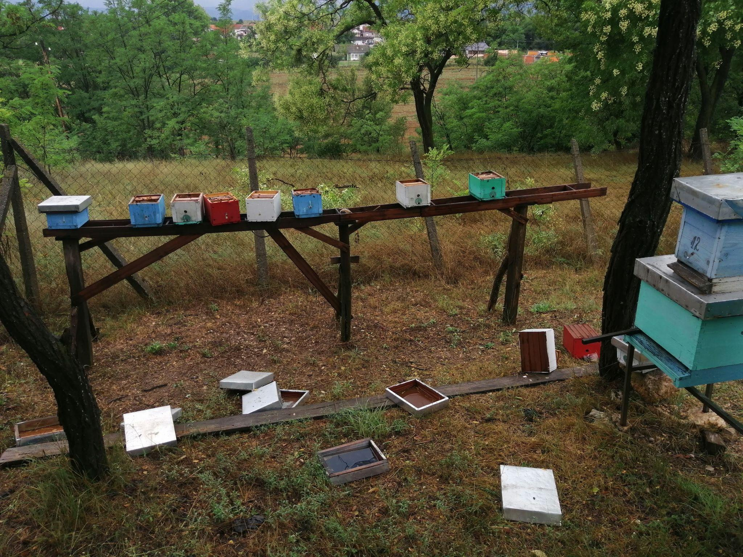

Guiding Questions / Class Discussion:
- Why can a colony starve even when honey is still present in the hive?
- How does poor ventilation increase moisture-related losses?
- Which of the three killers is hardest to detect without inspection tools?
Short Reading or Infographic:
The "Cold Shower" effect—how warm bee breath meets a cold lid to create lethal condensation.
Group Work Activity:
Small groups analyze case-study photos of winter hives and identify which “killer” is most likely responsible for colony failure.

Phase 3 – Application (Hands-On Practice)

Hands-On Activity:
      - Physical Security:Students apply their knowledge through practical winter preparation and inspection activities. First, they focus on physical security, learning how to stabilize hives using ratchet straps to prevent wind damage or tipping. Students also install metal mouse guards to protect colonies from rodents seeking warmth and food.
      - Drone Inspection: Next, students participate in a drone-assisted inspection using a DJI drone. After a simulated “storm scenario,” the drone is flown over the apiary to identify toppled hives, shifted lids, blocked entrances, or environmental hazards such as fallen branches or flooding risks. Emphasis is placed on safe flight procedures, ethical use, and maintaining distance to avoid disturbing the bees.Students compare drone-based observations with traditional ground-level inspections, discussing advantages and limitations of each method.
Video:

https://drive.google.com/file/d/1kBS92iVraNTBNhYoMKlL5Hzr9eTnZalO/view?usp=drive_link

Phase 4 – Reflection & Consolidation (Present & Connect)
Group Presentations
Student groups present an “Emergency Plan B” for a hive identified as light on stores during winter. Plans may include intervention methods such as the Mountain Camp Method (dry sugar feeding), insulation improvements, or repositioning hives for better protection. Students must justify their choices based on environmental conditions and risk factors.
Class Discussion:
The class engages in a guided discussion comparing remote monitoring using drones with traditional hands-on winter management. Students evaluate how drone inspections can reduce colony disturbance, improve response time after storms, and increase overall winter survival rates, while also recognizing situations where physical intervention remains necessary.

Reflection Activity:
Students individually write a short reflection or learning log describing what they learned about winter colony survival, which risk factor they consider most critical, and how technology such as drones can support sustainable and responsible beekeeping practices. They are encouraged to connect the lesson to broader themes of animal welfare, environmental stewardship, and innovation in agriculture.

Assessment Criteria
Quizzes with closed or open questions:
Short formative and summative quizzes are used to assess students’ understanding of key concepts related to winter colony survival. Closed questions (multiple choice / true–false) evaluate knowledge of thermocluster formation, optimal winter temperatures, and the “Three Big Killers” (starvation, moisture, physical damage). Open questions require students to explain cause–effect relationships, such as how moisture leads to colony loss or why non-invasive inspections are critical during winter.
Identification of winter pests and starvation signs
Students are assessed on their ability to correctly identify common winter threats, including rodents (mice), environmental hazards, and signs of starvation such as unusually light hives, dead bees head-first in cells, or clusters separated from food stores. Assessment is based on image analysis, field observation, and short written or oral explanations.
Self-assessment tools for individual reflection;
Students complete structured self-assessment checklists or reflection journals in which they evaluate their own learning progress, practical skills (e.g., applying the Heft Test, securing hives), and confidence in using drone technology responsibly. Reflection focuses on lessons learned, challenges encountered, and areas for further improvement
Peer review protocols for collaborative evaluation:
During group activities and presentations, students participate in peer review using predefined criteria. These include clarity of explanations, accuracy of winter management strategies, teamwork, and effective use of technology. Peer feedback encourages critical thinking, shared responsibility, and constructive communication.
Portfolios with selected outputs or documentation of learning process:
Each student or group compiles a learning portfolio containing selected outputs such as observation notes, emergency winter plans, diagrams, quiz results, and reflective entries. The portfolio demonstrates both theoretical understanding and practical application, documenting progress throughout the learning process.
Documentation of drone flight photos and videos from the apiary.Assessment includes the quality and relevance of drone-captured photos and videos used to document apiary conditions. Students are evaluated on safe flight execution, appropriate framing of images, correct identification of risks (e.g., toppled hives, blocked entrances), and the ability to interpret visual data to support winter management decisions.

Teaching Materials
1- Ratchet straps, mouse guards, 2:1 Syrup, Fondant, and hay bales.

