

Monitoring Volatile Organic Compounds (VOCs) in Horticultural Crops in Raised Beds Using Drones

FLIGHT RESOURCE CENTER

DSU RCSOO “Kiro Burnaz”


Table of Contents
Table of Contents 1
1. SHORT DESCRIPTION 2
(UP 3000 CHARACTERS) 2
2. TARGET 2
3. SUBJECT AREA 2
4. TYPE 2
5. DRONE USED 2
6. DURATION 3
7. LEARNING OBJECTIVES 3
8. KEY COMPETENCES DEVELOPED 3
1. Communication and Languages 3
2. Mathematical, Scientific, Technical and Professional Skills 3
3. Digital Competences 3
4. Personal, Social and Professional Competences 3
5. Safety, Quality and Sustainability 4
6. Citizenship and Cultural Competence 4
7. Creativity, Problem-Solving and Entrepreneurship 4
8. Work-Based Learning and Workplace Integration 4
9. Prior Knowledge / Prerequisites 4
10. Lesson/Project Outline 4
Phase 1 – Introduction (Engage & Contextualize) 4
Phase 2 – Exploration (Investigate & Compare) 4
Phase 3 – Application (Hands-On Practice) 5
Phase 4 – Reflection & Consolidation (Present & Connect) 5
11. Assessment Criteria 5
12. Teaching Materials 5
13. External Resources 5
14. References 6

SHORT DESCRIPTION

This lesson introduces students to the concept of volatile organic compounds (VOCs) emitted by plants, and their relevance in detecting plant stress and potential diseases. Students will use a custom drone equipped with sensors to monitor VOC emissions from horticultural crops onions and spinach grown in raised beds. The lesson emphasizes hands-on experience with drone flight, environmental monitoring, data collection, and interpretation. Students will learn to relate VOC levels to plant health indicators, such as growth rate, leaf color, and signs of stress. They will also explore environmental factors that influence VOC emissions, including temperature, humidity, and UV exposure. By the end of the lesson, students will be able to collect VOC data, interpret it, and discuss its implications for sustainable crop management.

TARGET
- 15
- 16
- 17
- 18
- Over 18

SUBJECT AREA
- Agriculture
- Disaster Response
- Constructions
- Water Management
- Environmental Protection
- Other

TYPE
- Lesson Plan
- Project
- Activity

DRONE USED
- Custom Drone
- Commercial drone (DJI)

DURATION
- 1 x 45-minute class
- 1 x 60-minute class
- 1 x 90-minute block
- 2 x 45-minute classes
- 2 x 60-minute classes
- Double session (2 × 60 minutes) optional project-based homework.

LEARNING OBJECTIVES
- Understand the role of VOCs in plant physiology and stress response
- Learn to operate drones equipped with environmental sensors to monitor VOCs in raised bed crops
- Analyze and interpret VOC data to detect stress or early signs of disease in onions and spinach
- Apply data-driven strategies to improve crop management and environmental awareness

KEY COMPETENCES DEVELOPED

1. Communication and Languages
- Literacy competence (understanding and producing written/oral texts)
- Communication in professional contexts
- Multilingual competence

2. Mathematical, Scientific, Technical and Professional Skills
- Mathematical competence
- Scientific, technological and engineering competence (STEM)
- Numeracy applied to work tasks
- Interpretation of technical information (manuals, diagrams, standards)
- Professional/technical skills
- Execution of practical tasks

3. Digital Competences
- Digital competence (general digital literacy)
- Use of digital tools in workplace settings

4. Personal, Social and Professional Competences
- Personal, social and learning-to-learn competence
- Teamwork and collaboration
- Autonomy and responsibility
- Work ethics and professional behaviour
- Adaptability and flexibility
- Cooperation with supervisors and colleagues

5. Safety, Quality and Sustainability
- Application of health and safety standards (OHS/SST)
- Quality procedures and workplace norms
- Environmental and sustainability awareness

6. Citizenship and Cultural Competence
- Citizenship competence
- Cultural awareness and expression competence

7. Creativity, Problem-Solving and Entrepreneurship
- Problem-solving and critical thinking
- Entrepreneurship competence
- Initiative and creativity
- Decision-making in real work situations

8. Work-Based Learning and Workplace Integration
- Integration into workplace routines
- Following professional instructions and procedures
- Use of tools, equipment and technology

This checklist merges the EU Key Competences for Lifelong Learning with the core competences expected in European Vocational Education and Training (VET).

Prior Knowledge / Prerequisites
Students should have a basic understanding of plant physiology, particularly how plants respond to stress and disease. Familiarity with environmental monitoring concepts, including temperature, humidity, and air quality, is helpful. Students should know the basics of drone operation, including safety protocols and simple navigation. Prior experience with data collection or graph interpretation is an advantage but not mandatory.

Lesson/Project Outline

Phase 1 – Introduction (Engage & Contextualize)

In this phase, students are introduced to Volatile Organic Compounds (VOCs) and their role in plant physiology. VOCs are natural chemicals emitted by plants in response to environmental conditions, stress, or potential pathogens. Students will learn that monitoring VOCs provides early indicators of plant stress or disease, often before visual symptoms appear.
The instructor will present the concept of raised beds and explain the environmental factors that can influence VOC emissions, such as temperature, humidity, UV radiation, air quality, and soil conditions. Students will understand why onions and spinach are chosen as examples of horticultural crops and how their VOC emissions differ based on stress levels and plant type.
Additionally, this phase will cover how drones equipped with sensors (BME680 for VOCs, PM2.5 sensor, CO sensor, and UV sensor) can collect real-time environmental and plant health data. Students will be introduced to the workflow: planning drone flights, placing sensors, recording VOCs, and linking the data to plant health indicators.

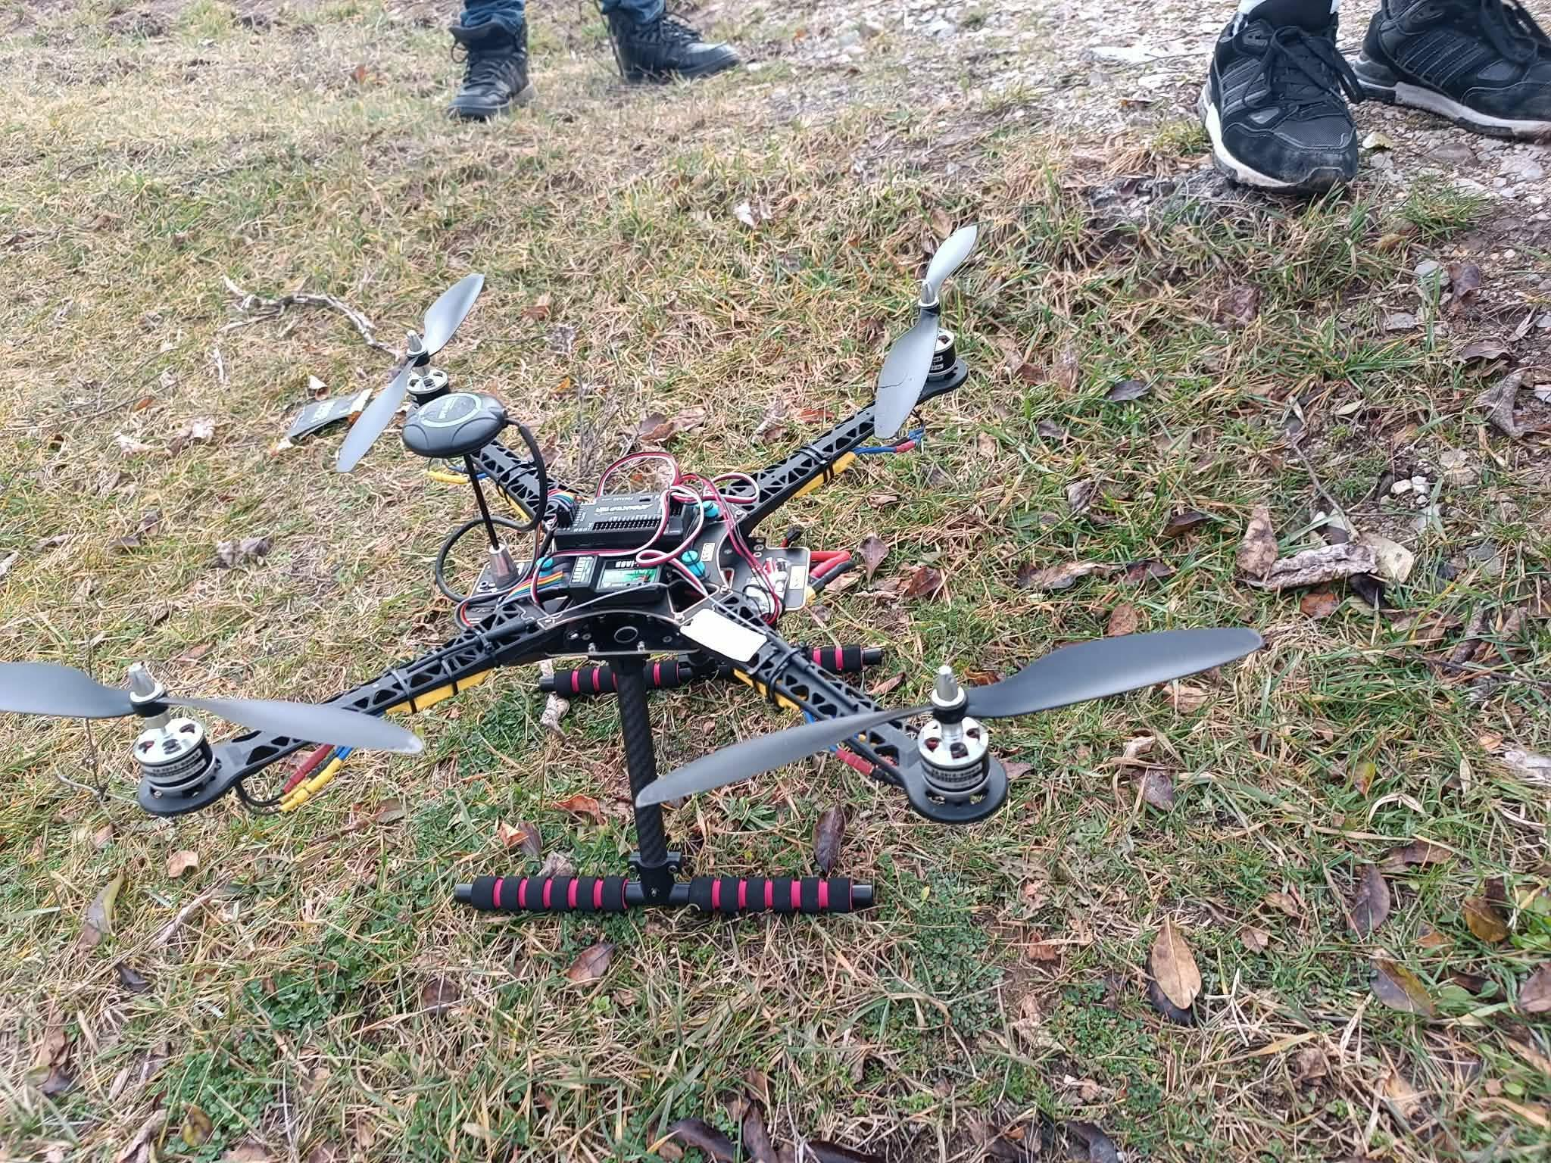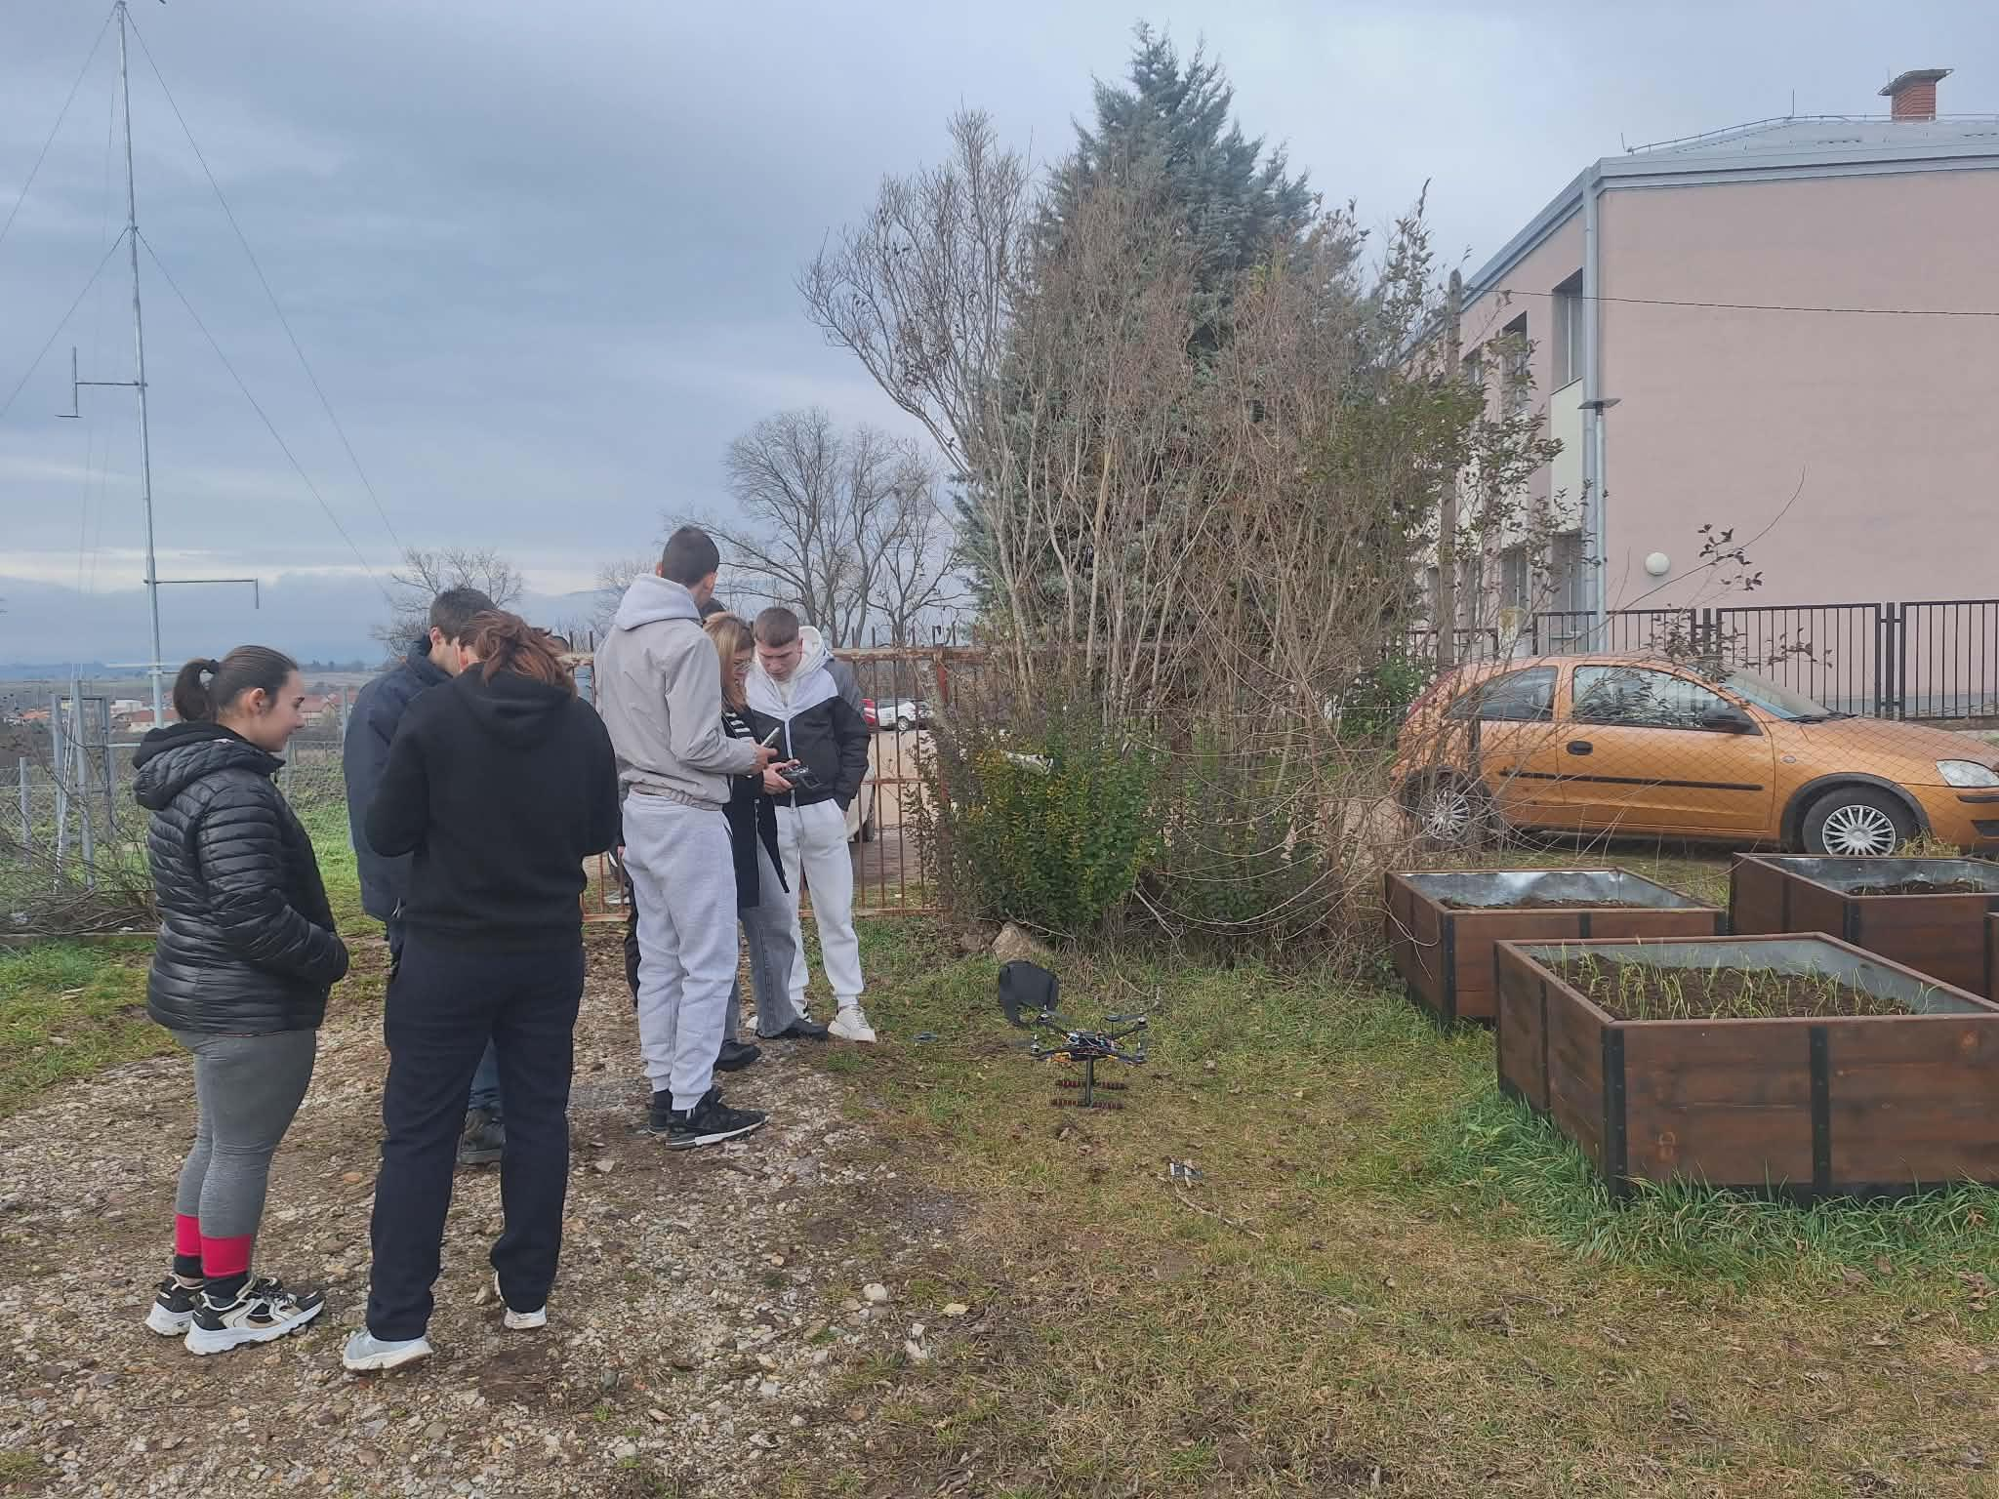

Guiding Questions / Class Discussion:

- What are VOCs, and why do plants emit them?
- How can VOCs help us detect plant stress or disease before visible signs appear?
- Which environmental factors might increase or decrease VOC emission in raised bed crops?
- How can technology like drones and sensors improve our understanding of crop health?
- Why might onions emit higher VOCs compared to spinach under similar conditions?

Phase 2 – Exploration (Investigate & Compare)

In this phase, students focus exclusively on Volatile Organic Compounds (VOCs) as indicators of plant physiological activity and stress in horticultural crops grown in raised beds.
Using the drone equipped with the BME680 sensor (VOC function only), students collect VOC readings above different sections of the raised beds. The purpose is to observe how VOC levels vary between plant areas and over time, and to interpret what these variations might indicate about plant condition.
The instructor explains that plants naturally emit VOCs as part of:
- Normal metabolic processes
- Defense mechanisms against pests or pathogens
- Stress responses (water stress, mechanical damage, disease)
Students learn that:
- Higher VOC readings may indicate increased plant activity or stress response.
- Gradual increases may suggest mild or developing stress.
- Sudden spikes may indicate acute stress or plant damage.
- Stable VOC levels may reflect healthy and balanced plant conditions.
Students compare:
- VOC levels in different raised beds
- VOC readings from different days
- Areas with visible plant differences (if any)

Photo/Diagram:
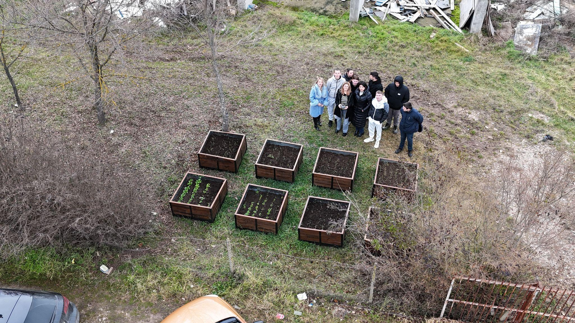

Guiding Questions / Class Discussion:
- Which raised bed shows the highest VOC emission?
- Are VOC levels stable, gradually increasing, or sharply rising?
- What could explain differences between beds?
- Could higher VOC levels indicate plant stress? Why?
- How can VOC monitoring help detect problems early?

Short Reading or Infographic:
Infographic showing VOCs as indicators of plant stress

IGroup Work Activity:
Students work in small groups to:
- Analyze the VOC data collected by the drone.
- Identify which raised bed may be under stress.
- Create a simple graph showing VOC trends over time.
- Provide a short explanation of their interpretation.
Each group prepares a brief summary for presentation in Phase 4

Phase 3 – Application (Hands-On Practice)
Hands-On Activity:
Students fly the drone over the raised beds following a predefined grid pattern.
Collect VOC data with the BME680 sensor, and environmental data with other sensors (temperature, humidity).
Record and analyze the data in small groups, comparing results between crops and bed sections.

Video:

DJI_20260206103756_0149_D.MP4

Photo/Diagram:

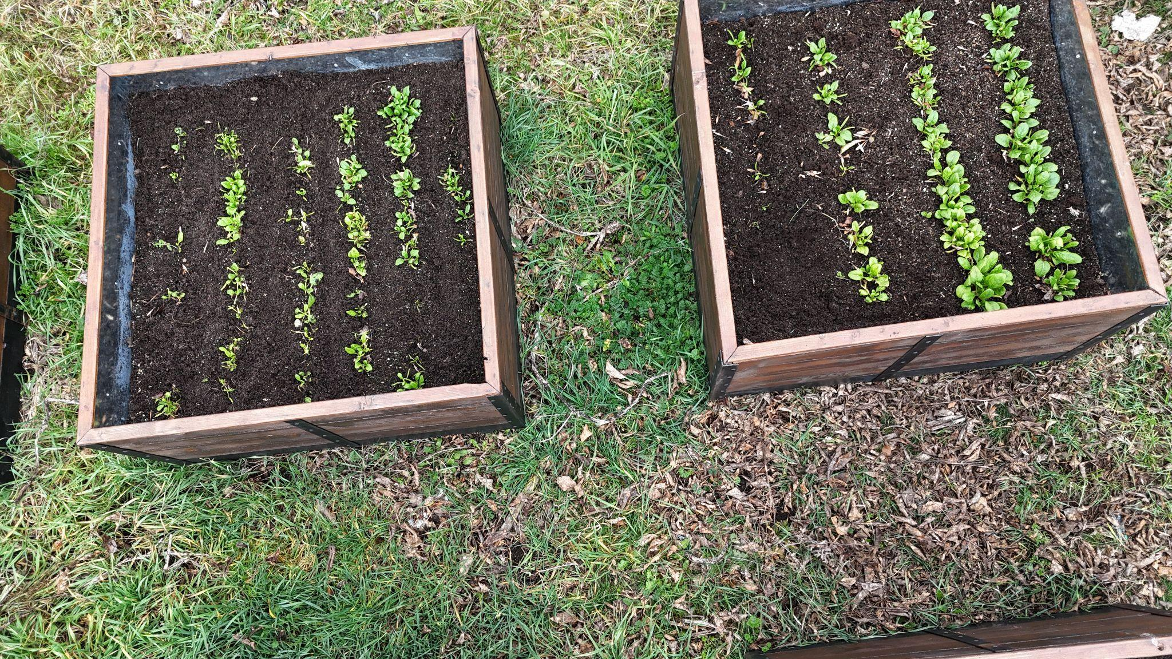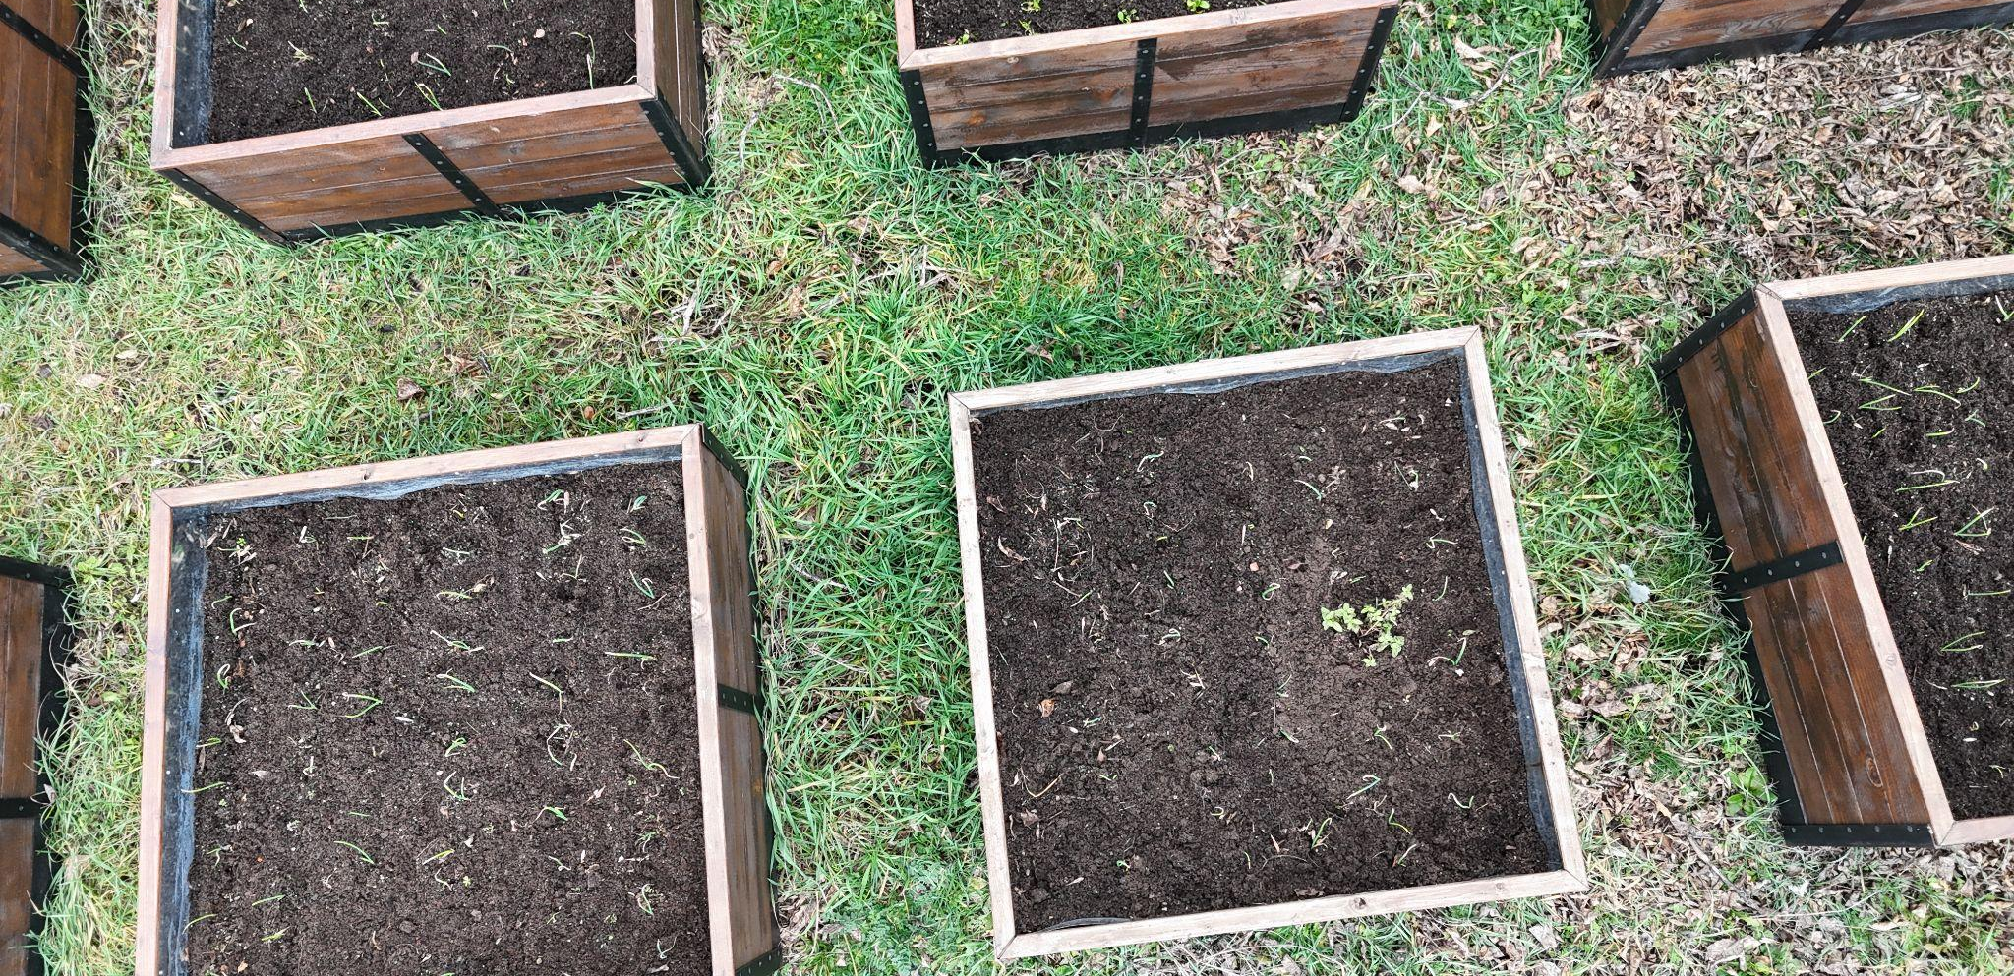

Phase 4 – Reflection & Consolidation (Present & Connect)

Groups present findings on VOC levels, possible stress areas, and suggestions for improved crop management.
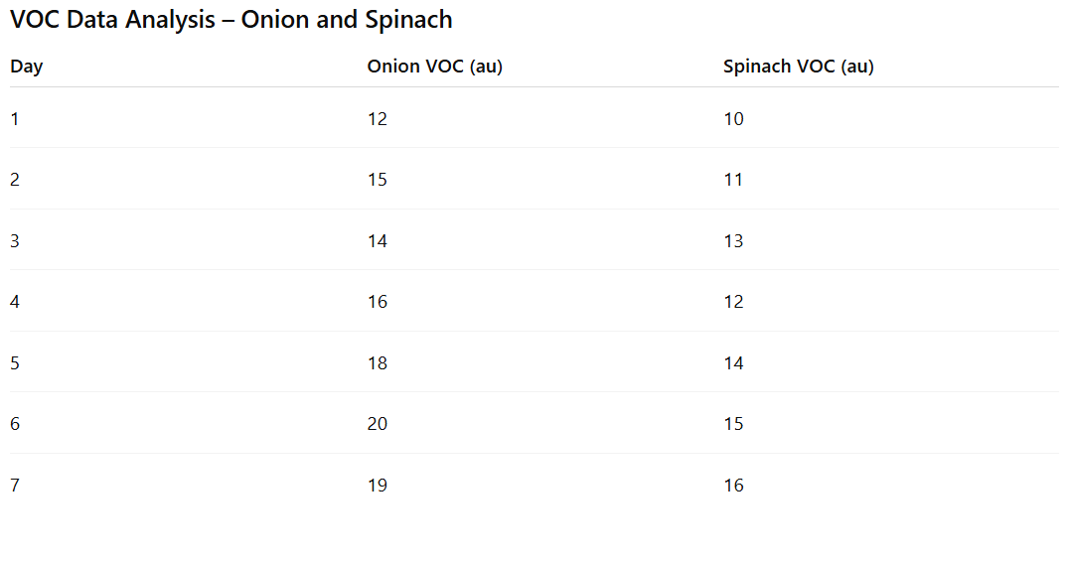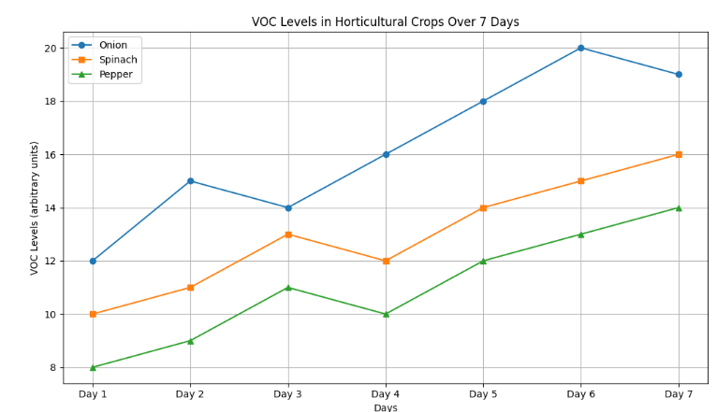

Group Presentations
Each group presents:Groups present findings on VOC levels, possible stress areas, and suggestions for improved crop management.
Class Discussion:
Compare VOC readings with expected results.
Discuss potential interventions to reduce stress and improve crop health.
- VOC Increase Over Time: Both crops show rising VOC levels over 7 days; onion generally higher than spinach.
- Crop Comparison: Onion emits more VOCs, indicating it is more sensitive to environmental stress.
- Fluctuations: Minor variations are normal, likely due to temperature, humidity, or UV changes.
- Plant Health: Higher VOCs may indicate stress or defense responses. Gradual increase suggests mild stress; sudden spikes could indicate severe stress or disease.
Conclusion: Onion shows stronger stress response than spinach. Monitoring VOCs helps detect stress or potential problems before visible symptoms appear.
Reflection Activity:
Students coStudents write a short reflection on how VOC monitoring could improve sustainable agriculture practices.

Assessment Criteria
Quizzes with closed or open questions:
Quizzes (Knowledge Check):
- Short quizzes with open and closed questions covering:
  - What VOCs are and their role in plants
  - Effects of stress factors (temperature, humidity, UV) on VOC emission
  - Basics of drone and sensor operation
- Checks individual understanding of both theory and practical application

Self-assessment tools for individual reflection;

Students complete a short self-assessment reflecting on:
- Their ability to operate the drone and sensors
- How they analyzed and interpreted VOC data
- What they learned about plant health and crop management

Peer review protocols for collaborative evaluation:

Groups evaluate other groups’ presentations and analyses
Discussion points include:
- Clarity of data presentation
- Logical interpretation of results
- Suggestions for improving data collection or presentation

Portfolios with selected outputs or documentation of learning process:

Includes all data, graphs, flight photos, group presentations, and reflection activities
Evaluation based on completeness and quality of documentation

Teaching Materials
Resource | Link
Drone with FLIGHT kit sensors (BME680)
PowerPoint presentation and sensor diagrams
Field data collection worksheets
Safety guidelines for drone operation
Internet access and basic classroom supplies (flipchart, markers)

