

Visible Marine Macro-Litter Mapping at Praia da Arda

FLIGHT RESOURCE CENTER

Sucessos Criativos

Table of Contents

1. SHORT DESCRIPTION 3
2. TARGET 3
3. SUBJECT AREA 3
4. TYPE 3
5. DRONE USED 3
6. DURATION 3
7. LEARNING OBJECTIVES 4
8. KEY COMPETENCES DEVELOPED 4
1. Communication and Languages 4
2. Mathematical, Scientific, Technical and Professional Skills 4
3. Digital Competences 4
4. Personal, Social and Professional Competences 4
5. Safety, Quality and Sustainability 5
6. Citizenship and Cultural Competence 5
7. Creativity, Problem-Solving and Entrepreneurship 5
8. Work-Based Learning and Workplace Integration 5
9. Prior Knowledge / Prerequisites 5
10. Lesson/Project Outline 6
Phase 1 – Introduction (Engage & Contextualize) 6
Phase 2 – Exploration (Investigate & Compare) 6
Phase 3 – Application (Hands-On Practice) 7

Phase 4 – Reflection & Consolidation (Present & Connect) 8
11. Assessment Criteria 8
12. Teaching Materials 9
13. External Resources 10
14. References 10

SHORT DESCRIPTION
Viana do Castelo's environmental monitoring programme identifies Praia da Arda as a marine-litter monitoring beach. This project coordinates low-altitude RGB mapping of a candidate 100 m section with a ground survey. The exact municipal monitoring segment must be confirmed before fieldwork. Students use a DJI Mavic 3 Enterprise to map visible macro-litter candidates, validate them on the ground and produce a hotspot map. RGB imagery does not detect all items, microplastics, chemical contamination or water-quality conditions.

TARGET
- 15
- 16 X
- 17 X
- 18 X
- Over 18 X

SUBJECT AREA
- Agriculture
- Disaster Response
- Constructions
- Water Management X
- Environmental Protection X
- Other

TYPE
- Lesson Plan
- Project X
- Activity

DRONE USED
- Custom Drone
- Commercial drone (DJI) X

DURATION
- 1 x 45-minute class
- 1 x 60-minute class
- 1 x 90-minute block
- 2 x 45-minute classes
- 2 x 60-minute classes
- Double session (2 × 60 minutes) optional project-based homework. X

LEARNING OBJECTIVES
O1: Describe the Portuguese marine-litter context at Praia da Arda and the value of standardised beach observation.
O2: Explain which visible macro-litter items may be documented with low-altitude RGB imagery and why detection remains incomplete.
O3: Plan a safe, repeatable 100 m beach survey integrating aerial coverage and ground validation.
O4: Create an orthomosaic, ground-validated litter point layer, subsection counts and a hotspot map.
O5: Communicate detection limits and avoid claims about microplastics, chemistry, source or complete absence.

KEY COMPETENCES DEVELOPED

1. Communication and Languages
- Literacy competence (understanding and producing written/oral texts) X
- Communication in professional contexts X
- Multilingual competence

2. Mathematical, Scientific, Technical and Professional Skills
- Mathematical competence X
- Scientific, technological and engineering competence (STEM) X
- Numeracy applied to work tasks X
- Interpretation of technical information (manuals, diagrams, standards) X
- Professional/technical skills X
- Execution of practical tasks X

3. Digital Competences
- Digital competence (general digital literacy) X
- Use of digital tools in workplace settings X

4. Personal, Social and Professional Competences
- Personal, social and learning-to-learn competence X
- Teamwork and collaboration X
- Autonomy and responsibility X
- Work ethics and professional behaviour X
- Adaptability and flexibility X
- Cooperation with supervisors and colleagues

5. Safety, Quality and Sustainability
- Application of health and safety standards (OHS/SST) X
- Quality procedures and workplace norms X
- Environmental and sustainability awareness X

6. Citizenship and Cultural Competence
- Citizenship competence X
- Cultural awareness and expression competence

7. Creativity, Problem-Solving and Entrepreneurship
- Problem-solving and critical thinking X
- Entrepreneurship competence
- Initiative and creativity X
- Decision-making in real work situations X

8. Work-Based Learning and Workplace Integration
- Integration into workplace routines
- Following professional instructions and procedures X
- Use of tools, equipment and technology X
This checklist merges the EU Key Competences for Lifelong Learning with the core competences expected in European Vocational Education and Training (VET).

Prior Knowledge / Prerequisites
- Basic knowledge of marine litter and beach environments.
- Basic map and image-reading skills.
- Introductory spreadsheet and GIS skills.
- Drone-safety awareness and ability to work in coordinated aerial and ground teams.

Lesson/Project Outline

Phase 1 – Introduction (Engage & Contextualize)
Show the contextual photograph of Praia da Arda and locate the beach in Viana do Castelo. Students describe the visible beach setting without inferring any litter condition from the image.
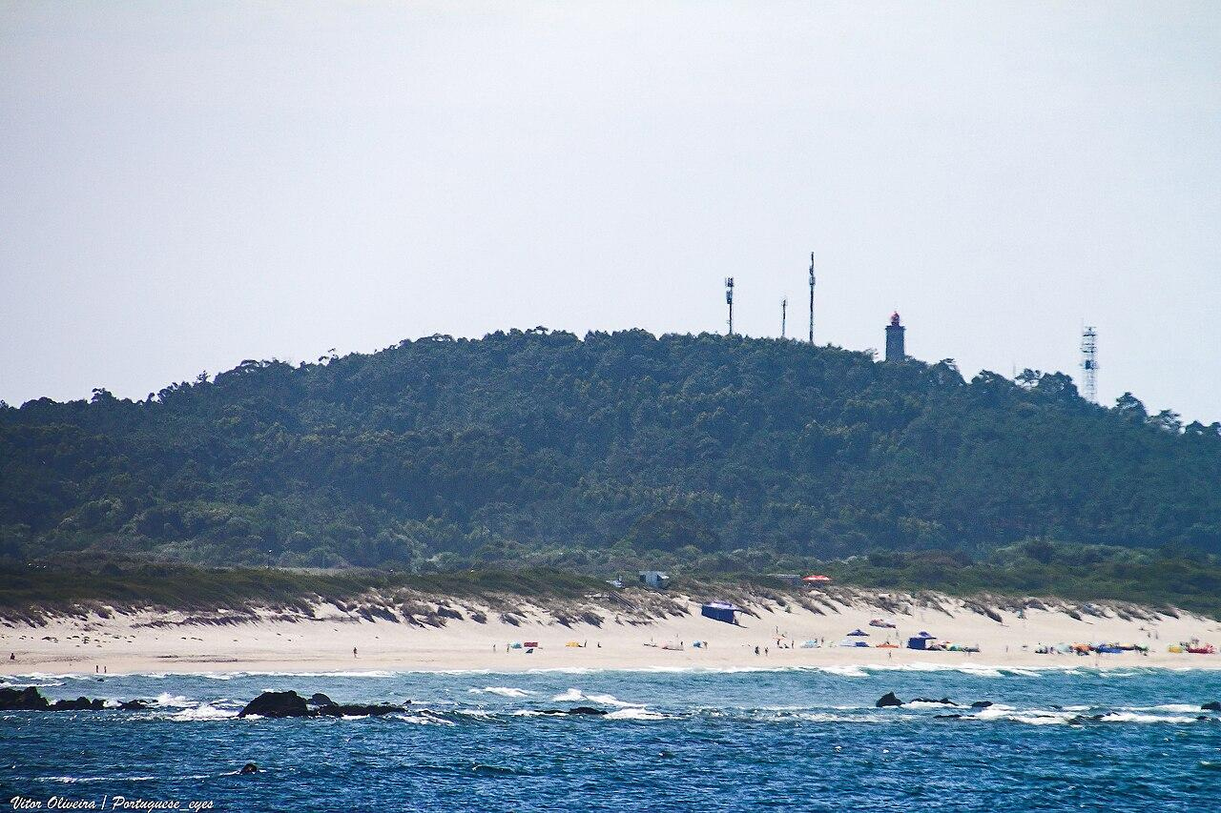
Read the municipal monitoring information and establish that Praia da Arda is named in a real local marine-litter programme.
Compare visible macro-litter examples with small, buried, low-contrast or obscured items likely to be missed in aerial RGB imagery.
Discuss why microplastics, dissolved pollutants, microbiological contamination and water chemistry are outside the capability of the standard RGB camera.
Expected student outputs
- A capability-and-limits chart for aerial RGB beach-litter observation.

Phase 2 – Exploration (Investigate & Compare)
Examine the route map for the candidate 100 m section. The approximately 410 m grid is not a flight authorisation and has not been flown.
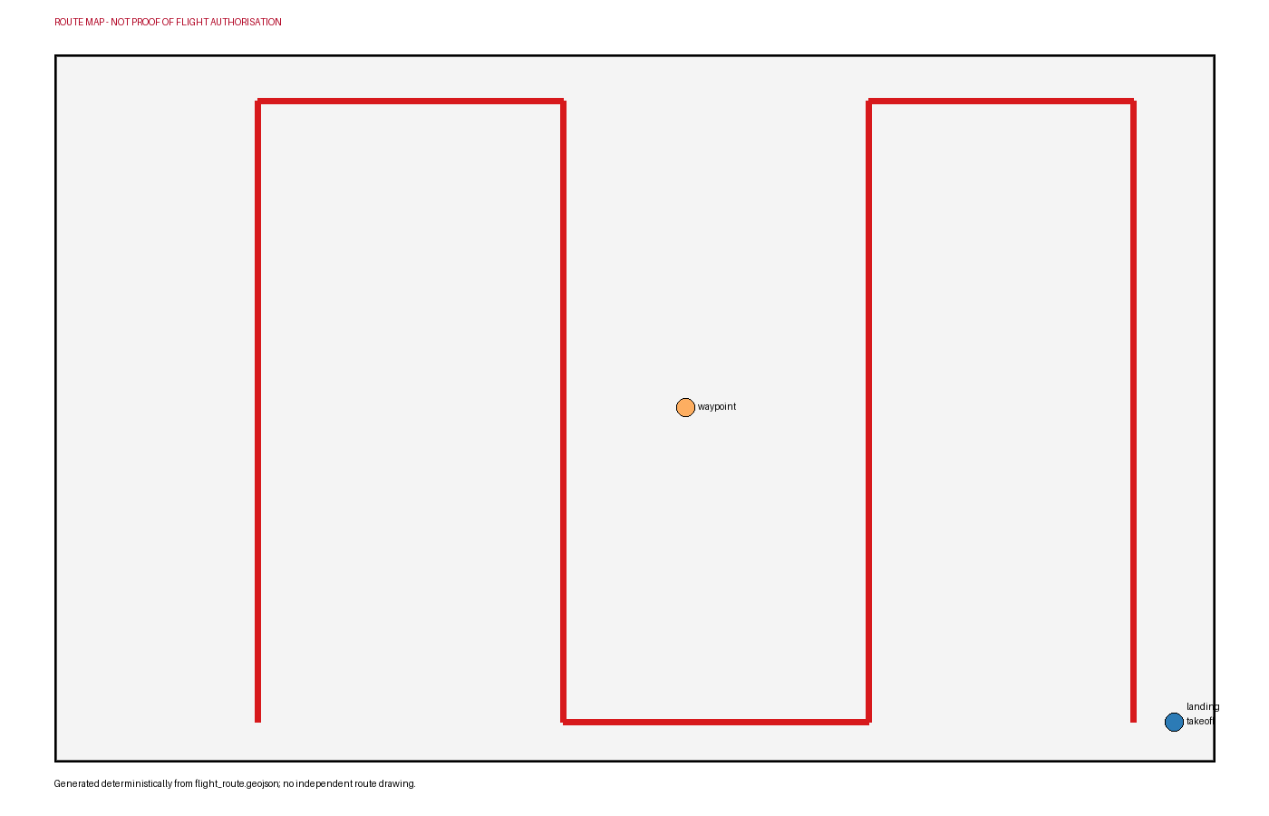
Relate the proposed 25 m AGL survey, approximately 80% forward overlap and 70% side overlap to object visibility and complete beach coverage.
Divide the 100 m section into four 25 m subsections and prepare a consistent candidate-object naming and position method.
Plan the coordinated ground check: observers confirm visible candidates, classify items using the agreed method and record aerial misses without moving objects solely for the image.
Review tide, beach users, wildlife, wind, takeoff area and current aviation/image-capture permissions. Identify all abort conditions.
Expected student outputs
- An annotated route, 25 m subsection plan and coordinated ground-validation method.

Phase 3 – Application (Hands-On Practice)
Confirm the exact 100 m segment with CMIA or the responsible authority and obtain all required site and operational permissions.
Assign pilot, observer, safety lead, ground-survey pairs and data manager roles. Establish a controlled takeoff area and keep uninvolved people outside the operating area.
If conditions allow, acquire consistent nadir RGB photographs along the approved grid while maintaining visual line of sight and safe separation.
Ground teams walk the agreed section after or outside the flight operation, validate candidate objects and record item class, position, subsection and whether the aerial review detected it.
Quality-check and process accepted imagery into an orthomosaic. Digitise only ground-validated visible macro-litter candidates and retain missed or uncertain detections in the audit table.
Calculate counts by category and 25 m subsection, compare aerial detections with ground records and compose a hotspot map with a clear detection-limit statement.
Expected student outputs
- An orthomosaic if image quality permits, a ground-validated litter point layer, category table, detection audit and hotspot map.

Phase 4 – Reflection & Consolidation (Present & Connect)
Teams present the orthomosaic, validation table, category summary and hotspot map.
Compare which item sizes, colours and positions were easy or difficult to detect and explain why non-detection is not proof of absence.
Peer reviewers check that no result is described as chemical, microbiological or microplastic measurement.
Design a repeat survey using the same segment, subsections, tide window, altitude, classification and ground-validation method.
Expected student outputs
- A monitoring poster and reflection explaining detection limits and repeatability.

Assessment Criteria
- The student explains the verified local monitoring context and the limits of RGB observation.
- The student plans the 100 m route, subsections and aerial/ground coordination accurately.
- The student follows safe operating roles and responds appropriately to people, wildlife, tide and weather.
- The student links every mapped candidate to a ground-validation record and preserves uncertain or missed detections.
- The student produces clear category, subsection and hotspot outputs without unsupported contamination claims.
- The student reflects on detection bias and proposes a comparable repeat survey.

Teaching Materials
Resource | Link
CMIA Viana do Castelo – Marine Litter Environmental Indicator | https://ambiente.cm-viana-castelo.pt/indicadores-ambientais/lixo-marinho
OSPAR – Beach Litter Monitoring and Assessment | https://www.ospar.org/work-areas/eiha/marine-litter/assessment-of-marine-litter/beach-litter
OSPAR – CEMP Guidelines for Marine Litter Monitoring on Beaches | https://www.ospar.org/documents?v=44122
OpenDroneMap – Orthophoto Processing and Outputs | https://docs.opendronemap.org/outputs/
QGIS Training Manual – Vector Data, Spatial Analysis and Map Layout | https://docs.qgis.org/latest/en/docs/training_manual/index.html

External Resources
Resource | Link
Indicador ambiental: lixo marinho | https://ambiente.cm-viana-castelo.pt/indicadores-ambientais/lixo-marinho
Relatorio de Monitorizacao de Lixo Marinho 2019 | https://ambiente.cm-viana-castelo.pt/download/indicadores-ambientais/lixo-marinho/2019/Relatorio%20Monitorizacao%20Lixo%20Marinho%202019.pdf
Using unmanned aerial systems for marine macro-litter mapping | https://www.mdpi.com/2072-4292/12/16/2599
OSPAR beach litter monitoring guideline | https://www.ospar.org/documents?v=44122
Portugal UAS geographical-zone map | https://dnt.anac.pt/mapa.html
Aeronaves nao tripuladas (drones) | https://www.aan.pt/subPagina-AAN-001.005.005-aeronaves-n-o-tripuladas-drones

References
CMIA / Municipio de Viana do Castelo. Indicador ambiental: lixo marinho. https://ambiente.cm-viana-castelo.pt/indicadores-ambientais/lixo-marinho
CMIA / Municipio de Viana do Castelo. Relatorio de Monitorizacao de Lixo Marinho 2019. https://ambiente.cm-viana-castelo.pt/download/indicadores-ambientais/lixo-marinho/2019/Relatorio%20Monitorizacao%20Lixo%20Marinho%202019.pdf
OpenStreetMap contributors. OpenStreetMap Praia da Arda record. https://www.openstreetmap.org/search?query=Praia%20da%20Arda%2C%20Portugal
DJI. DJI Mavic 3 Enterprise specifications. https://enterprise.dji.com/mavic-3-enterprise/specs
Remote Sensing (MDPI). Using unmanned aerial systems for marine macro-litter mapping. https://www.mdpi.com/2072-4292/12/16/2599
OSPAR Commission. Beach litter indicator assessment. https://oap.ospar.org/en/ospar-assessments/quality-status-reports/qsr-2023/indicator-assessments/beach-litter/
OSPAR Commission. OSPAR beach litter monitoring guideline. https://www.ospar.org/documents?v=44122
Autoridade Nacional da Aviacao Civil. Portugal UAS geographical-zone map. https://dnt.anac.pt/mapa.html
Autoridade Aeronautica Nacional. Aeronaves nao tripuladas (drones).

