

Multispectral Vineyard Variability Mapping near INIAV Dois Portos

FLIGHT RESOURCE CENTER

Sucessos Criativos

Table of Contents

1. SHORT DESCRIPTION 3
2. TARGET 3
3. SUBJECT AREA 3
4. TYPE 3
5. DRONE USED 3
6. DURATION 3
7. LEARNING OBJECTIVES 4
8. KEY COMPETENCES DEVELOPED 4
1. Communication and Languages 4
2. Mathematical, Scientific, Technical and Professional Skills 4
3. Digital Competences 4
4. Personal, Social and Professional Competences 4
5. Safety, Quality and Sustainability 5
6. Citizenship and Cultural Competence 5
7. Creativity, Problem-Solving and Entrepreneurship 5
8. Work-Based Learning and Workplace Integration 5
9. Prior Knowledge / Prerequisites 5
10. Lesson/Project Outline 6
Phase 1 – Introduction (Engage & Contextualize) 6
Phase 2 – Exploration (Investigate & Compare) 6
Phase 3 – Application (Hands-On Practice) 7

Phase 4 – Reflection & Consolidation (Present & Connect) 8
11. Assessment Criteria 8
12. Teaching Materials 9
13. External Resources 10
14. References 10

SHORT DESCRIPTION
INIAV's Dois Portos pole at Quinta da Almoinha has verified viticulture and precision-agriculture functions. A nearby mapped vineyard supplies a candidate survey geometry, but its ownership and availability as an institutional teaching block must be confirmed before fieldwork. Students use a standard DJI Mavic 3 Multispectral—with factory-integrated RGB, green, red, red-edge and near-infrared cameras—to map relative canopy variability. NDVI and NDRE outputs help prioritise ground observation; they do not diagnose disease, water stress, nutrient status or yield.

TARGET
- 15
- 16 X
- 17 X
- 18 X
- Over 18 X

SUBJECT AREA
- Agriculture X
- Disaster Response
- Constructions
- Water Management
- Environmental Protection
- Other

TYPE
- Lesson Plan
- Project X
- Activity

DRONE USED
- Custom Drone
- Commercial drone (DJI) X

DURATION
- 1 x 45-minute class
- 1 x 60-minute class
- 1 x 90-minute block
- 2 x 45-minute classes
- 2 x 60-minute classes
- Double session (2 × 60 minutes) optional project-based homework. X

LEARNING OBJECTIVES
O1: Explain how factory-integrated multispectral imaging can reveal relative spatial variability in vineyard canopy reflectance.
O2: Plan a systematic vineyard survey with appropriate overlap, consistent illumination and obstacle awareness.
O3: Process aligned RGB and multispectral imagery and calculate canopy-masked NDVI and NDRE using documented bands.
O4: Link variability zones to ground observations without diagnosing their agronomic cause from imagery alone.
O5: Produce a sampling-priority map and communicate uncertainty to a vineyard manager or researcher.

KEY COMPETENCES DEVELOPED

1. Communication and Languages
- Literacy competence (understanding and producing written/oral texts) X
- Communication in professional contexts X
- Multilingual competence

2. Mathematical, Scientific, Technical and Professional Skills
- Mathematical competence X
- Scientific, technological and engineering competence (STEM) X
- Numeracy applied to work tasks X
- Interpretation of technical information (manuals, diagrams, standards) X
- Professional/technical skills X
- Execution of practical tasks X

3. Digital Competences
- Digital competence (general digital literacy) X
- Use of digital tools in workplace settings X

4. Personal, Social and Professional Competences
- Personal, social and learning-to-learn competence X
- Teamwork and collaboration X
- Autonomy and responsibility X
- Work ethics and professional behaviour X
- Adaptability and flexibility X
- Cooperation with supervisors and colleagues

5. Safety, Quality and Sustainability
- Application of health and safety standards (OHS/SST) X
- Quality procedures and workplace norms X
- Environmental and sustainability awareness X

6. Citizenship and Cultural Competence
- Citizenship competence X
- Cultural awareness and expression competence

7. Creativity, Problem-Solving and Entrepreneurship
- Problem-solving and critical thinking X
- Entrepreneurship competence
- Initiative and creativity X
- Decision-making in real work situations X

8. Work-Based Learning and Workplace Integration
- Integration into workplace routines
- Following professional instructions and procedures X
- Use of tools, equipment and technology X
This checklist merges the EU Key Competences for Lifelong Learning with the core competences expected in European Vocational Education and Training (VET).

Prior Knowledge / Prerequisites
- Basic knowledge of vine canopy structure and vineyard rows.
- Basic understanding of reflectance and the purpose of green, red, red-edge and near-infrared bands.
- Introductory GIS and raster-data skills.
- Drone-safety awareness, with attention to trellis wires, poles, powerlines, workers and vehicles.

Lesson/Project Outline

Phase 1 – Introduction (Engage & Contextualize)
Use the Torres Vedras vineyard photograph to identify rows, headlands, canopy gaps and inter-row ground. Clarify that it is regional context rather than a photograph of the candidate block.
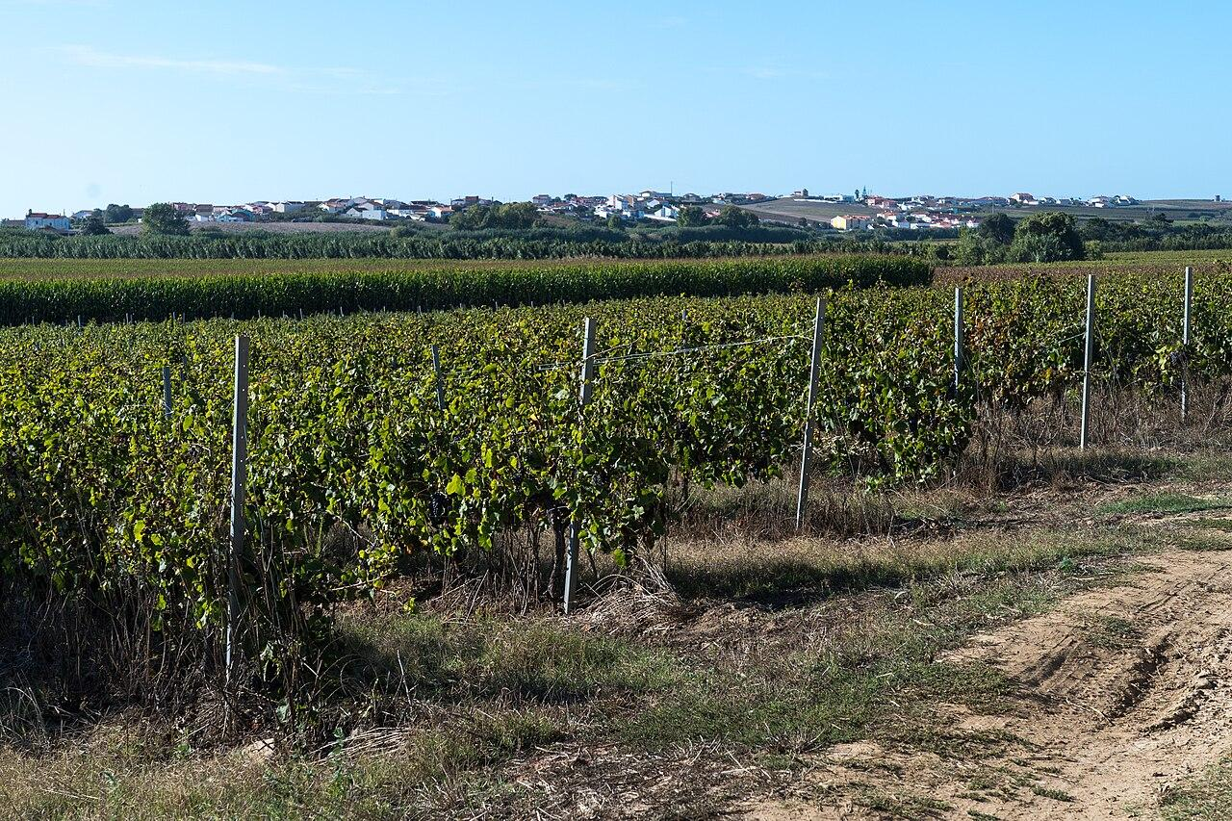

Introduce the verified viticulture and precision-agriculture role of INIAV Dois Portos and the need for institutional confirmation of the exact teaching parcel.
Compare RGB and multispectral observations. Explain that the DJI Mavic 3 Multispectral records green, red, red-edge and near-infrared bands with its standard cameras.
Discuss why relative spectral variability can guide inspection but cannot independently diagnose disease, water stress, nutrient deficiency or yield.
Expected student outputs
- A comparison chart explaining RGB, multispectral bands and the limits of vegetation indices.

Phase 2 – Exploration (Investigate & Compare)
Study the grid drawn within the mapped vineyard geometry. The approximately 520 m route is not a flight authorisation and has not been flown.
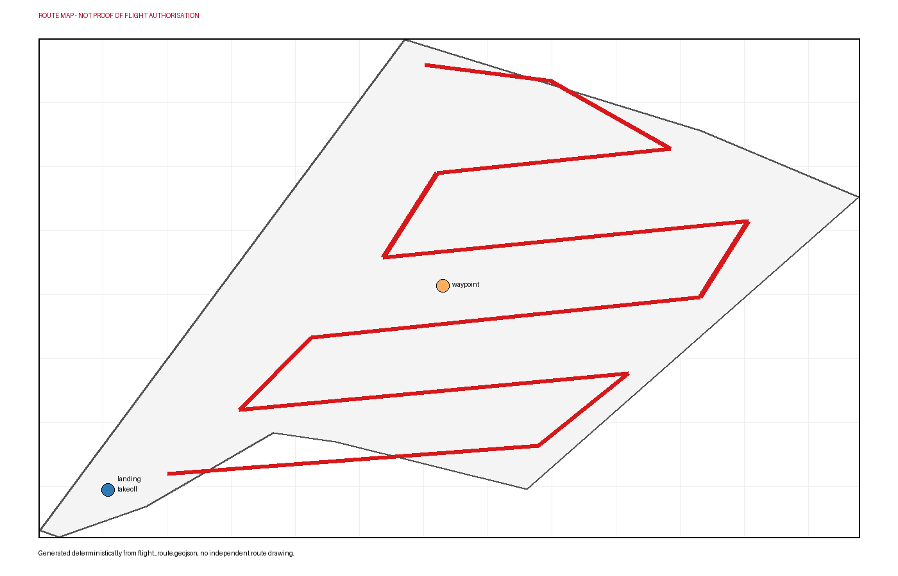

Relate the proposed 40 m AGL survey, approximately 80% forward overlap and 75% side overlap to row coverage and image alignment.
Identify likely obstacles and operating conflicts, including trellis wires, poles, powerlines, workers, vehicles and crop operations.
Plan consistent illumination and the manufacturer-supported pre/post radiometric workflow. Record timing, exposure, aircraft and calibration metadata.
Design a ground-observation sheet for canopy density, gaps and visible conditions without assigning a diagnosis before evidence is available.
Expected student outputs
- An annotated route, obstacle plan, capture settings and ground-observation design.

Phase 3 – Application (Hands-On Practice)
Confirm the actual survey block, land access, crop-operation timing and current aviation and image-capture conditions with INIAV or the landowner.
Assign pilot, observer, safety lead, ground-observation team and data manager roles. Inspect headland space, obstacles and people before flight.
If all conditions are met, acquire the factory-integrated RGB and multispectral image sets along the approved grid using consistent settings and illumination controls.
Copy and back up the original images, check completeness and alignment, and reject blurred, saturated or inconsistent captures with reasons.
Generate aligned RGB and multispectral orthomosaics. Mask inter-row soil and non-canopy areas before calculating NDVI and NDRE from the documented bands.
Divide the canopy into relative variability zones, calculate simple row or zone summaries and select ground-observation priorities. Do not attach an agronomic diagnosis to a spectral pattern without supporting evidence.
Expected student outputs
- Aligned orthomosaics if image quality permits, canopy-masked NDVI/NDRE maps, relative zones and a sampling-priority map.

Phase 4 – Reflection & Consolidation (Present & Connect)
Teams present the RGB view, canopy mask, NDVI/NDRE patterns, ground observations and sampling-priority map.
Peer reviewers check whether each interpretation is a measured index, a ground observation or an unsupported agronomic explanation.
Discuss how illumination, phenological timing, canopy masking, mixed pixels and processing choices affect repeatability.
Recommend a repeat-survey and ground-sampling design suitable for comparison with a later date.
Expected student outputs
- A manager-style briefing that separates spectral variability, ground observations and possible explanations requiring further evidence.

Assessment Criteria
- The student explains the supported capabilities of the DJI Mavic 3 Multispectral accurately.
- The student plans repeatable capture and identifies vineyard obstacles and operating conflicts.
- The student manages RGB and multispectral imagery and documents processing and masking choices.
- The student calculates and interprets relative NDVI/NDRE patterns without making unsupported diagnoses.
- The student links mapped zones to suitable ground-observation priorities.
- The student communicates uncertainty and proposes a comparable repeat survey.

Teaching Materials
Resource | Link
INIAV – Polo de Inovação de Dois Portos | https://www.iniav.pt/organica/polos-serv-desc/polo-dois-portos
INIAV – Coleção Ampelográfica Nacional | https://www.iniav.pt/can
DJI – Mavic 3 Multispectral Specifications | https://enterprise.dji.com/mavic-3-m/specs
OpenDroneMap – Multispectral Processing Guide | https://docs.opendronemap.org/multispectral/
Copernicus Browser – Sentinel-2 Multispectral and NDVI Exploration | https://browser.dataspace.copernicus.eu/

External Resources
Resource | Link
Colecao Ampelografica Nacional | https://www.iniav.pt/index.php?id=1745
Polo de Dois Portos | https://www.iniav.pt/organica/polos-serv-desc/polo-dois-portos
DJI Mavic 3 Multispectral specifications | https://enterprise.dji.com/mavic-3-m/specs
UAV-based multispectral monitoring in a Portuguese vineyard | https://www.mdpi.com/2073-4395/9/10/581
Portugal UAS geographical-zone map | https://dnt.anac.pt/mapa.html
Aeronaves nao tripuladas (drones) | https://www.aan.pt/subPagina-AAN-001.005.005-aeronaves-n-o-tripuladas-drones

References
Instituto Nacional de Investigacao Agraria e Veterinaria. Colecao Ampelografica Nacional. https://www.iniav.pt/index.php?id=1745
Instituto Nacional de Investigacao Agraria e Veterinaria. Polo de Dois Portos. https://www.iniav.pt/organica/polos-serv-desc/polo-dois-portos
OpenStreetMap contributors. OpenStreetMap vineyard way 1097464864. https://www.openstreetmap.org/way/1097464864
DJI. DJI Mavic 3 Multispectral specifications. https://enterprise.dji.com/mavic-3-m/specs
Biosystems Engineering / Elsevier. Assessment of vineyard vigour using UAV multispectral imagery. https://www.sciencedirect.com/science/article/pii/S1537511023001149
Agronomy (MDPI). UAV-based multispectral monitoring in a Portuguese vineyard. https://www.mdpi.com/2073-4395/9/10/581
Autoridade Nacional da Aviacao Civil. Portugal UAS geographical-zone map. https://dnt.anac.pt/mapa.html
Autoridade Aeronautica Nacional. Aeronaves nao tripuladas (drones). https://www.aan.pt/subPagina-AAN-001.005.005-aeronaves-n-o-tripuladas-drones
Alexey Komarov / Wikimedia Commons. Vineyards in Torres Vedras 4.

