

Visible Post-Wildfire Recovery and Erosion Indicators at Fragua, Talhadas

FLIGHT RESOURCE CENTER

Sucessos Criativos

Table of Contents

1. SHORT DESCRIPTION 3
2. TARGET 3
3. SUBJECT AREA 3
4. TYPE 3
5. DRONE USED 3
6. DURATION 3
7. LEARNING OBJECTIVES 4
8. KEY COMPETENCES DEVELOPED 4
1. Communication and Languages 4
2. Mathematical, Scientific, Technical and Professional Skills 4
3. Digital Competences 4
4. Personal, Social and Professional Competences 4
5. Safety, Quality and Sustainability 5
6. Citizenship and Cultural Competence 5
7. Creativity, Problem-Solving and Entrepreneurship 5
8. Work-Based Learning and Workplace Integration 5
9. Prior Knowledge / Prerequisites 5
10. Lesson/Project Outline 6
Phase 1 – Introduction (Engage & Contextualize) 6
Phase 2 – Exploration (Investigate & Compare) 6
Phase 3 – Application (Hands-On Practice) 7

Phase 4 – Reflection & Consolidation (Present & Connect) 8
11. Assessment Criteria 8
12. Teaching Materials 9
13. External Resources 10
14. References 10

SHORT DESCRIPTION
Official sources document September 2024 wildfire activity in Sever do Vouga and a fire in the parish of Talhadas. This project plans an RGB survey of a candidate track-bounded parcel northwest of Fragua. The exact parcel, access and intersection with the documented burn area must be confirmed before fieldwork. Using the standard camera of a DJI Mavic 3 Enterprise, students map visible green cover, bare ground, standing dead vegetation and visible erosion indicators. These observations are surface proxies; they do not measure burn severity, soil condition or ecological recovery.

TARGET
- 15
- 16 X
- 17 X
- 18 X
- Over 18 X

SUBJECT AREA
- Agriculture
- Disaster Response X
- Constructions
- Water Management
- Environmental Protection X
- Other

TYPE
- Lesson Plan
- Project X
- Activity

DRONE USED
- Custom Drone
- Commercial drone (DJI) X

DURATION
- 1 x 45-minute class
- 1 x 60-minute class
- 1 x 90-minute block
- 2 x 45-minute classes
- 2 x 60-minute classes
- Double session (2 × 60 minutes) optional project-based homework. X

LEARNING OBJECTIVES
O1: Explain how wildfire can alter visible land cover and increase concern about exposed ground and erosion.
O2: Distinguish visible RGB indicators from burn-severity, soil or ecological measurements that require other evidence.
O3: Interpret and plan a compact mapping route while accounting for terrain, trees, fire danger and emergency activity.
O4: Create a ground-checked visible-cover classification and map visible bare-ground, rill and stabilisation features where resolvable.
O5: Evaluate uncertainty and design a comparable repeat-survey protocol.

KEY COMPETENCES DEVELOPED

1. Communication and Languages
- Literacy competence (understanding and producing written/oral texts) X
- Communication in professional contexts X
- Multilingual competence

2. Mathematical, Scientific, Technical and Professional Skills
- Mathematical competence X
- Scientific, technological and engineering competence (STEM) X
- Numeracy applied to work tasks X
- Interpretation of technical information (manuals, diagrams, standards) X
- Professional/technical skills X
- Execution of practical tasks X

3. Digital Competences
- Digital competence (general digital literacy) X
- Use of digital tools in workplace settings X

4. Personal, Social and Professional Competences
- Personal, social and learning-to-learn competence X
- Teamwork and collaboration X
- Autonomy and responsibility X
- Work ethics and professional behaviour X
- Adaptability and flexibility X
- Cooperation with supervisors and colleagues

5. Safety, Quality and Sustainability
- Application of health and safety standards (OHS/SST) X
- Quality procedures and workplace norms X
- Environmental and sustainability awareness X

6. Citizenship and Cultural Competence
- Citizenship competence X
- Cultural awareness and expression competence

7. Creativity, Problem-Solving and Entrepreneurship
- Problem-solving and critical thinking X
- Entrepreneurship competence
- Initiative and creativity X
- Decision-making in real work situations X

8. Work-Based Learning and Workplace Integration
- Integration into workplace routines
- Following professional instructions and procedures X
- Use of tools, equipment and technology X
This checklist merges the EU Key Competences for Lifelong Learning with the core competences expected in European Vocational Education and Training (VET).

Prior Knowledge / Prerequisites
- Basic understanding of wildfire effects and surface erosion.
- Basic RGB image interpretation and map literacy.
- Introductory GIS/file-management skills.
- Drone-safety awareness, including visual line of sight and cancellation during emergency or high-fire-risk conditions.

Lesson/Project Outline

Phase 1 – Introduction (Engage & Contextualize)
Use the regional photograph to locate Sever do Vouga and explain that it provides landscape context, not evidence of the candidate parcel's current condition.
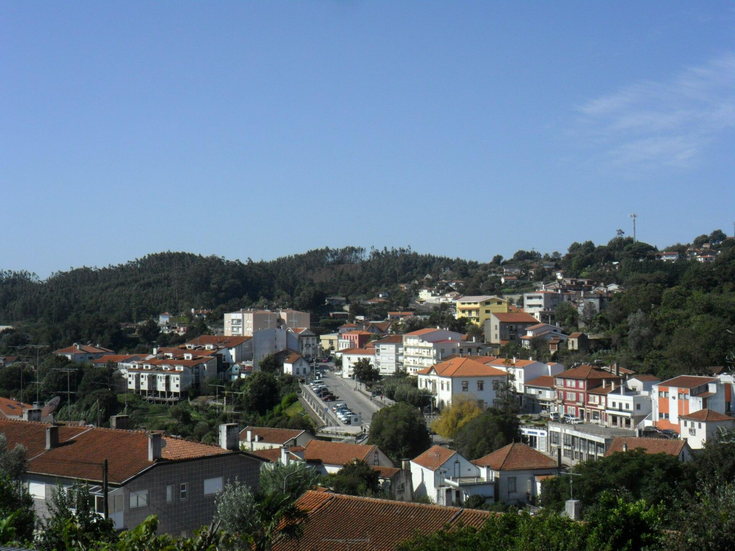
Sever do Vouga regional landscape context. Dafema, CC BY-SA 3.0.
Read the Copernicus and Polícia Judiciária summaries to establish the verified September 2024 regional and Talhadas fire context.
Sort example observations into directly visible features—green cover, bare ground, standing dead vegetation and rills—and claims that RGB images alone cannot establish.
Frame the guiding question: how can repeatable RGB mapping document visible post-fire landscape patterns without overstating ecological meaning?
Expected student outputs
- A verified-context note and visible-versus-not-measurable classification chart.

Phase 2 – Exploration (Investigate & Compare)
Examine the route map for the candidate parcel northwest of Fragua. The approximately 900 m grid is not a flight authorisation and has not been flown.
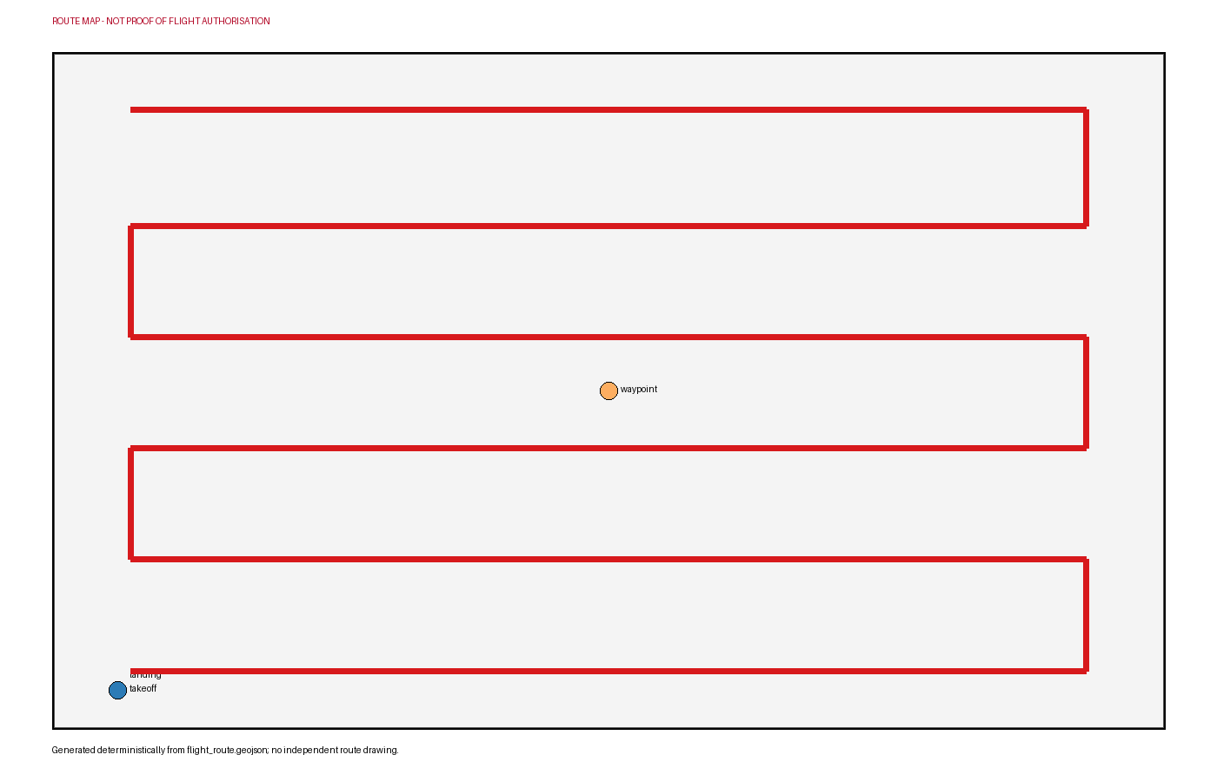
Discuss the proposed 60 m AGL strategy with approximately 80% forward and 70% side overlap, noting that terrain and tree clearance must be confirmed on site.
Design ground-observation points that can check whether RGB classes represent green vegetation, bare ground, dead vegetation or another surface.
Identify hazards: steep or uneven ground, trees, track users, wind, smoke, active response, high rural-fire danger and wildlife.
Prepare a simple class legend and rule set that avoids assigning burn severity, soil chemistry or recovery status from colour alone.
Expected student outputs
- An annotated route, ground-check plan and RGB class legend.

Phase 3 – Application (Hands-On Practice)
Before any field activity, confirm the parcel, land access, relation to the documented fire area and current operational permissions. Cancel during elevated fire danger, smoke or emergency response.
Assign pilot, observer, safety lead, ground-observation team and data manager roles. Inspect terrain, tree height, takeoff area, people and visibility.
If all conditions are satisfied, acquire consistent nadir RGB photographs along the approved grid while maintaining visual line of sight and conservative terrain clearance.
Record ground photographs and class labels at agreed points without entering unsafe areas. Link every ground observation to its position and time.
Quality-check the images, then create an orthomosaic and digitise ground-checked visible-cover classes, bare-ground patches and clearly visible rills or erosion-control features.
Summarise area or frequency only for features that can be mapped reliably, and record obscured, shadowed or ambiguous zones as uncertain.
Expected student outputs
- An orthomosaic if image quality permits, a ground-checked visible-cover layer and a visible erosion-indicator map.

Phase 4 – Reflection & Consolidation (Present & Connect)
Teams present the visible-cover and erosion-indicator map together with the ground checks supporting each class.
Peer reviewers identify one valid observation, one uncertain interpretation and one claim the data cannot support.
Compare the value of broad aerial coverage with the detail supplied by ground observations.
Design a repeat survey using comparable season, illumination, altitude, class rules and ground checks.
Expected student outputs
- A limitations-focused briefing and repeat-survey protocol.

Assessment Criteria
- The student distinguishes verified fire context from unconfirmed parcel conditions.
- The student identifies features that RGB imagery can and cannot support.
- The student plans a safe route and responds correctly to fire, terrain, weather and emergency constraints.
- The student links ground observations to mapped classes and documents uncertain areas.
- The student produces a clear, traceable visible-cover and erosion-indicator map.
- The student reflects critically on limitations and proposes a comparable repeat survey.

Teaching Materials
Resource | Link
Polícia Judiciária – Forest Fire in Talhadas, Sever do Vouga | https://www.policiajudiciaria.pt/detencao-por-crimes-de-incendio-florestal-em-sever-do-vouga/
Copernicus EMS – Information Bulletin 174: Wildfires in Portugal | https://mapping.emergency.copernicus.eu/news/information-bulletin-174-copernicus-emergency-management-service-monitors-wildfires-in-portugal/
EFFIS – European Forest Fire Information System | https://forest-fire.emergency.copernicus.eu/
Copernicus Browser – Sentinel-2 Before/After Imagery | https://browser.dataspace.copernicus.eu/
IPMA – Mainland Rural Fire Danger | https://www.ipma.pt/en/riscoincendio/rcm.pt/

External Resources
Resource | Link
Wildfire in Portugal, September 2024 | https://mapping.emergency.copernicus.eu/news/wildfire-in-portugal/
Detencao por crimes de incendio florestal em Sever do Vouga | https://www.policiajudiciaria.pt/detencao-por-crimes-de-incendio-florestal-em-sever-do-vouga/
DJI Mavic 3 Enterprise specifications | https://enterprise.dji.com/mavic-3-enterprise/specs
Portugal UAS geographical-zone map | https://dnt.anac.pt/mapa.html
Aeronaves nao tripuladas (drones) | https://www.aan.pt/subPagina-AAN-001.005.005-aeronaves-n-o-tripuladas-drones

References
Copernicus Emergency Management Service. Wildfire in Portugal, September 2024. https://mapping.emergency.copernicus.eu/news/wildfire-in-portugal/
Policia Judiciaria. Detencao por crimes de incendio florestal em Sever do Vouga. https://www.policiajudiciaria.pt/detencao-por-crimes-de-incendio-florestal-em-sever-do-vouga/
OpenStreetMap contributors. OpenStreetMap Fragua locality, node 1750703110. https://www.openstreetmap.org/node/1750703110
DJI. DJI Mavic 3 Enterprise specifications. https://enterprise.dji.com/mavic-3-enterprise/specs
Applied Sciences (MDPI). Monitoring post-fire forest recovery using RGB UAV imagery. https://www.mdpi.com/2076-3417/11/12/5423
Drones (MDPI). UAS-based wildfire mapping and fire severity estimation: methods and limitations. https://www.mdpi.com/2504-446X/3/2/43
Autoridade Nacional da Aviacao Civil. Portugal UAS geographical-zone map. https://dnt.anac.pt/mapa.html
Autoridade Aeronautica Nacional. Aeronaves nao tripuladas (drones).

