

Mapping Shoreline and Dune-Edge Change at Cova-Gala

FLIGHT RESOURCE CENTER

Sucessos Criativos

Table of Contents

1. SHORT DESCRIPTION 3
2. TARGET 3
3. SUBJECT AREA 3
4. TYPE 3
5. DRONE USED 3
6. DURATION 3
7. LEARNING OBJECTIVES 4
8. KEY COMPETENCES DEVELOPED 4
1. Communication and Languages 4
2. Mathematical, Scientific, Technical and Professional Skills 4
3. Digital Competences 4
4. Personal, Social and Professional Competences 4
5. Safety, Quality and Sustainability 5
6. Citizenship and Cultural Competence 5
7. Creativity, Problem-Solving and Entrepreneurship 5
8. Work-Based Learning and Workplace Integration 5
9. Prior Knowledge / Prerequisites 5
10. Lesson/Project Outline 6
Phase 1 – Introduction (Engage & Contextualize) 6
Phase 2 – Exploration (Investigate & Compare) 6
Phase 3 – Application (Hands-On Practice) 7

Phase 4 – Reflection & Consolidation (Present & Connect) 8
11. Assessment Criteria 8
12. Teaching Materials 9
13. External Resources 10
14. References 10

SHORT DESCRIPTION
Praia da Cova-Gala is a documented beach in Figueira da Foz, within the Cova-Gala–Costa de Lavos coastal sector assessed by the Portuguese Environment Agency. For the cited 2018–2021 period, APA reported that 90% of this approximately 4 km sector was in erosion, including 55% classified as severe or extreme. This project uses the factory-integrated RGB camera of a DJI Mavic 3 Enterprise to plan repeatable aerial documentation of a visible shoreline proxy and dune edge. Students create an orthomosaic and mapped observations while recognising that a single survey cannot establish a long-term erosion rate.

TARGET
- 15
- 16 X
- 17 X
- 18 X
- Over 18 X

SUBJECT AREA
- Agriculture
- Disaster Response
- Constructions
- Water Management X
- Environmental Protection X
- Other

TYPE
- Lesson Plan
- Project X
- Activity

DRONE USED
- Custom Drone
- Commercial drone (DJI) X

DURATION
- 1 x 45-minute class
- 1 x 60-minute class
- 1 x 90-minute block
- 2 x 45-minute classes
- 2 x 60-minute classes
- Double session (2 × 60 minutes) optional project-based homework. X

LEARNING OBJECTIVES
O1: Explain coastal erosion and distinguish the waterline, wet/dry line, dune toe and vegetation edge as different visible coastal indicators.
O2: Interpret a real geospatial survey route and explain how altitude, image overlap, tide and time influence repeatable RGB mapping.
O3: Plan a supervised DJI Mavic 3 Enterprise survey that protects people, wildlife and the dune environment.
O4: Organise geotagged RGB photographs and process suitable imagery into an orthomosaic and separate coastal-feature layers.
O5: Compare compatible dated information, communicate uncertainty and avoid unsupported claims about erosion rate or cause.

KEY COMPETENCES DEVELOPED

1. Communication and Languages
- Literacy competence (understanding and producing written/oral texts) X
- Communication in professional contexts X
- Multilingual competence

2. Mathematical, Scientific, Technical and Professional Skills
- Mathematical competence X
- Scientific, technological and engineering competence (STEM) X
- Numeracy applied to work tasks X
- Interpretation of technical information (manuals, diagrams, standards) X
- Professional/technical skills X
- Execution of practical tasks X

3. Digital Competences
- Digital competence (general digital literacy) X
- Use of digital tools in workplace settings X

4. Personal, Social and Professional Competences
- Personal, social and learning-to-learn competence X
- Teamwork and collaboration X
- Autonomy and responsibility X
- Work ethics and professional behaviour X
- Adaptability and flexibility X
- Cooperation with supervisors and colleagues

5. Safety, Quality and Sustainability
- Application of health and safety standards (OHS/SST) X
- Quality procedures and workplace norms X
- Environmental and sustainability awareness X

6. Citizenship and Cultural Competence
- Citizenship competence X
- Cultural awareness and expression competence

7. Creativity, Problem-Solving and Entrepreneurship
- Problem-solving and critical thinking X
- Entrepreneurship competence
- Initiative and creativity X
- Decision-making in real work situations X

8. Work-Based Learning and Workplace Integration
- Integration into workplace routines
- Following professional instructions and procedures X
- Use of tools, equipment and technology X
This checklist merges the EU Key Competences for Lifelong Learning with the core competences expected in European Vocational Education and Training (VET).

Prior Knowledge / Prerequisites
- Basic knowledge of coastal processes and sediment movement.
- Basic map literacy, including coordinates, scale, lines and polygons.
- Introductory drone-safety awareness and ability to work in assigned team roles.
- Basic file management and familiarity with a GIS or teacher-led mapping application.

Lesson/Project Outline

Phase 1 – Introduction (Engage & Contextualize)
Show the contextual photograph of Praia da Cova-Gala and locate the beach in Figueira da Foz. Students separate visible observations from conclusions that the photograph cannot support.
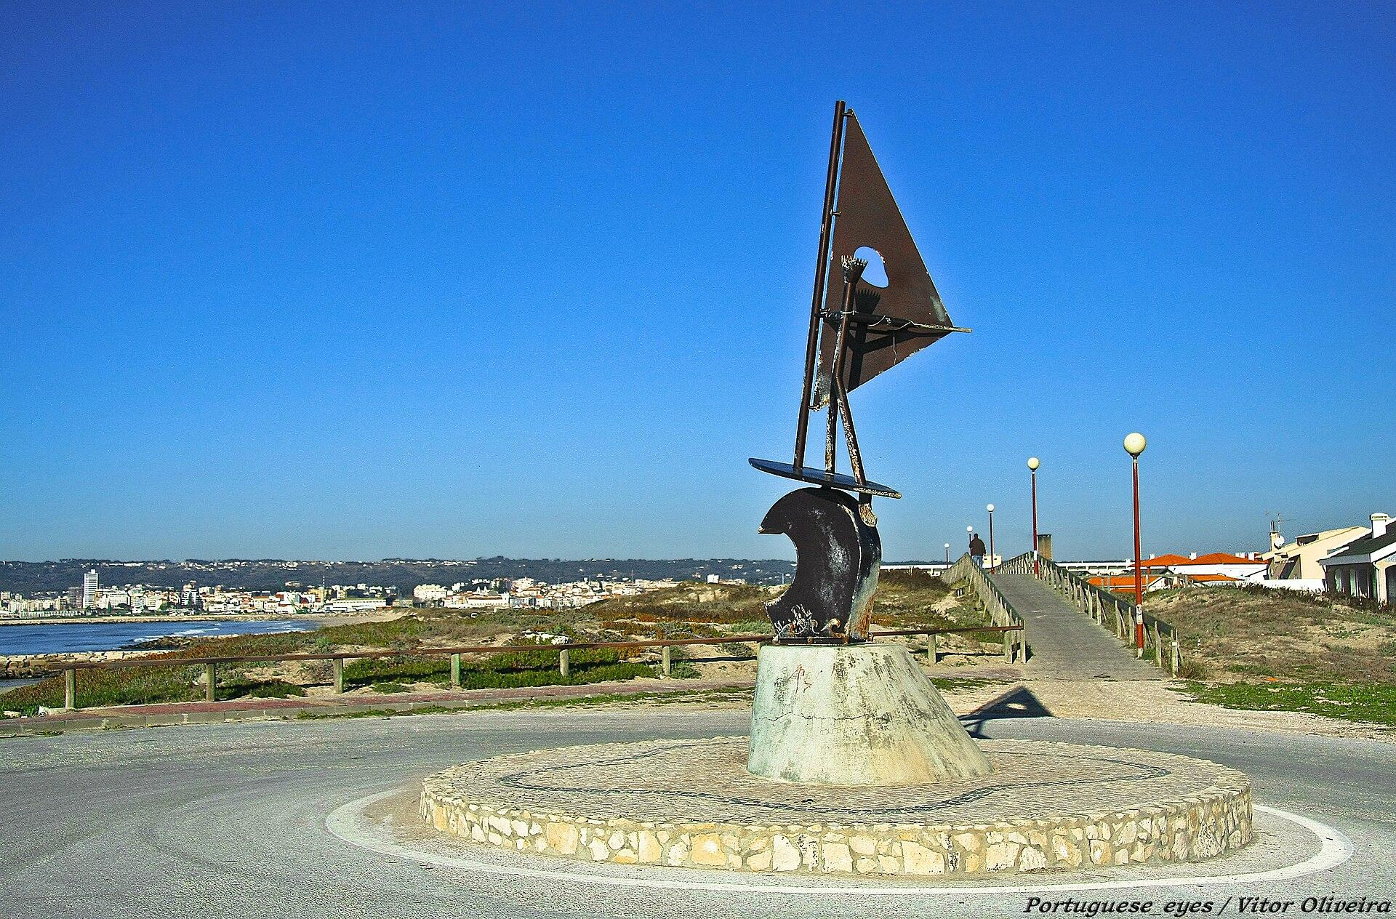
Introduce the APA coastal diagnosis and clarify that its percentages and retreat values refer to the cited 2018–2021 sector, not to measurements made by the class.
Compare simple sketches of the waterline, wet/dry line, dune toe and vegetation edge. Groups choose one shoreline proxy and one dune-edge proxy for consistent mapping.
Discuss how an aerial RGB view can extend coverage while still requiring careful interpretation and repeat observations.
Expected student outputs
- A labelled coastal-feature sketch and a concise, evidence-based monitoring question.

Phase 2 – Exploration (Investigate & Compare)
Study the proposed route map generated from the real Cova-Gala coordinates. The approximately 520 m grid is not a flight authorisation and has not been flown.
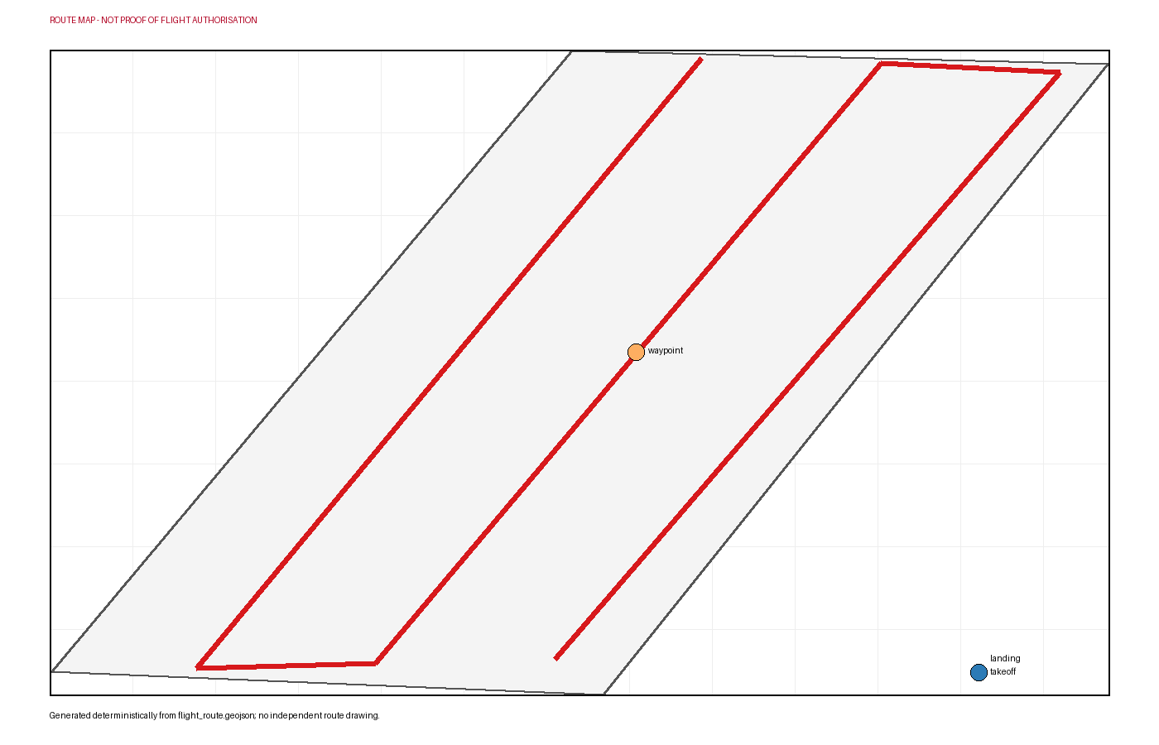

Relate the proposed 60 m AGL survey, approximately 80% forward overlap and 70% side overlap to complete nadir photographic coverage.
Identify the proposed takeoff area, study boundary, flight lines and landing point. Check whether visual line of sight can be maintained from the operating area.
Prepare a comparison table showing how tide, wave run-up, camera angle, image resolution, georeferencing and feature interpretation can shift a mapped line.
Review the need for current AAN, ANAC, land-manager and environmental checks. Students record conditions that would cancel the activity, including people, birds, unsuitable wind or tide.
Expected student outputs
- An annotated route briefing and a completed field-planning checklist.

Phase 3 – Application (Hands-On Practice)
Assign pilot, visual observer, safety and environmental observer, mission recorder and data manager roles under teacher supervision.
If every permission and safety condition is met, inspect the takeoff area, establish a controlled zone and confirm weather, tide, people, wildlife, aircraft, batteries and return-to-home settings.
Fly the approved version of the proposed grid at the authorised altitude using consistent nadir RGB settings and sufficient overlap. Maintain visual line of sight and stop for any unsafe condition.
After landing, copy the original geotagged photographs and flight record to a protected folder, make a backup and reject blurred, poorly exposed or incomplete imagery with a recorded reason.
Process accepted images in approved photogrammetry software. Inspect alignment, gaps and distortion before exporting an orthomosaic in a documented coordinate reference system.
In GIS, digitise the selected shoreline proxy and visible dune edge into separate layers. Record date, operator, proxy and uncertainty, then make only compatible comparisons.
Expected student outputs
- A quality-controlled image set and orthomosaic, if fieldwork and image quality permit, plus separate shoreline and dune-edge layers and an uncertainty-aware map.

Phase 4 – Reflection & Consolidation (Present & Connect)
Teams present their coastal monitoring map, explain the chosen proxies and trace each conclusion to an image, map layer or cited source.
Compare digitising choices and discuss how tide, image quality and georeferencing affect interpretation.
Identify what the drone added—systematic coverage and repeatable documentation—and what one RGB survey cannot measure.
Propose a repeat survey using comparable timing, proxy definitions and processing, together with the permissions and evidence that would be needed.
Expected student outputs
- A short team presentation and an individual reflection on evidence quality and repeat monitoring.

Assessment Criteria
- The student explains the local coastal context accurately and distinguishes the selected shoreline and dune-edge indicators.
- The student interprets the route, altitude and overlap and contributes to a responsible go/no-go decision.
- The student follows assigned roles, protects people and wildlife and records field conditions and deviations.
- The student organises imagery carefully and evaluates alignment, coverage and positional limitations.
- The student produces clear, separate map layers and uses only compatible evidence for comparison.
- The student presents supported conclusions, uncertainty and a realistic repeat-monitoring proposal.

Teaching Materials
Resource | Link
APA – Diagnosis of the State of the Portuguese Coastal Strip | https://apambiente.pt/destaque2/apa-atualiza-diagnostico-do-estado-da-faixa-costeira
Copernicus Browser – Satellite Imagery and Temporal Comparison | https://browser.dataspace.copernicus.eu/
OpenDroneMap – Orthophoto Processing and Outputs | https://docs.opendronemap.org/outputs/
QGIS Training Manual – GIS Mapping and Spatial Analysis | https://docs.qgis.org/latest/en/docs/training_manual/index.html
USGS – UAS-SfM for Coastal Research | https://www.usgs.gov/publications/uas-sfm-coastal-research-geomorphic-feature-extraction-and-land-cover-classification

External Resources
Resource | Link
APA updates diagnosis of the state of the coastal strip | https://apambiente.pt/destaque2/apa-atualiza-diagnostico-do-estado-da-faixa-costeira
Praia da Cova-Gala beach record | https://bandeiraazul.abaae.pt/plataforma/index.php?id=189&p=beaches&s=beach
DJI Mavic 3 Enterprise specifications | https://enterprise.dji.com/mavic-3-enterprise/specs
Portugal UAS geographical-zone map | https://dnt.anac.pt/mapa.html
Aeronaves nao tripuladas (drones) | https://www.aan.pt/subPagina-AAN-001.005.005-aeronaves-n-o-tripuladas-drones

References
Agencia Portuguesa do Ambiente. APA updates diagnosis of the state of the coastal strip. https://apambiente.pt/destaque2/apa-atualiza-diagnostico-do-estado-da-faixa-costeira
ABAAE / Blue Flag Portugal. Praia da Cova-Gala beach record. https://bandeiraazul.abaae.pt/plataforma/index.php?id=189&p=beaches&s=beach
OpenStreetMap contributors. OpenStreetMap beach geometry, way 212896662. https://www.openstreetmap.org/way/212896662
DJI. DJI Mavic 3 Enterprise specifications. https://enterprise.dji.com/mavic-3-enterprise/specs
U.S. Geological Survey. UAS-SfM for coastal research: geomorphic feature extraction and land-cover classification. https://www.usgs.gov/publications/uas-sfm-coastal-research-geomorphic-feature-extraction-and-land-cover-classification
Autoridade Nacional da Aviacao Civil. Portugal UAS geographical-zone map. https://dnt.anac.pt/mapa.html
Autoridade Aeronautica Nacional. Aeronaves nao tripuladas (drones). https://www.aan.pt/subPagina-AAN-001.005.005-aeronaves-n-o-tripuladas-drones
Instituto da Conservacao da Natureza e das Florestas. ICNF forms and authorisations. https://www.icnf.pt/oquefazemos/formularios

