

GASKİ Genel Müdürlüğü

Water Pipeline Leak Detection and Visual Inspection Project

Activity Reference: 3.2 - Development of projects for FLIGHT RESOURCE CENTER

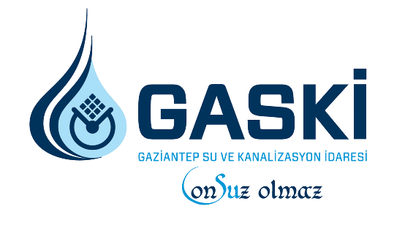

Table of Contents

1. TITLE 2
2. SHORT DESCRIPTION 2
3. SUBJECT AREA 3
4. TYPE 3
5. DRONE USED 3
6. DURATION 3
7. LEARNING OBJECTIVES 4
8. 9. Key Competences Developed 5
9. Prior Knowledge / Prerequisites 5
10. Lesson Outline 6
Phase 1 – Introduction (Engage & Contextualize) 6
Phase 2 – Exploration (Investigate & Compare) 7
Phase 3 – Application (Hands-On Practice) 8
Phase 4 – Reflection & Consolidation (Present & Connect) 9
11. Assessment Criteria 9
12. Teaching Materials 10
13. External Resources 10
14. References

1. TITLE
Water Pipeline Leak Detection and Visual Inspection
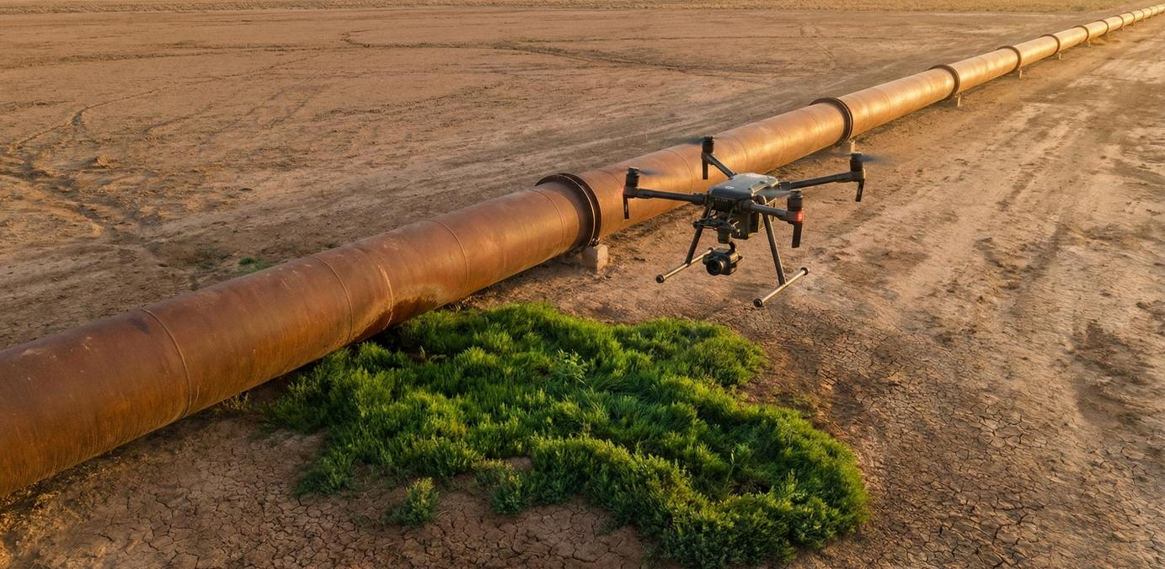
2. SHORT DESCRIPTION
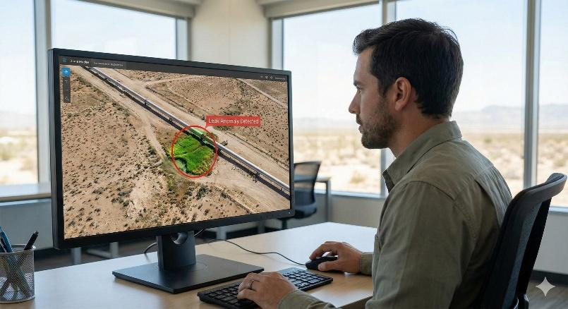
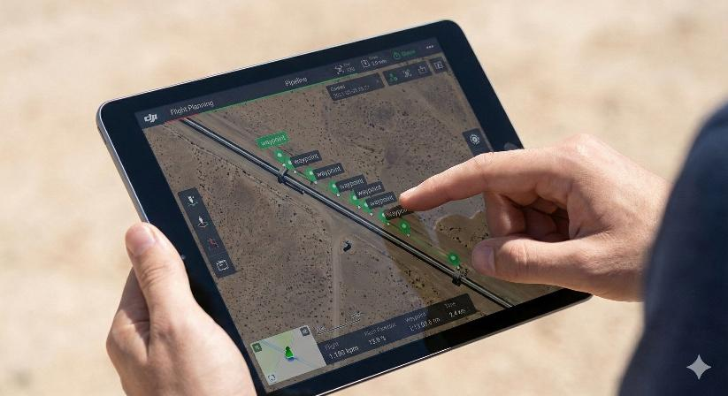
This project is designed for ISCED Level 3 (Upper Secondary) VET students to combat "Non-Revenue Water" losses, a critical issue in global water management. While traditional manual inspection of kilometers-long water transmission lines takes weeks, students in this project will reduce this process to minutes using commercial drone technology (DJI, etc.). Students will utilize ground station software like Litchi or DJI Pilot to create complex "Autonomous Waypoint" flight plans. By analyzing the acquired high-resolution aerial imagery, they will detect underground leaks through surface indicators such as vegetation anomalies (unexpected greening) and soil moisture. This process equips students not only with drone piloting skills but also with competencies in Remote Sensing and Infrastructure Asset Management.

3. SUBJECT AREA
- Agriculture
- Disaster Response
- Constructions
- Water Management
- Environmental Protection
- Other

4. TYPE
- Lesson Plan
- Project
- Activity

5. DRONE USED
Commercial drone (DJI - Mavic/Air/Mini Series)

6. DURATION
- 1 x 45-minute class
- 1 x 60-minute class
- 1 x 90-minute block
- 2 x 45-minute classes
- 2 x 60-minute classes
- Double session (2 × 60 minutes) optional project-based homework.

7. LEARNING OBJECTIVES
(Structured according to Subject + Action + Object + Context)
- Students (Subject) will plan and simulate (Action verb) a continuous and safe autonomous flight route (Waypoint Mission) (Object) over linear infrastructure assets using Google Earth Pro or mission planning software (Context).
- Students (Subject) will detect (Action verb) anomalies indicating leaks, such as sudden vegetation density or soil color changes (Object), by examining orthomosaics or serial aerial photos recorded by the drone in arid terrain (Context).
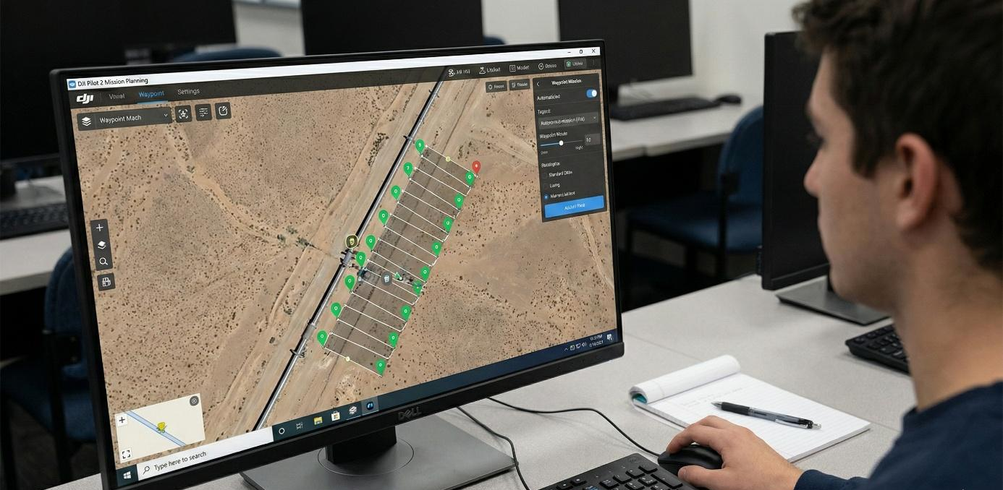
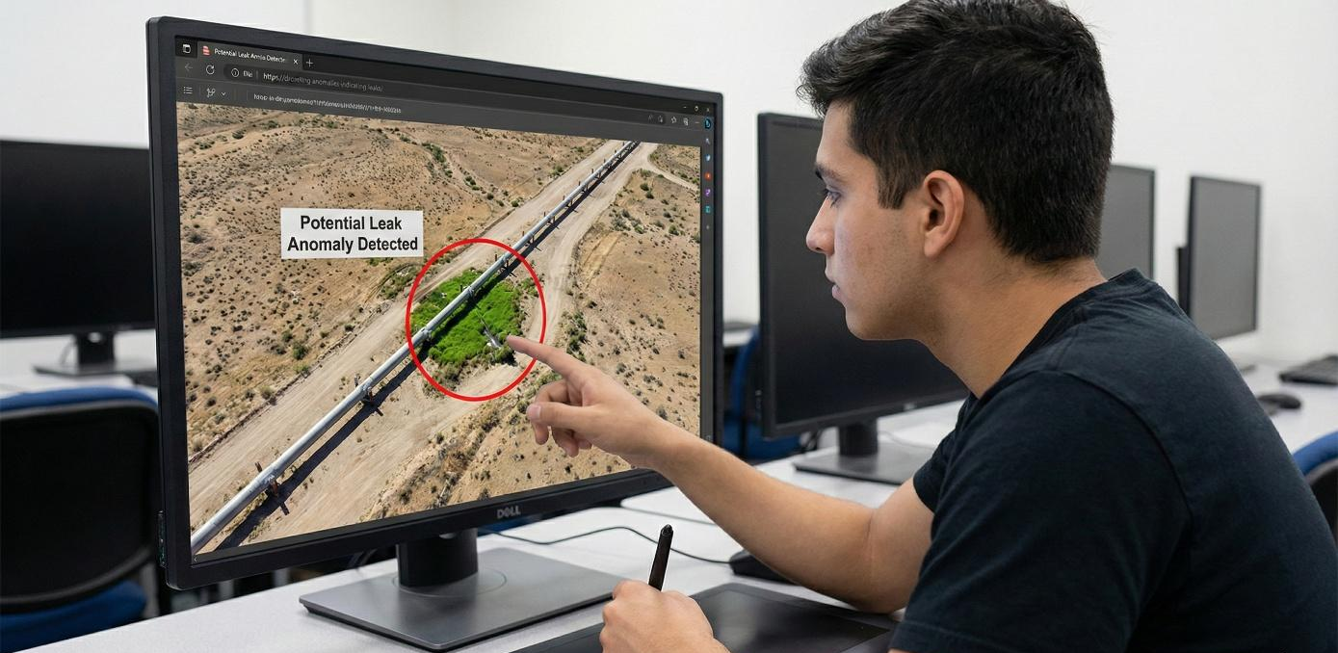
- Students (Subject) will create (Action verb) a digital, prioritized "Fault Detection and Maintenance Work Order" report (Object) by extracting the GPS coordinates of the identified suspicious points to enable rapid intervention by maintenance teams (Context).

8. KEY COMPETENCES DEVELOPED
- Digital competence:
  - Understanding autonomous flight algorithms and using Ground Control Station (GCS) software (Litchi, DJI Pilot) at a professional level.
  - Managing coordinate systems (WGS84) on digital maps and interpreting telemetry data.
- Entrepreneurship competence:
  - Gaining awareness of "Resource Efficiency" by analyzing the cost of water losses.
  - Developing a sectoral vision by proposing innovative, fast, and cost-effective technological solutions instead of traditional, costly, and slow inspection methods.
- Mathematical competence and competence in STEM:
  - Optimizing missions by calculating the relationship between flight time, battery capacity, and drone speed.
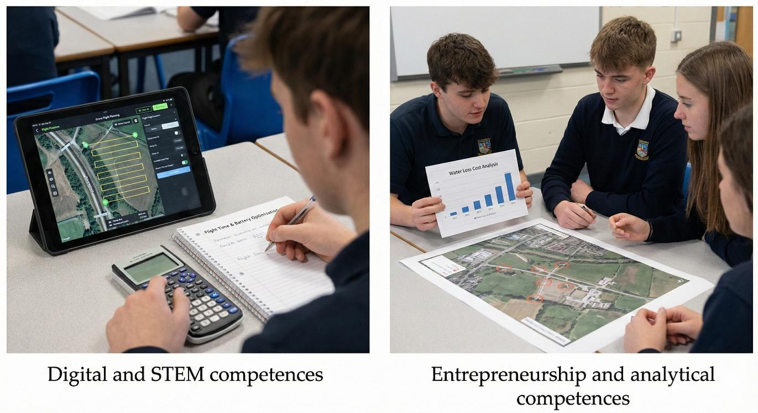
  - Mathematically planning image quality by calculating photo overlap ratios.

9. PRIOR KNOWLEDGE / PREREQUISITES
• Basic map literacy (Satellite image interpretation).
• Ability to use smart devices (tablets/smartphones).
• Familiarity with basic photography terms (Gimbal angle, Exposure).

10. LESSON OUTLINE
Phase 1 – Introduction: Engage & Contextualize (Duration: 15 Minutes)
- Purpose: To enable students to understand "Physical Water Losses" as the invisible face of the global water crisis and to emphasize the necessity of technological intervention.
- Scenario ("Invisible Loss"): The teacher presents the statistic: "30% of treated clean water worldwide never reaches the tap." The economic cost (lost tax money) and environmental cost (wasted energy) of this situation are discussed.
- Critical Question: "A water pipeline runs for kilometers under a desert or forest. How would you know there is a burst without digging or walking the entire line?"
- Visual Material: A real arid terrain (e.g., Central Anatolia or Africa) is shown to students via Google Earth Pro. An "unexplained, straight line of greenery" (vegetation anomaly) in the middle of the drought is pointed out. It is explained that this is the "vegetative signature" of an underground leak.
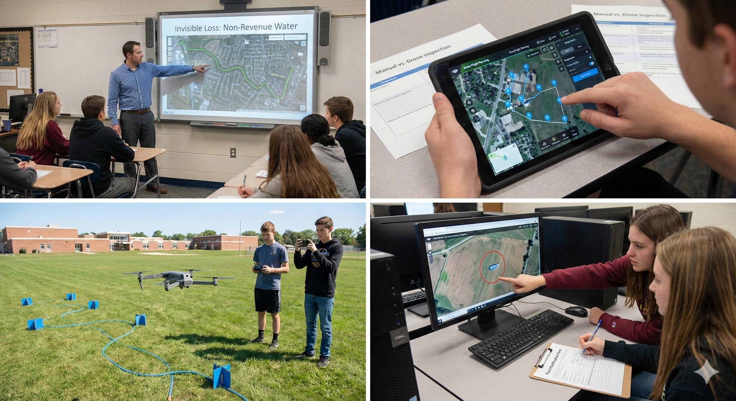

Phase 2 – Exploration: Investigate & Compare (Duration: 25 Minutes)
- Purpose: To analyze the difference between manual and autonomous inspection and to grasp the logic of flight planning.
- Technology Comparison: A comparison table is created in class:
  - Manual Method: Slow (5 km/day), Exhausting, Prone to human error, Costly.
  - Drone Method: Fast (50 km/day), Efficient, Repeatable (Autonomous), Economical.
- Software Training (Mission Planning):
  - Students open the DJI Pilot 2 or Litchi application on their tablets.
  - The concept of "Waypoint" is introduced. It is explained how the drone flies independently of the controller by following GPS coordinates (Latitude, Longitude, Altitude).
  - Failsafe Setting: The question "What to do if the connection with the drone is lost?" is answered (e.g., selecting 'Continue Mission' or 'Return to Home').
- Simulation Setup:
  - A "Representative Transmission Line" is created in the schoolyard or gym using a blue strip (or garden hose) laid on the ground.
  - "Blue Cardboards" representing leaks or (if outdoors) areas wetted with water are prepared at 3 random points along the line.

Phase 3 – Application: Hands-On Practice (Duration: 35 Minutes)
- Purpose: To apply the theoretical flight plan in the field and collect data.
- Mission Planning (Desktop/Tablet):
  - Students draw the flight route over the representative line on their tablets.
  - Parameters: Altitude: 5 meters, Speed: 2 m/s, Gimbal Pitch: -90° (Straight Down / Nadir).
- Pre-Flight Check: Battery status, memory card space, and propellers are checked. Environmental safety is ensured.
- Field Operation (Hands-On):
  - The planned mission is uploaded to the drone (Upload Mission).
  - Start: The drone takes off automatically. The student does not touch the sticks but acts as a "Safety Pilot," monitoring telemetry data (altitude, speed, battery) on the screen.
  - The drone records video while scanning the line and lands automatically when the designated route is complete.
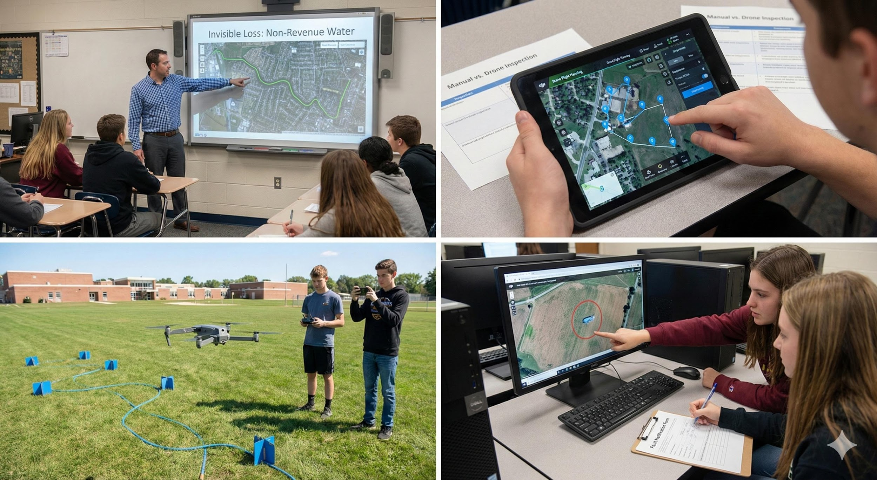

Phase 4 – Reflection & Consolidation: Present & Connect (Duration: 15 Minutes)
- Purpose: To analyze the collected imagery, transform it into "Information," and report it.
- Data Analysis (Detective Game):
  - The high-resolution video captured by the drone is projected onto a large screen or smartboard.
  - As the video plays, students shout "STOP" when they spot a sign of a leak (blue cardboards or wet spots on the ground).
- Reporting and Work Order:
  - The approximate coordinate or location of the detected point on the line is noted (e.g., "At the 12th meter of the line").
  - Students fill out a short "Fault Notification Form" addressed to a Water Utility Maintenance Team.
  - Form Content: Fault Type (Leak), Priority (Urgent), Location, Required Equipment (Excavator/Repair Clamp).
11. ASSESSMENT CRITERIA
• Flight Plan Success: Whether the drone followed the line by centering it perfectly.
• Detection Accuracy: How many of the simulated leak points were correctly identified.
• Reporting Quality: Accuracy of coordinates and the technical language of the report.

12. TEACHING MATERIALS
• Commercial Drone (DJI Mavic, Air, or Mini series).
• Tablet/Phone (Flight software installed).
• Representative Pipeline (Strips, hose).
• Simulated Leak Markers.
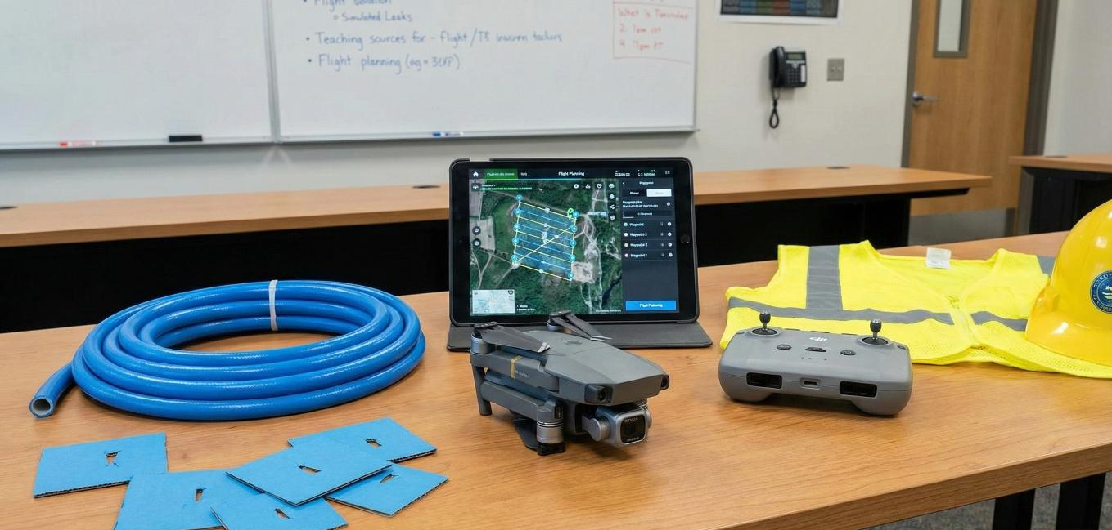

13. EXTERNAL RESOURCES
• IWA (International Water Association) Water Loss Management Reports.
• DJI Enterprise Pipeline Inspection Case Studies.

